**A Lab Manual**

**on**

**DEVOPS LAB**

**R22**

**(III- B. Tech. – II– Semester)**

**Submitted to**

**DEPARTMENT OF COMPUTER SCIENCE& ENGINEERING**

**(DATA SCIENCE)**

**By**

**Ms.Penugonda Anusha**

(Asst Professor, Dept. of CSE (DS))

**Mr. Deekshith Chary**

(Asst Professor, Dept. of CSE(DS))

**Mr. Mohsin**

(Asst Professor, Dept. of CSE(DS))



**CMR INSTITUTE OF TECHNOLOGY**

Kandlakoya(V), Medchal Road, Hyderabad – 501 401

Ph. No. 08418-222042, 22106 Fax No. 08418-222106

**(2024-25)**

**CONTENTS**

|  |  |  |
| --- | --- | --- |
| **Sl. No.** | **Particulars** | **Page No.** |
|  | Vision and Mission | **2** |
|  | Syllabus | 4 |
|  | Student Entry Behavior or Pre-requisites | 5 |
|  | Course Outcomes | 6 |
|  | Mapping of Course with PEOs-POs | 7 |
|  | Mapping Of Course Outcomes with POs | 9 |
|  | Direct Course Assessment | 10 |
|  | Indirect Course Assessment | 11 |
|  | Overall Course Assessment and Attainment level | 13 |
|  | Pi diagrams, Bar charts, Histograms for representing results | 14 |
|  | Lesson/Course Plan | 15 |
|  | Programs | 16 |

1. **Vision and Mission**

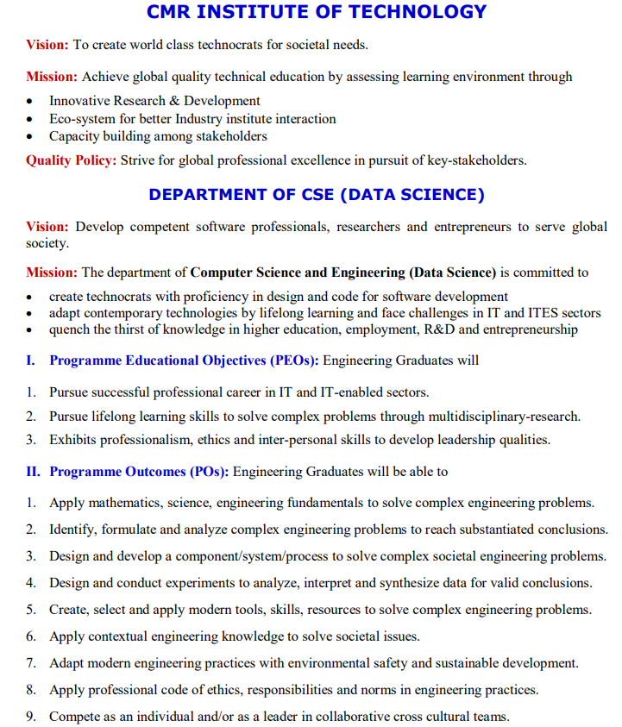

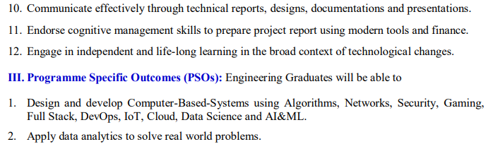

**2.Syllabus**

**Devops LAB**

|  |  |  |  |  |  |
| --- | --- | --- | --- | --- | --- |
| **Course** | **B.Tech.-VI-Sem.** | **L** | **T** | **P** | **C** |
| **Course Code** | **22CDPC66** | - | - | **2** | **1** |

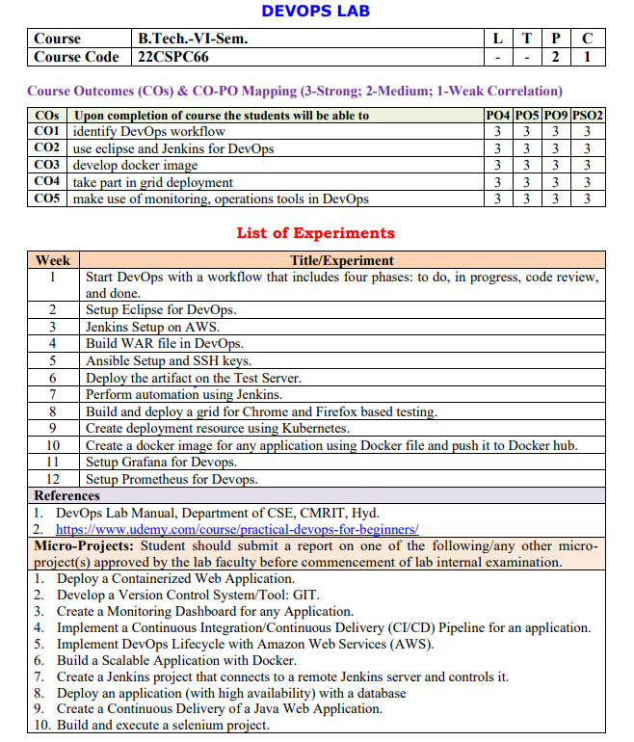

**3.Student Entry Behavior or Pre-requisites**

* Students should have basic knowledge on Linux commands
* Students should have basic knowledge on basic programming.
* Student should have knowledge on software engineering concepts
* These prerequisites are taken by the students during the first two years. However during the initial sessions the topics are reviewed.

**4.Course Outcomes**

|  |  |
| --- | --- |
| **Course Outcome** | **Course Outcome Statements** |
| **CO - 1** | identify DevOps workflow |
| **CO – 2** | use eclipse for DevOps |
| **CO – 3** | develop docker image |
| **CO – 4** | take part in grid deployment |
| **CO – 5** | make use of Jenkins framework in DevOps |

**5.Mapping of Course with PEOs-POs**

(Only Ticking)

**Program Educational Objectives (PEOs)**

|  |  |  |
| --- | --- | --- |
| **Sl. No.** | **PEOs Name** | **Program Education Objective Statements** |
| **1** | **PEO - 1** | **Pursue successful professional career in IT and IT-enabled sectors. [PO’s: 1,2,3,4,5,7,8,9,10,11 and 12] [PSO’s: 1 and 2]** |
| **2** | **PEO – 2** | **Pursue lifelong learning skills to solve complex problems through multidisciplinary-research. [PO’s: 1,2,3,4,5,6,7,8,9,10 and 12] [PSO’s: 1, 2 ]** |
| **3** | **PEO – 3** | **Exhibits professionalism, ethics and inter-personal skills to develop leadership qualities. [PO’s: 1,2,3,4,5,6,7,8,9,10,11 and 12] [PSO’s: 2 ]** |

**Program Outcomes (POs)**

|  |  |  |
| --- | --- | --- |
| **PO Name** | **Graduate Attributes** | **PO Statements** |
| **PO1** | **Engineering knowledge** | **Apply mathematics, science, engineering fundamentals to solve complex engineering problems. [PEO’s: 1,2 and 3] [PSO’s: 1,2 ]** |
| **PO 2** | **Problem analysis** | **Identify, formulate and analyze complex engineering problems to reach substantiated conclusions. [PEO’s: 1,2 and 3] [PSO’s: 1,2 ]** |
| **PO 3** | **Design/ development of solutions** | **Design and develop a component/system/process to solve complex societal engineering problems. [PEO’s: 1,2 and 3] [PSO’s: 1,2]** |
| **PO 4** | **Conduct investigations of complex problems** | **Design and conduct experiments to analyze, interpret and synthesize data for valid conclusions. [PEO’s: 1,2 and 3] [PSO’s: 1,2 ]** |
| **PO 5** | **Modern tool usage** | **Create, select and apply modern tools, skills, resources to solve complex engineering problems. [PEO’s: 1,2 and 3] [PSO’s: 1,2 ]** |
| **PO 6** | **The engineer and society** | **Apply contextual engineering knowledge to solve societal issues. [PEO’s: 2 and 3]** |
| **PO 7** | **Environment and sustainability** | **Adapt modern engineering practices with environmental safety and sustainable development. [PEO’s: 1,2 and 3]** |
| **PO 8** | **Ethics** | **Apply professional code of ethics, responsibilities and norms in engineering practices. [PEO’s: 1,2 and 3] [PSO’s: 2 ]** |
| **PO 9** | **Individual and team work** | **Compete as an individual and/or as a leader in collaborative cross cultural teams. [PEO’s: 1,2 and 3]** |
| **PO 10** | **Communication** | **Communicate effectively through technical reports, designs, documentations and presentations. [PEO’s: 1,2 and 3] [PSO’s: 2 ]** |
| **PO 11** | **Project management and finance** | **Endorse cognitive management skills to prepare project report using modern tools and finance. [PEO’s: 1 and 3] [PSO’s: 2]** |
| **PO 12** | **Life-long learning** | **Engage in independent and life-long learning in the broad context of technological changes. [PEO’s: 1,2 and 3] [PSO’s: 1,2 ]** |

**6.Mapping Of Course Outcomes With POs**

|  |  |  |  |  |  |  |  |  |  |  |  |  |  |  |
| --- | --- | --- | --- | --- | --- | --- | --- | --- | --- | --- | --- | --- | --- | --- |
| **No** | **Course Outcomes** | **Po1** | **Po2** | **Po3** | **Po4** | **Po5** | **Po6** | **Po7** | **Po8** | **Po9** | **Po10** | **Po11** | **Po12** | **Avg** |
| **1** | **CO - 1** |  |  |  | **3** | **3** |  |  |  | **3** |  |  |  |  |
| **2** | **CO – 2** |  |  |  | **3** | **3** |  |  |  | **3** |  |  |  |  |
| **3** | **CO – 3** |  |  |  | **3** | **3** |  |  |  | **3** |  |  |  |  |
| **4** | **CO – 4** |  |  |  | **3** | **3** |  |  |  | **3** |  |  |  |  |
| **5** | **CO – 5** |  |  |  | **3** | **3** |  |  |  | **3** |  |  |  |  |
|  | **Avg** |  |  |  | **3** | **3** |  |  |  | **3** |  |  |  |  |

**7.Direct Course Assessment**

(As mentioned in following table of 10 parameters, of which consider only the parameters required for this courses)

|  |  |  |  |  |  |
| --- | --- | --- | --- | --- | --- |
| **No** | **Description** | **Targeted Performance** | **Actual Performance** | **Remarks** | **Course Attainment** |
| **1** | **Internal Marks(25)** | **80% of Students(182 Students) should Secure 60% of Internal Marks i.e., 15 Marks** |  |  |  |
| **2** | **External Marks(50)** | **80% of Students(182 Students) should Secure 70% of External Marks i.e., 35 Marks** |  |  |  |
| **3** | **Clearing of Subject** | **A minimum of 95% of Students(216 Students) should clear this course in first attempt** |  |  |  |
| **4** | **Getting First Class** | **90% of Students(205 Students) should Secure I Class Marks i.e., 45 Marks in my course** |  |  |  |
| **5** | **Distinction** | **80% of Students (182 Students) should secure First Class With Distinction i.e., 53 Marks in my course** |  |  |  |
| **6** | **Outstanding Performance** | **60% of Students (137 Students) should secure 80% and above Marks. i.e., 60 Marks in my course** |  |  |  |

**8.Indirect Course Assessment**

(As mentioned-strong (3), moderate (2), weak (1) & no comment (0))

**Mission Statement of CSE**

* **Impart fundamentals through state of art technologies for research and career in Computer Science & Engineering(DS).**
* **Create value-based, socially committed professionals for anticipating and satisfying fast changing societal requirements.**
* **Foster continuous self learning abilities through regular interaction with various stake holders for holistic development.**

**Correlation of Mission Elements with Mission Statement of CSE(DS) Department related to the Course (only Ticking given by faculty)**

|  |  |  |  |  |  |
| --- | --- | --- | --- | --- | --- |
| **No** | **Mission Elements** | **Strong** | **Moderate** | **Weak** | **No Comment** |
| **M-1** | **Impart Fundamentals** | √ |  |  |  |
| **M-2** | **State Of Art Technologies** | √ |  |  |  |
| **M-3** | **Research & Career Development** | √ |  |  |  |
| **M-4** | **Value based Socially Committed Professional** | √ |  |  |  |
| **M-5** | **Anticipating & Satisfying Industry Trends** |  | √ |  |  |
| **M-6** | **Changing Societal Requirements** |  |  | √ |  |
| **M-7** | **Foster Continuous Learning** | √ |  |  |  |
| **M-8** | **Self Learning Abilities** | √ |  |  |  |
| **M-9** | **Interaction with stakeholders** | √ |  |  |  |
| **M-10** | **Holistic Development** |  | √ |  |  |

**Indirect Course Assessment through Student Satisfaction Survey**

**(Note for *: Parameters used for course teaching like**

**a: Classroom teaching b: Simulations c:labs d: Mini_Projects**

**e: Major Projects f: Conferences g: professional activities**

**h: Technical Clubs i: Guest Lectures j: Workshops k: Technical Fests l:Tutorials m:NPTLs n:Digital Library o: Industrial Visits p: software Tools q: Internship/training r:Technical Seminars**

**s: NSS t: NSS u: sports etc.**

|  |  |  |  |  |  |  |
| --- | --- | --- | --- | --- | --- | --- |
| **No** | **Question Based on PEO/ PO/PSO/CO** | **Parameters**  **(a /b /c…/)\*** | **Strong (3)** | **Moderate (2)** | **Weak (1)** | **No comment (0)** |
| **1** | **Did the course impart fundamentals through interactive learning and contribute to core competence?** |  |  |  |  |  |
| **2** | **Did the course provide the required knowledge to foster continuous learning?** |  |  |  |  |  |
| **3** | **Whether the syllabus content anticipates & satisfies the industry and societal needs?** |  |  |  |  |  |
| **4** | **Whether the course focuses on value based education to be a socially committed professional?** |  |  |  |  |  |
| **5** | **Rate the role of the facilitator in mentoring and promoting the self learning abilities to excel academically and professionally?** |  |  |  |  |  |
| **6** | **Rate the methodology adopted and techniques used in teaching learning processes?** |  |  |  |  |  |
| **7** | **Rate the course in applying sciences & engineering fundamentals in providing research based conclusions with the help of modern tools?** |  |  |  |  |  |
| **8** | **Did the course have any scope to design, develop and test a system or component?** |  |  |  |  |  |
| **9** | **Rate the scope of this course in addressing cultural, legal, health, environment and safety issues?** |  |  |  |  |  |
| **10** | **Scope of applying management fundamentals to demonstrate effective technical project presentations & report writing?** |  |  |  |  |  |
|  | **Total** |  |  |  |  |  |
|  | **Average** |  |  |  |  |  |
| **Total Average** | |  |  | | | |

**9.Overall Course Assessment**

(80% Direct + 20% Indirect, if any)

|  |  |  |  |
| --- | --- | --- | --- |
| **No** | **Assessment Type** | **Weightage** | **Attainment Level** |
| **1** | **Direct-Assignment, Quiz, Subjective, University Exams, Results, Bench Marks** | **0.8** |  |
| **2** | **Indirect-Surveys-Questionnaire** | **0.2** |  |
|  | **Overall** |  |  |

**DEVOPS LAB Course Attainment level:**

**10.Pi diagrams, Bar charts, Histograms**

(For representing previous results, if any)

|  |  |  |  |
| --- | --- | --- | --- |
| **ICS Pass % for Last 4 Academic Years** | **Appeared** | **Passed** | **Pass%** |
|  |  |  |  |

**11.Lesson/Course Plan**

|  |  |  |  |  |
| --- | --- | --- | --- | --- |
| Week No. | Name of the Program | Week | Text Books | **Mode of Assessment** |
| 1 | Start DevOps with a workflow that includes four phases: to do, in progress, code review, and done | 1 | R1 | By observations, lab records, viva-voice |
| 2 | Setup Eclipse for DevOps. | 2 | R1 | By observations, lab records, viva |
| 3 | Jenkins Setup on AWS. | 3 | R1 | By observations, lab records, viva |
| 4 | Build WAR file in DevOps. | 4 | R1 | By observations, lab records, viva |
| 5 | Ansible Setup and SSH keys. | 5 | R1 | By observations, lab records, viva |
| 6 | Deploy the artifact on the Test Server. | 6 | R1 | By observations, lab records, viva |
| 7 | Perform automation using Jenkins. | 7 | R1 | By observations, lab records, viva |
| 8 | Build and deploy a grid for Chrome and Firefox based testing. | 8 | R1 | By observations, lab records, viva |
| 9 | Create deployment resource using Kubernetes. | 9 | R1 | By observations, lab records, viva |
| 10 | Create a docker image for any application using Docker file and push it to Docker hub. | 10 | R1 | By observations, lab records, viva |
| 11 | Setup Grafana for Devops. | 11 | R1 | By observations, lab records, viva |
| 12 | Setup Prometheus for Devops. | 12 | R1 | By observations, lab records, viva |

**12.Programs**

**Experiment-1**

**Aim: Start DevOps with a workflow that includes four phases: to do, in progress, code review, and done.**

**Require Software& Tools:** JIRA, KANBAN.

**Procedure:**

**Phase 1: To Do**

* **Objective:** Identify and prioritize tasks or features to be developed.
* **Key Actions:**
  + Define tasks clearly in a backlog.
  + Prioritize tasks based on impact, urgency, and dependencies.
  + Assign owners or teams to each task.

**Tools:**  
Jira, Trello, GitHub Issues, or Asana.

**Phase 2: In Progress**

* **Objective:** Actively work on tasks selected from the "To Do" phase.
* **Key Actions:**
  + Begin coding or configuring based on task requirements.
  + Update the task status to reflect ongoing work.
  + Ensure team members collaborate effectively (e.g., stand-ups, pair programming).

**Best Practices:**

* Use branches in version control systems for individual tasks (e.g., Git feature branches).
* Write unit tests alongside development.

**Phase 3: Code Review**

* **Objective:** Validate the quality, functionality, and security of the code.
* **Key Actions:**
  + Submit pull requests for peer review.
  + Review code for adherence to standards, logic, and potential issues.
  + Approve or request changes.

**Tools:**  
GitHub Pull Requests, GitLab Merge Requests, Bitbucket.

**Automation:**  
Integrate CI/CD pipelines to run tests automatically during reviews.

**Phase 4: Done**

* **Objective:** Mark tasks as completed and deploy changes if necessary.
* **Key Actions:**
  + Merge the approved code into the main branch.
  + Deploy to staging or production environments.
  + Monitor deployment and validate functionality.

**Post-Completion:**

* Add documentation for the changes.
* Gather feedback from stakeholders or users.

**Workflow Visualization**

A Kanban board or similar visual representation can help track the status of tasks across these phases. For example:

1. **To Do**: Contains all pending tasks.
2. **In Progress**: Tasks currently being worked on.
3. **Code Review**: Tasks awaiting review or approval.
4. **Done**: Completed and deployed tasks.

**Tools:**

Trello, Jira, Azure.

**Output:-**

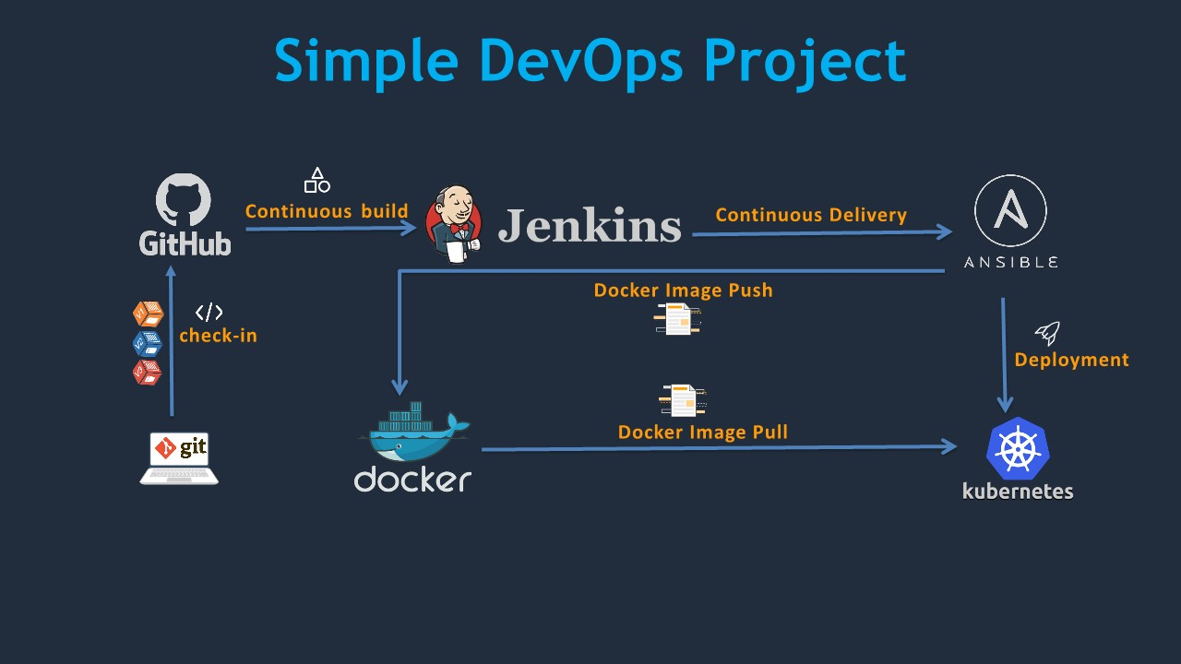

**Experiment-2**

**Aim: Setups Eclipse for Devops**

**Note:** Write the given steps in your lab manual. The provided image is just for your better understanding.

**Require Software& Tools:** Eclipse, Java jdk-17, Tomcat v.9, TestNG and Dependencies.

**Procedure:**

**Step-1:** Install Jdk-17 and set the java path in System environment

**Step-2**: Download eclipse zipfile and extract the contents the all eclipse file

**Step-3:**Create a Maven Project from eclipse as:

**OR**

Click on File in left corner -> Click on new -> click on Maven Project and follow the given image steps.

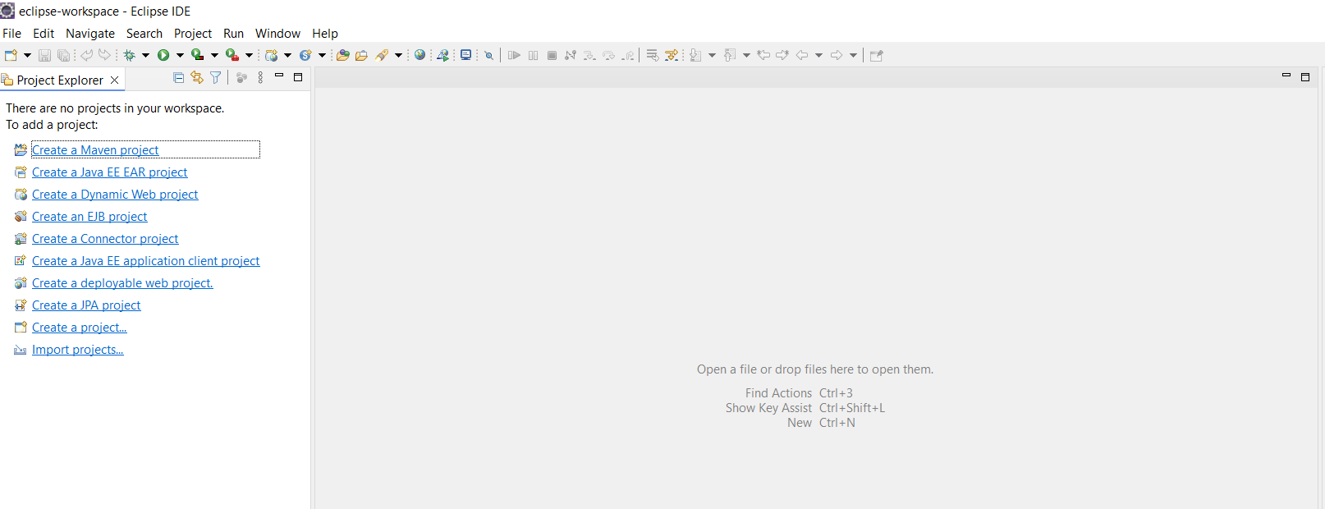

b.

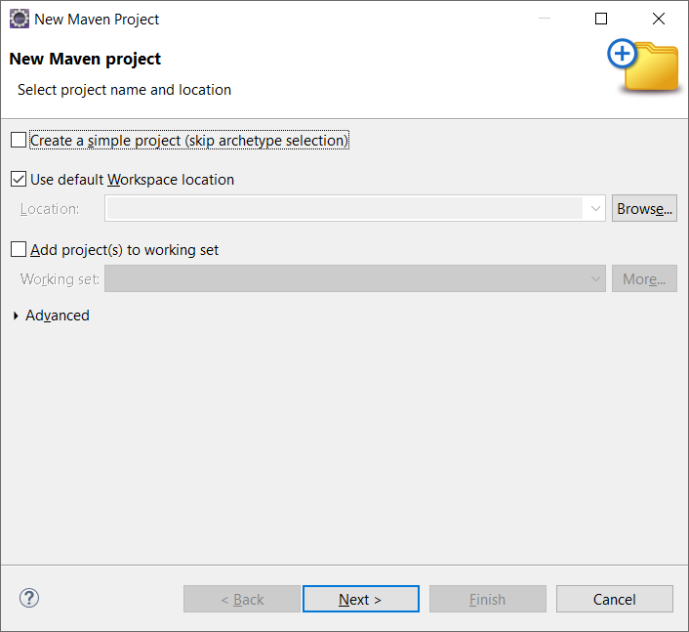

1. Click Next and Search **org.apache.maven.archetypes** and select webapp file

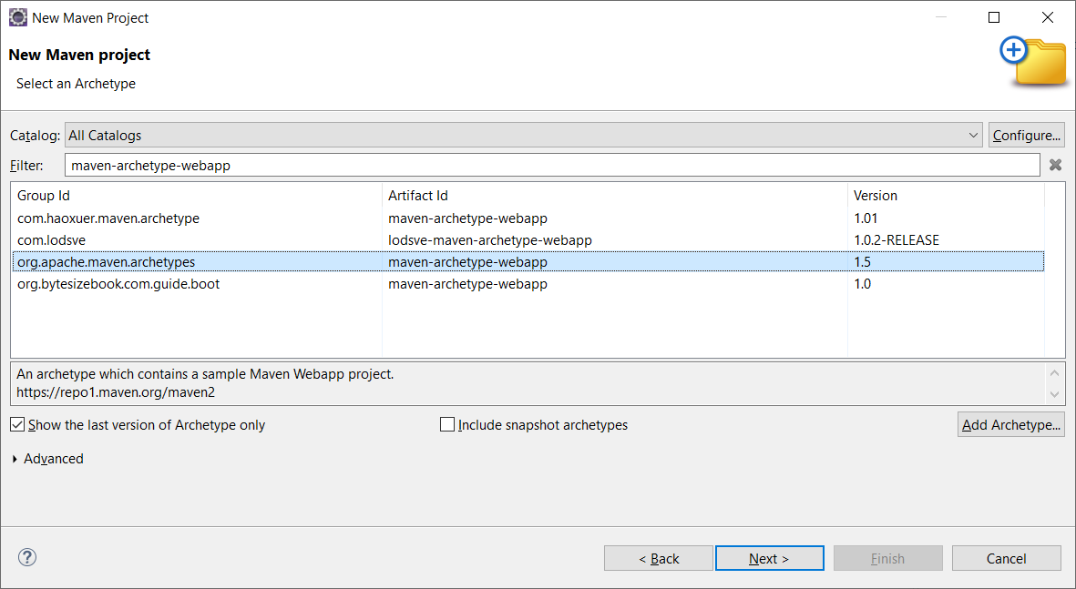

1. In a **group id** you can type anything like name and in a**artefact id:** you can type anything like your roll number

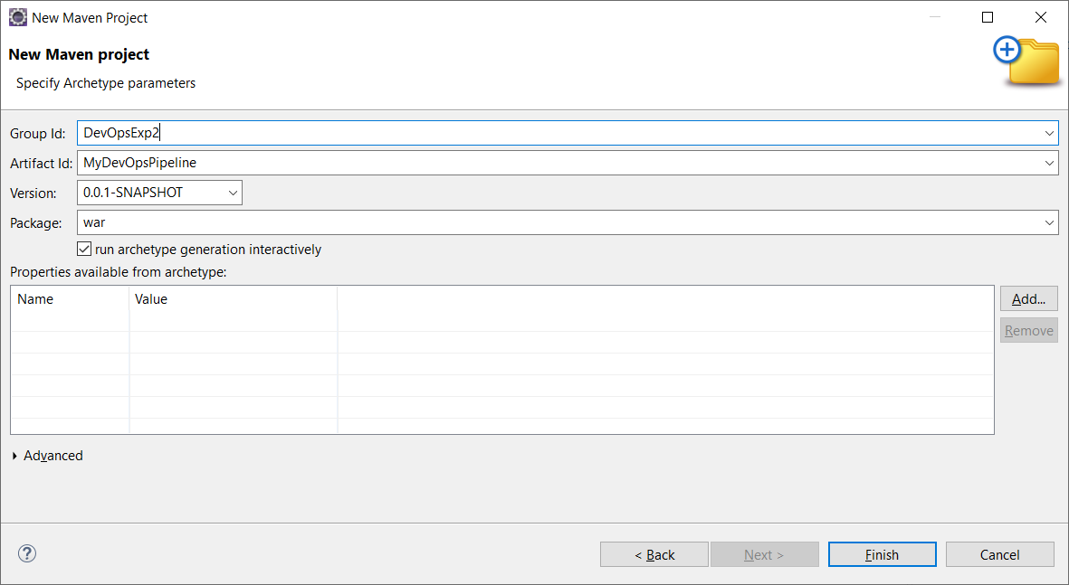

1. Click Finish

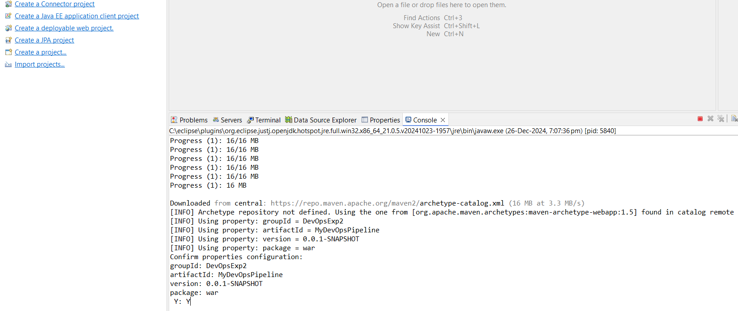

1. Type Y and Press enter, You should see a Build Success message as below:

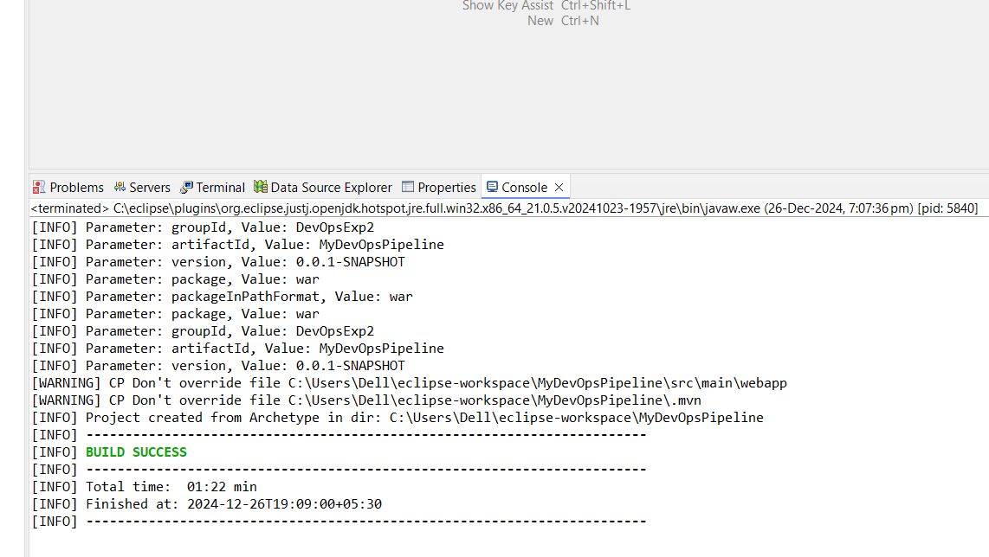

**Step-4:**now open your **pom.xml** file and add your **dependencies (Given file, Copy and Paste)**

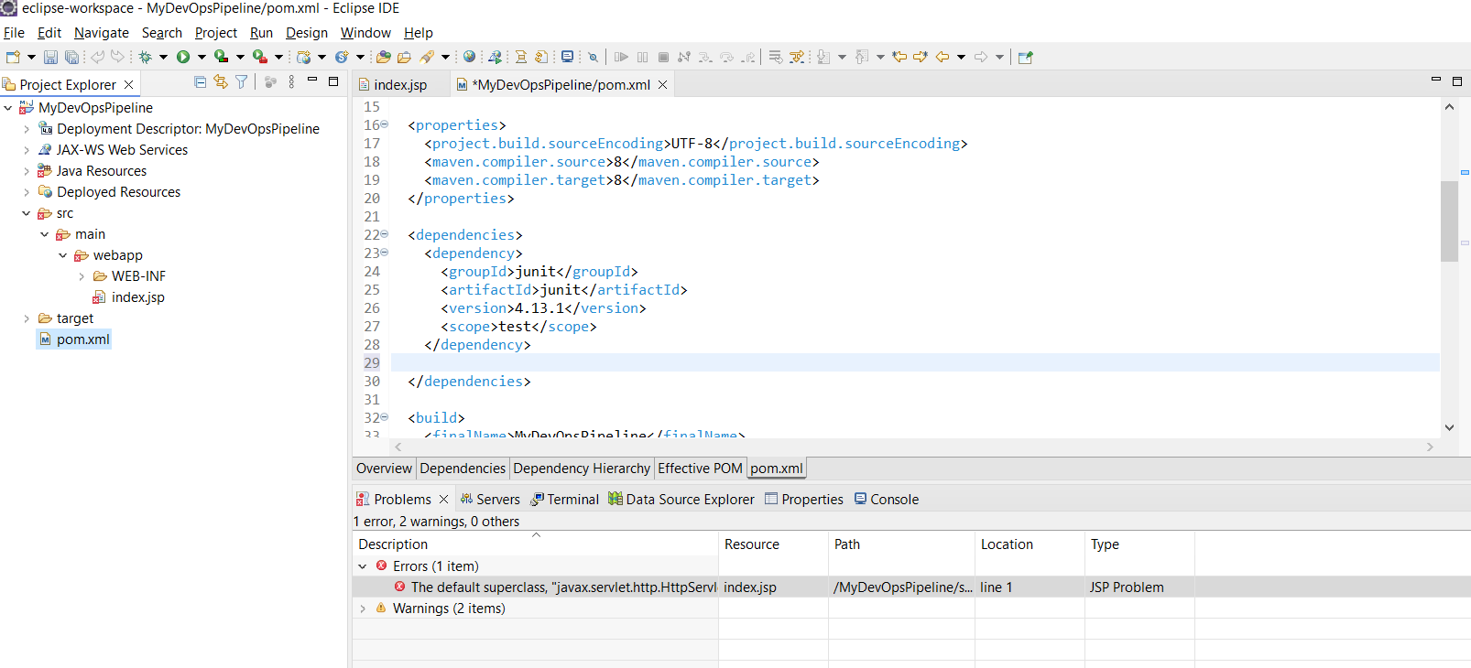

**Step-5: Update your project once (Right click on Project -> click on Maven -> click on Update Project)**

**Step-6:** Download **Apache tomcat v9** from Official website.

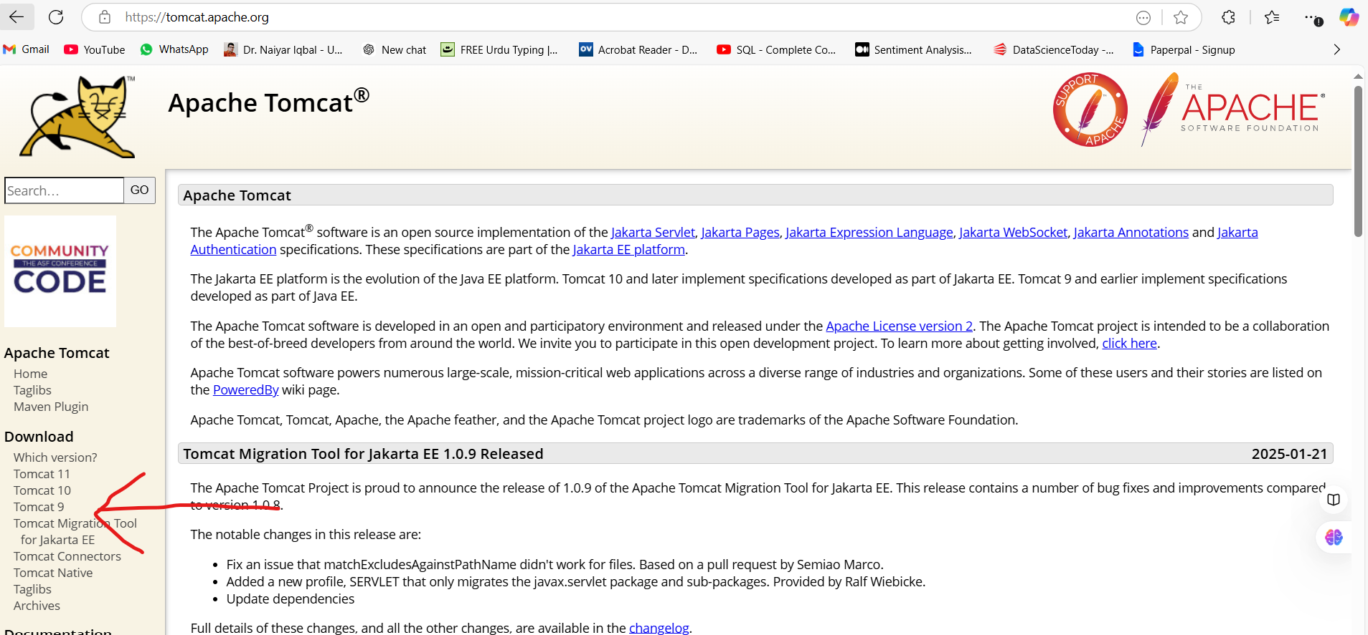

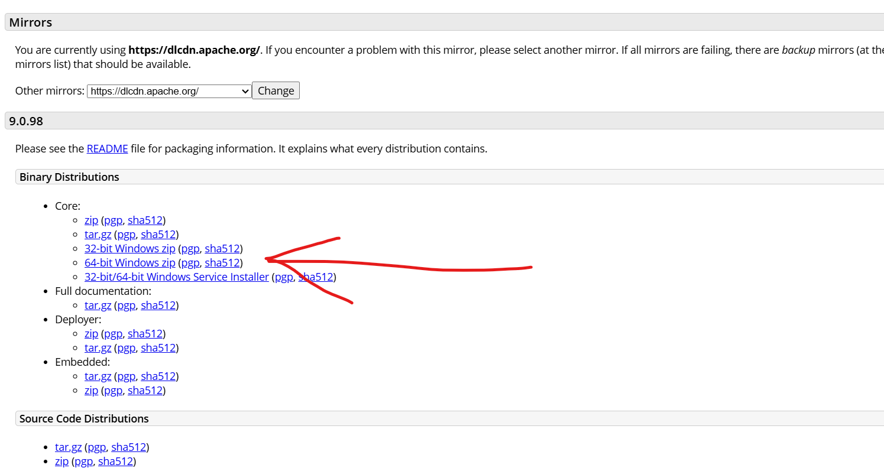

**Step-7:** After Download the Apache tomcat, Extract the .zip file and paste your apache-tomcat-9.0.98 folder in your folder

**Step-8:** Now click on your **project option in Menu -> Click on Properties -> Click on Targeted Runtime**

**Step-9:** Click on **new or follow the given image**

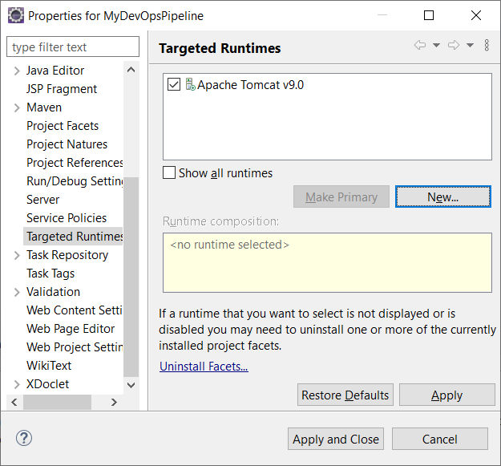

**Step-10:** Select Apache Tomcat v9.0

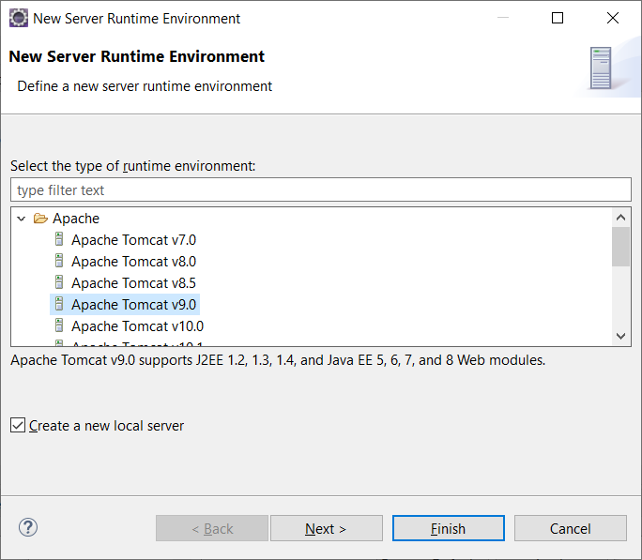

**Step-11:** Click on Browse and Select your Extracted file and then click on finish as given image

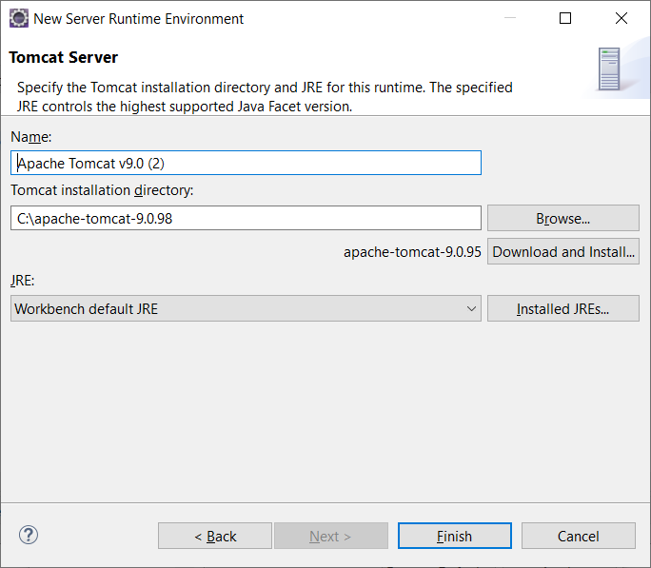,

**Step-12:** Now Click on **help Menu ->**click on **Install new Software.**

**Step-13:** Click on **Add** and it will show a **popup dialog box** like given image

In the place of Name type: **TestNG**

In the place of Location type: **https://testng.org/testng-eclipse-update-site/**

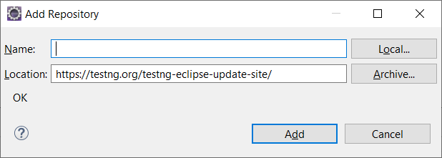

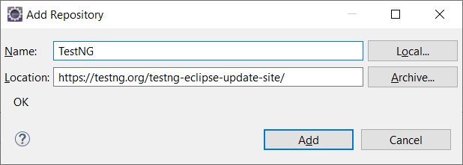

**Step-14:**Click on **Add ->**It will load a**testNG Dependencies ->**Select**TestNg**like given Imageand then click **Next.**

**It will take 10 minute to update TestNG in our Project**

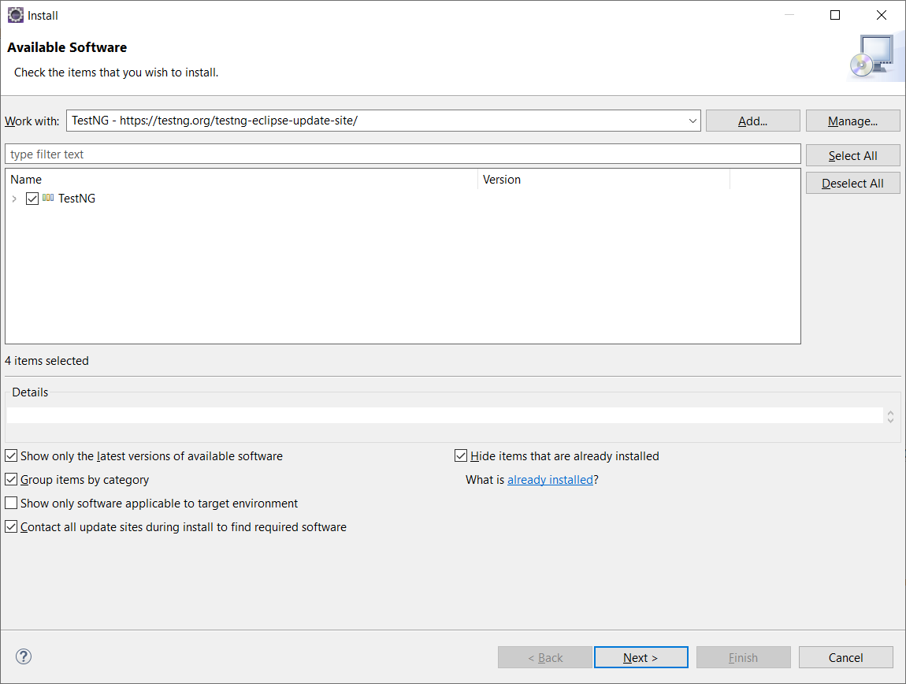

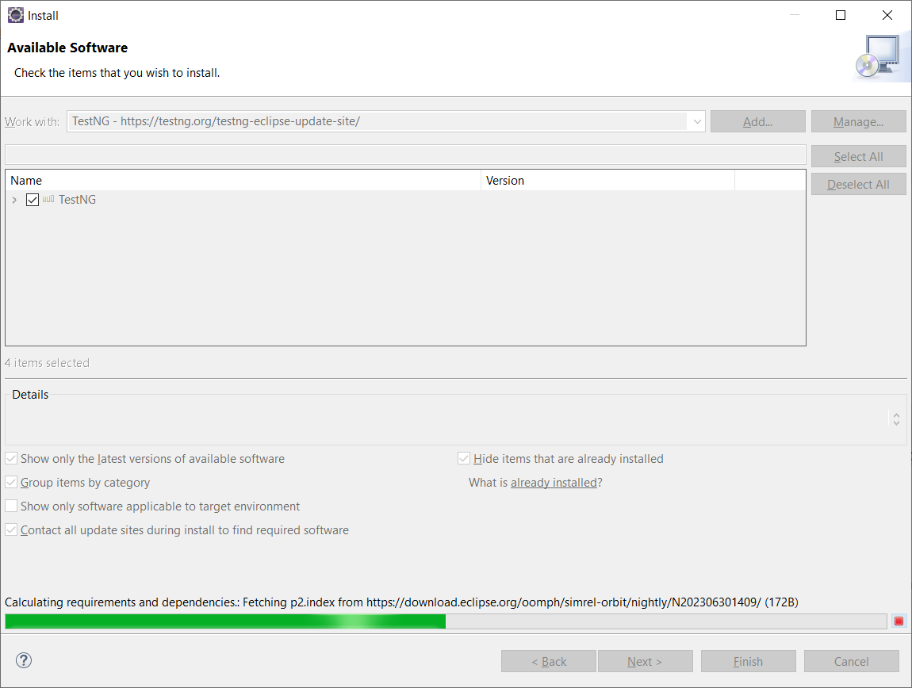

**Step-15: After downloading the all dependencies it will show some file select all and click on next.**

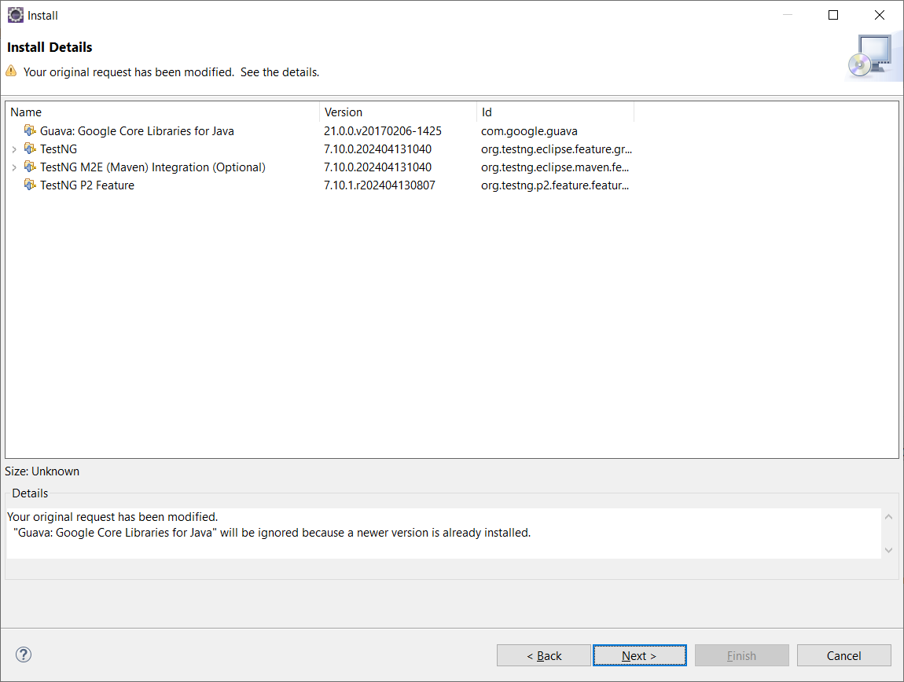

**Step-16: Accept Terms and condition** and click on **finish**

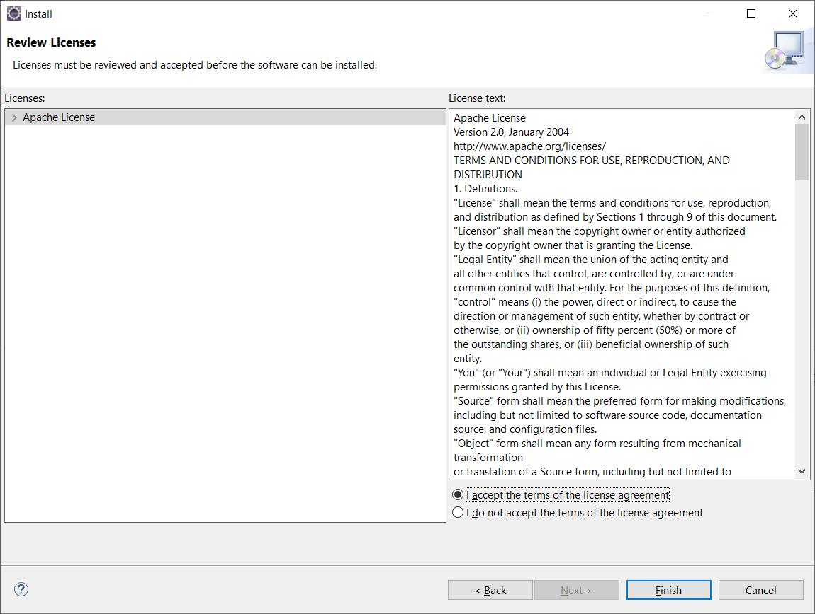

**Step-17:**After finish it will show **restart option (Restart the Project**) otherwise just **update** once of your project.

**Step-18:** Now Login your**GitHub Account.**

**Step-19:** Create a New **Repository** and Copy your **Repository** and paste in notepad

**Step-20:** After that **Click** on your **Profile** in Right corner **-> Click on Setting.**

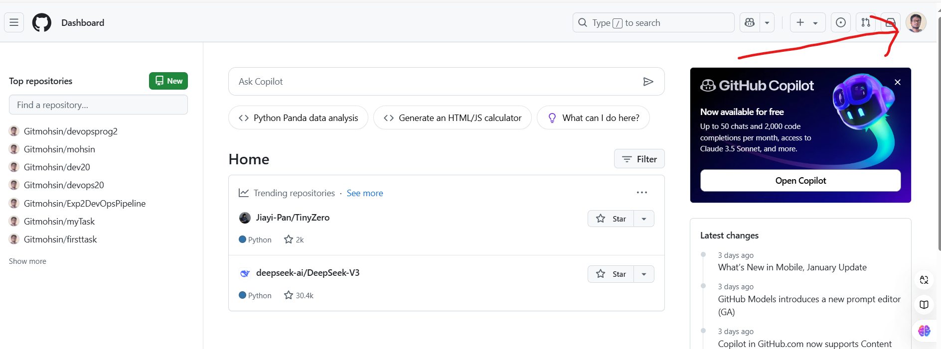

**Step-21:** It will show a new page, scroll down and select the **developer setting ->**click on **personal access token ->**select **Token(Classic) ->**click on **Generate new token** and select **Generate new token(Classic) ->**write your **token name** and select **repo option** and scroll down and click on **Generate Token.** (Follow the given Image)



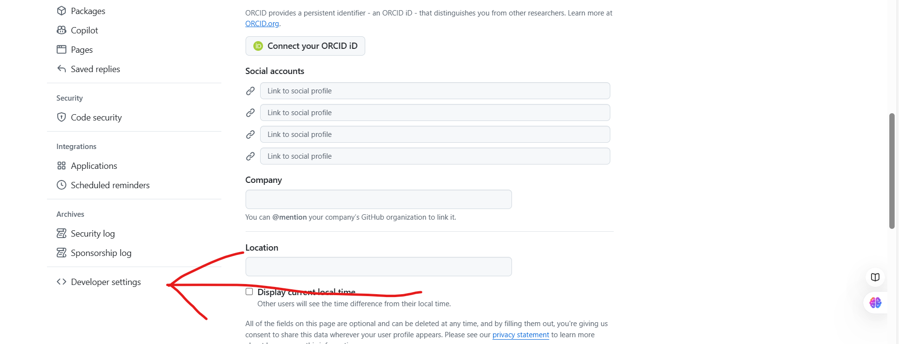

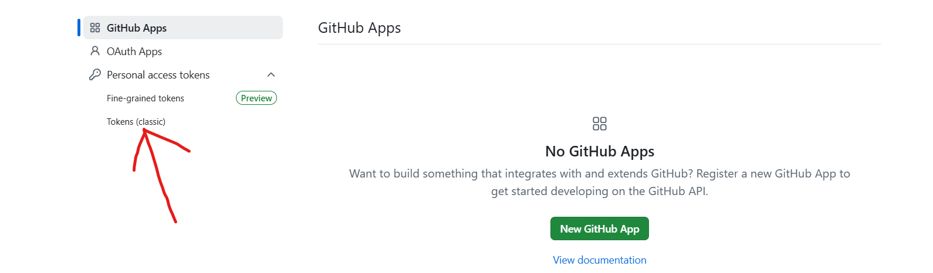

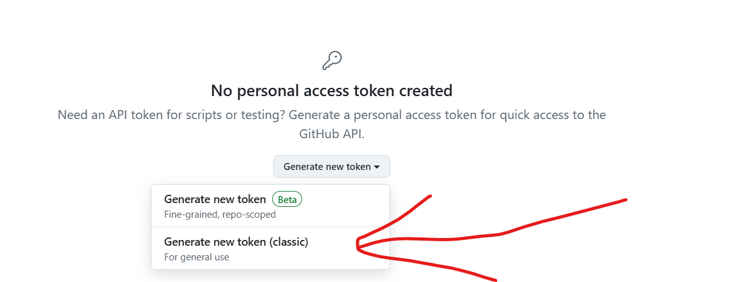

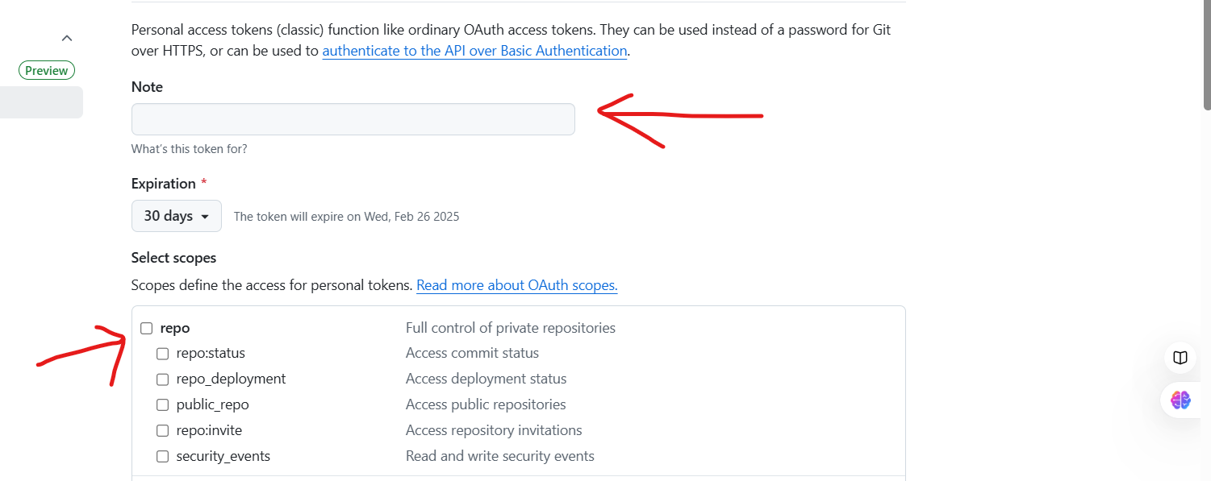

**Step-22:** After Generating the **token** copy the token id and paste in a**NotePad.**

**Step-23:** Now come on your project and right click on your**project ->**Click on **Team ->**Click on **Share Project.**

**Step- 24:** It will open a Dialog Box for**GitHub**Setup, select the **option Use or create repository in parent folder of project - >**Select your Project and Click on **Create Repository** and click on **Finish.**

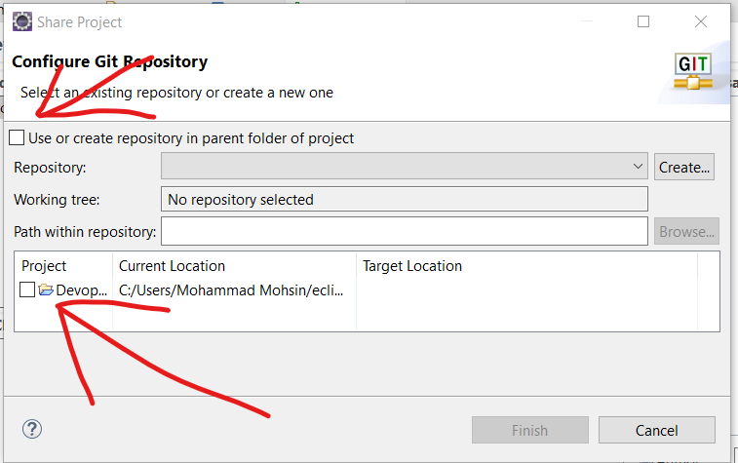

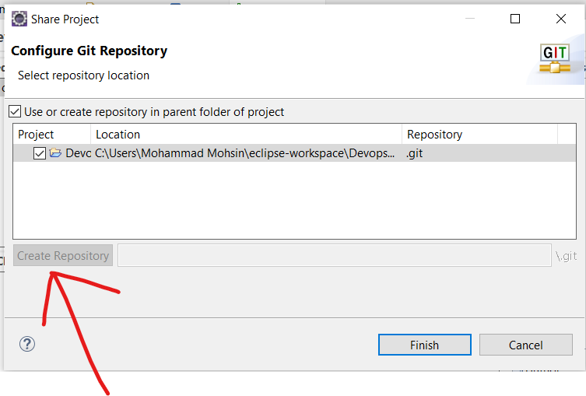

**Step-25**: After that again **Right click on yourProject** and select the **Team** -> click on **Commit**-> and **stage your all file** -> and Write a comment (i.e. First Commit) and click on **Commit and push**-> after that it show an **error dialog ->**click **OK ->**now again click on **Push Head** Button

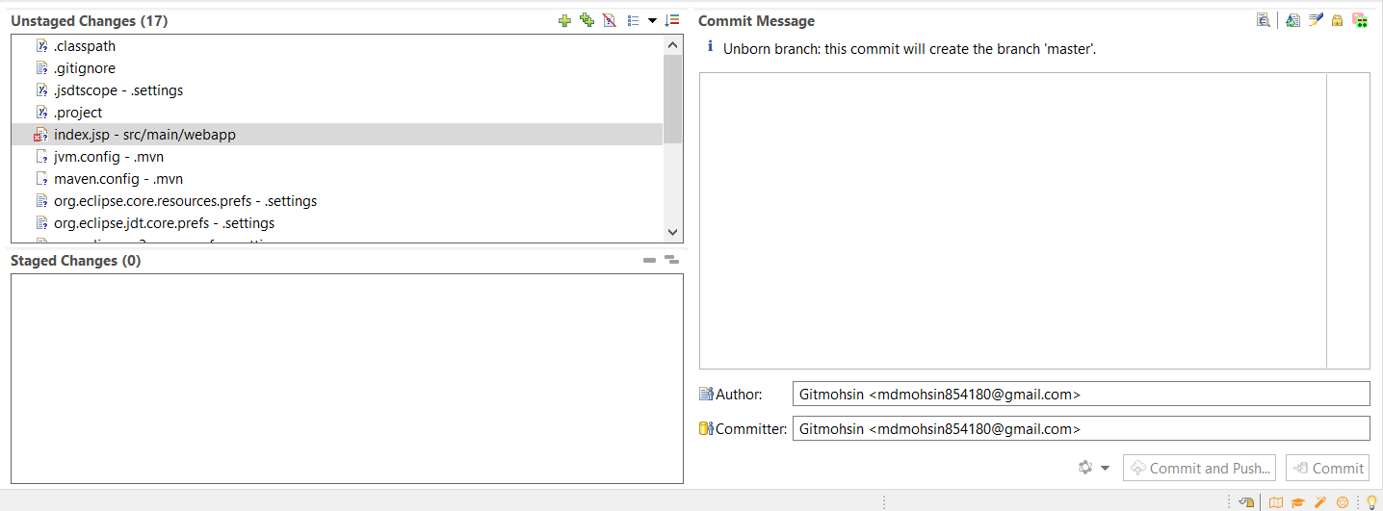

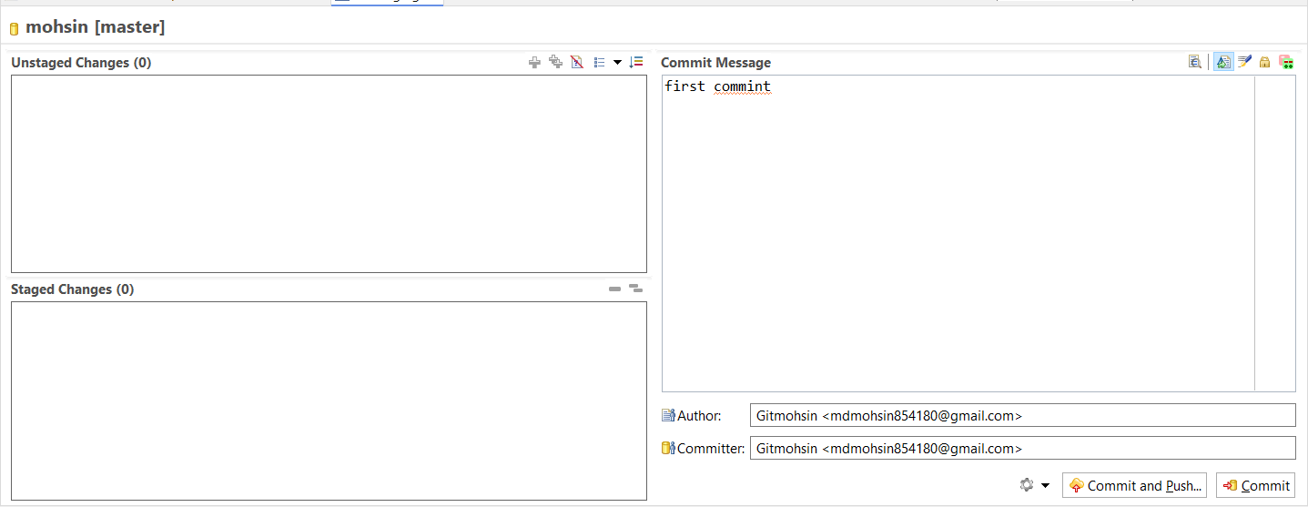

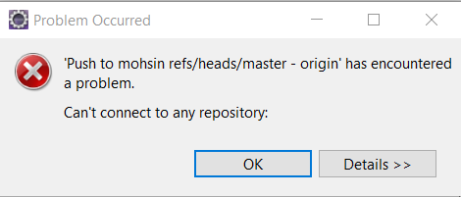

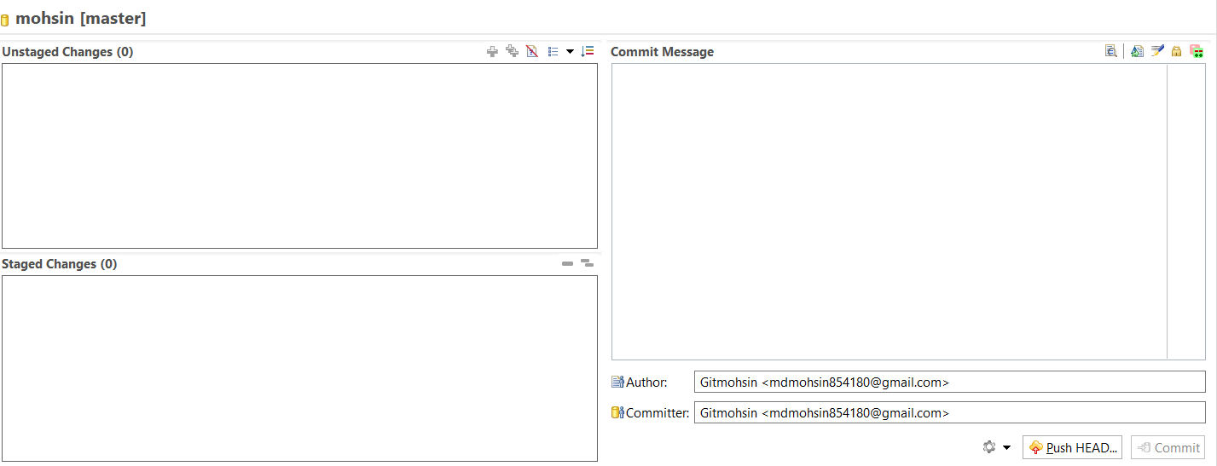

**Step-26**: After that again click on **Push Head,** it will show a **dialog** like given image, paste your **Repository URL** in **URL** section and type your**GitHub User Id and Password** in User, password section -> Click on **preview ->**Again clickon **Preview.**

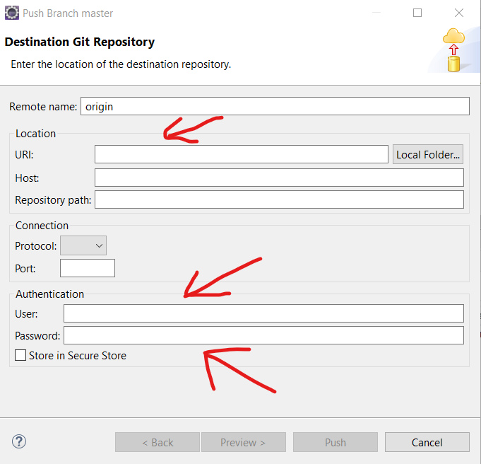

**Step-27:**After that it will again show a **user Id** and **Password** option **->**just type your**Github id** in user section and paste your **Token id** in Password section -> click on **push ->**one more time it will ask **user id and** password just repeat your last step with u**ser id and token id ->**now check your **repository on github,** your file is **uploaded or not**

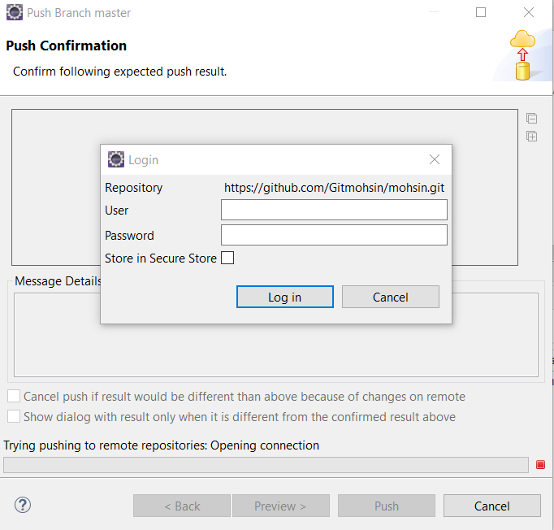

**Step-28:**Now you have to create a simple java code in SRC File, so first open your project from **file manager->**open **SRC - >**Create two folder in **SRC -> first name: java, second name: test ->**now open **test folder** and create two more folder in **test folder ->**now come on your **eclipse IDE** and **Update** your project once -> After that create a java class file with a Statement **“Hello World”**in your **SRC/TEST/java** folder.

**Step-29:**Now Push again your **all unstage files** in your**GitHubRepository**with **different version** or **Comment** (Its just for Version Control).

**Step-30: Now Check again your Repository your recent file is uploaded or not with different version.**

**Output:-**





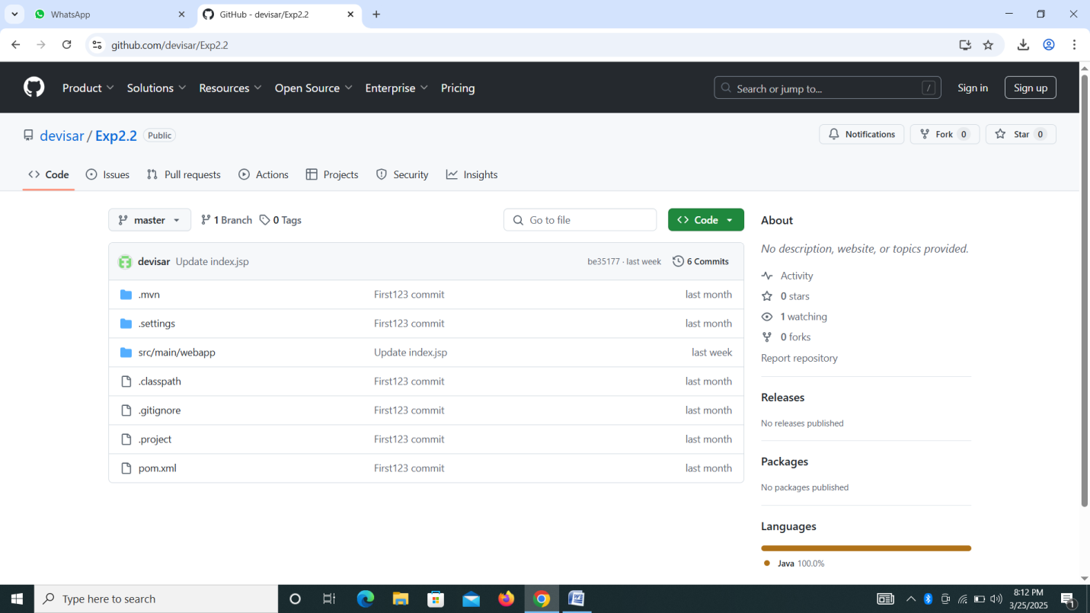

**Experiment-3**

**Aim: Jenkins Setup on AWS.**

**Note:** Write the given steps in your lab manual. The provided image is just for your better understanding.

**Require Software & Tools:** AWS, MobaXterm Software.

**Procedure:**

**Step-1:** Search AWS Free Tier Account in any Browser and Create an Account. (if you have already an account then leave the steps) 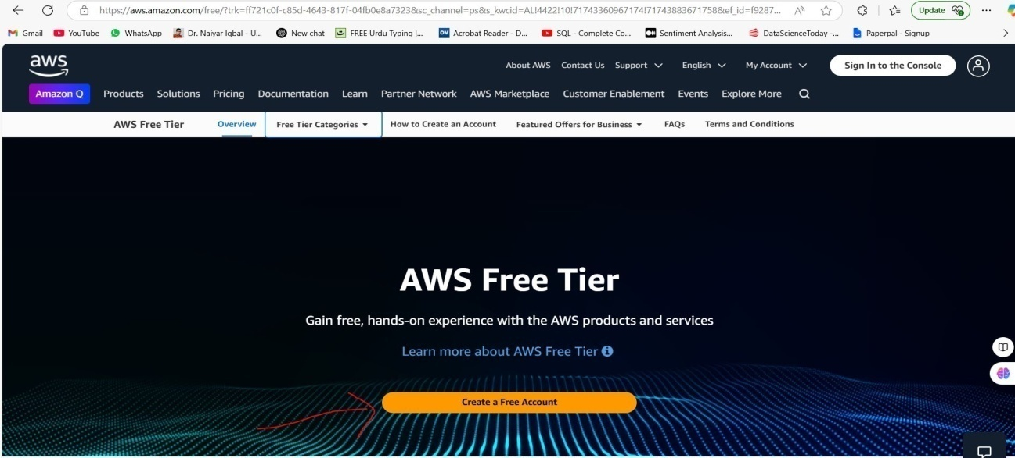

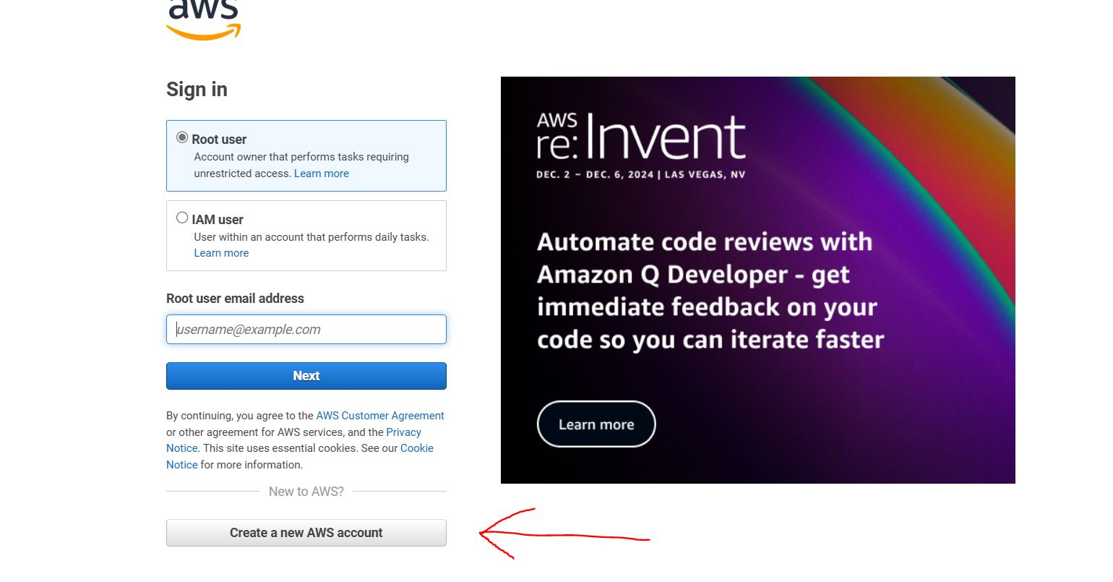

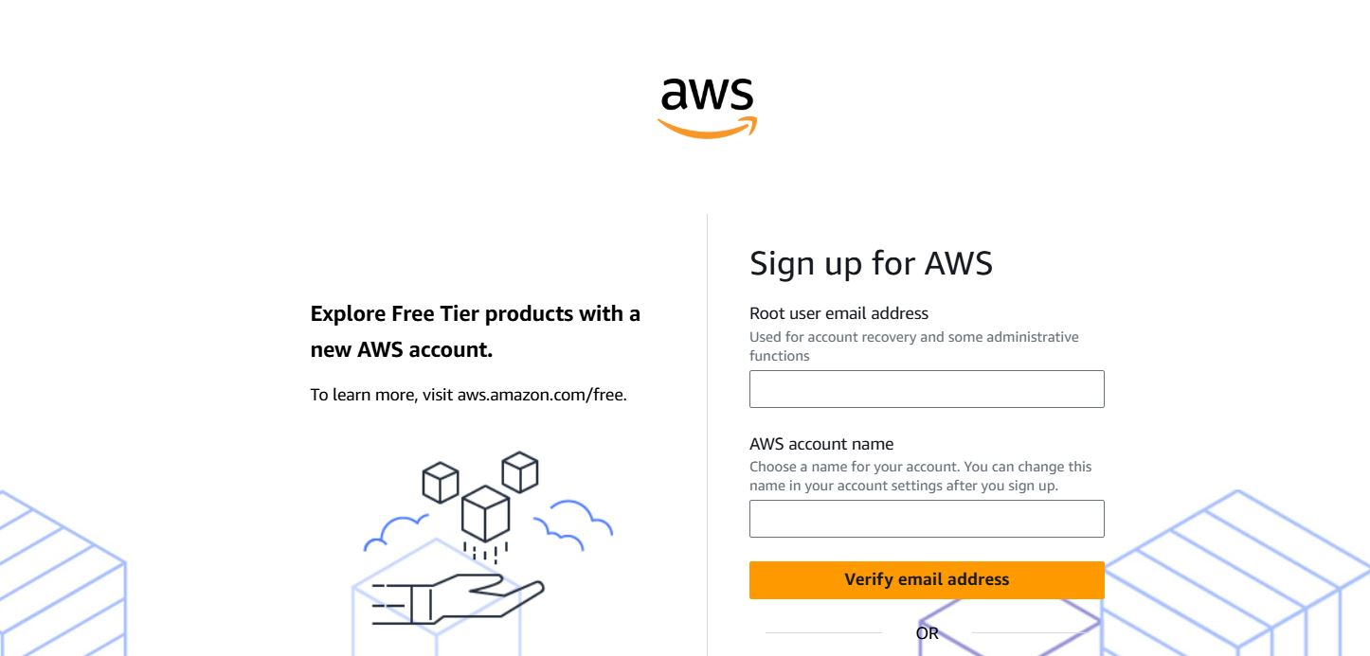

**Step-2:** After Creating the Account, Just Login as a ROOT User

**Step-3:** After Login It will show your account -> Click on EC2 option -> Click on Launch Instance

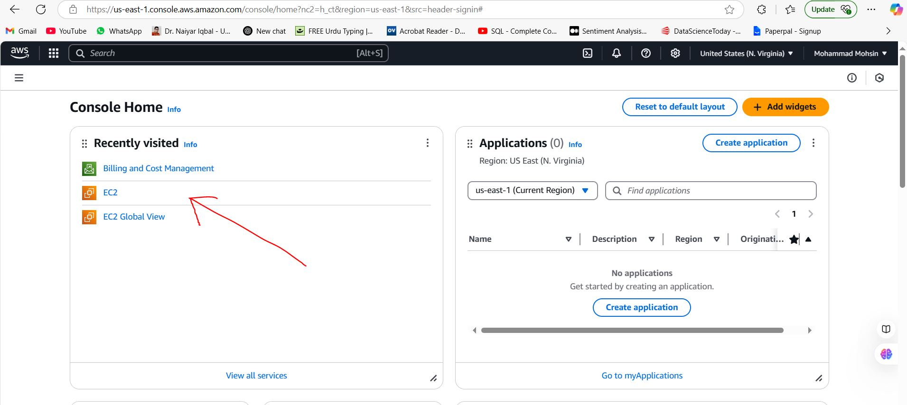

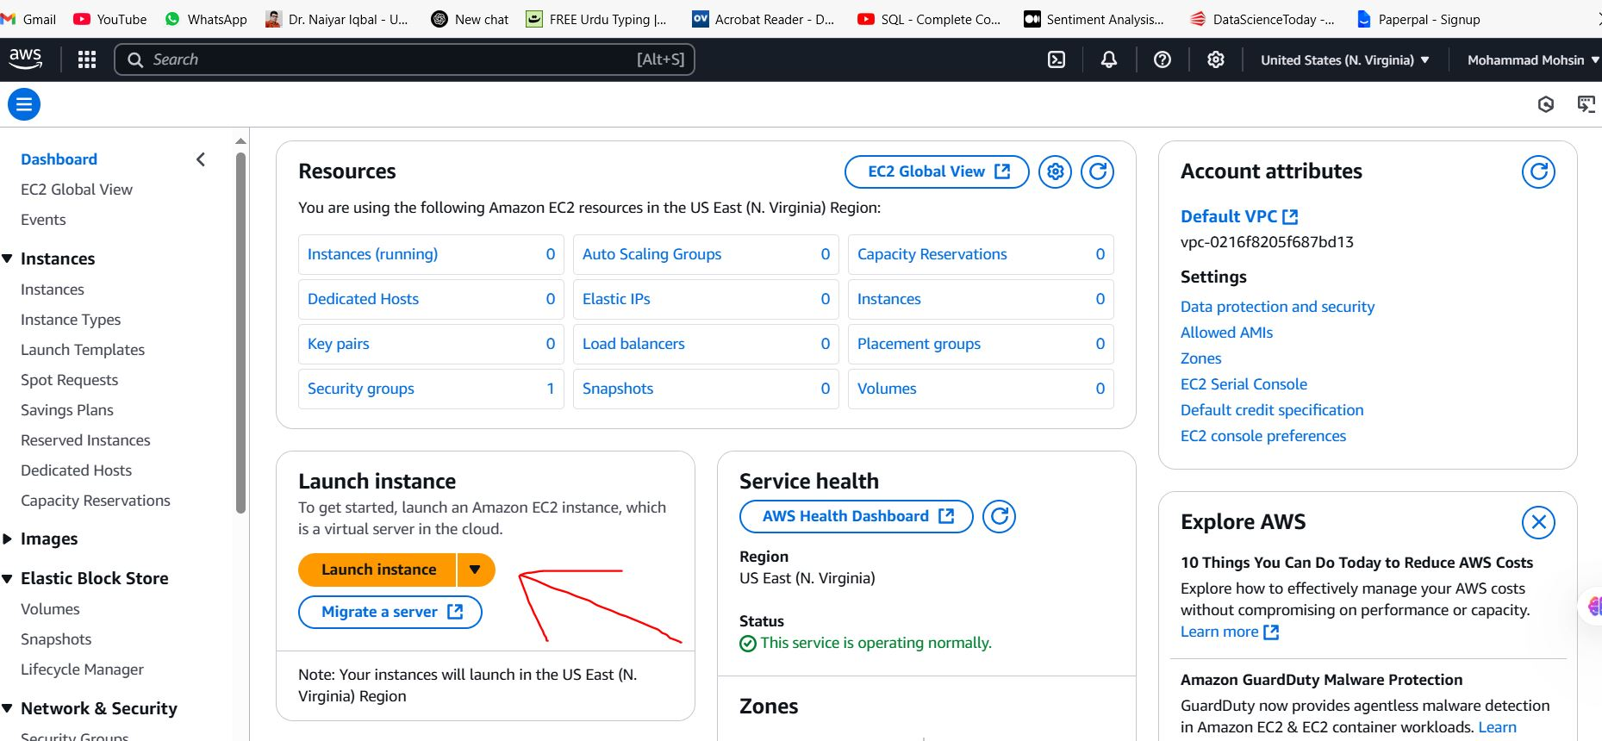

**Step-4:** After Clicking on Launch Instance It will ask Instance Name and Other things -> Write Instance Name as Jenkins -> Select Application and IOS Image as Ubuntu ->Scroll Down and Come on Instance Type Option and Select t2.Medium -> Now Come in Key Pair(Login) Section and Click on Create New Key Pair -> Write your Key Pair Name as Exp3 -> Select RSA -> Select .pem-> Click on Create Key Pair. 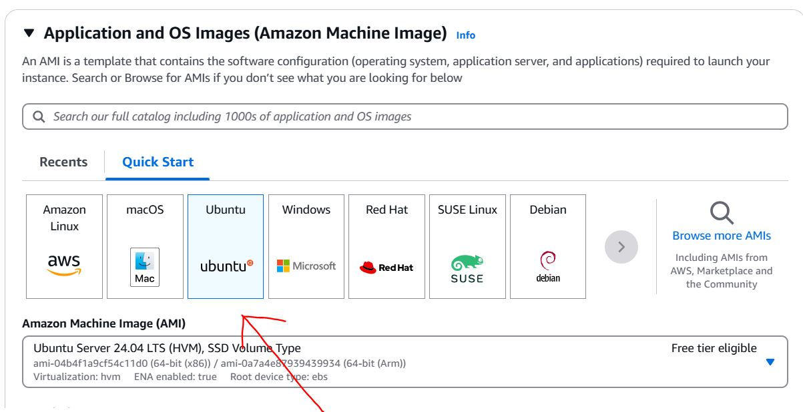

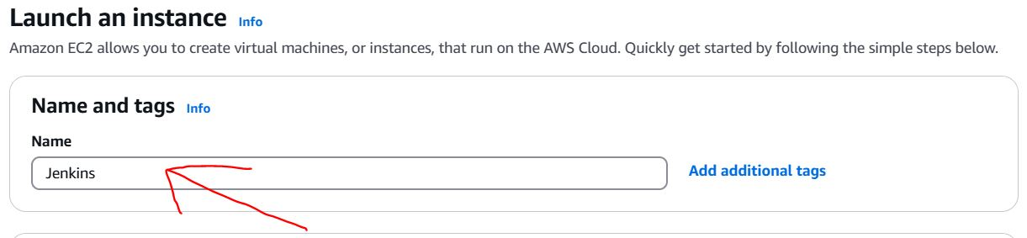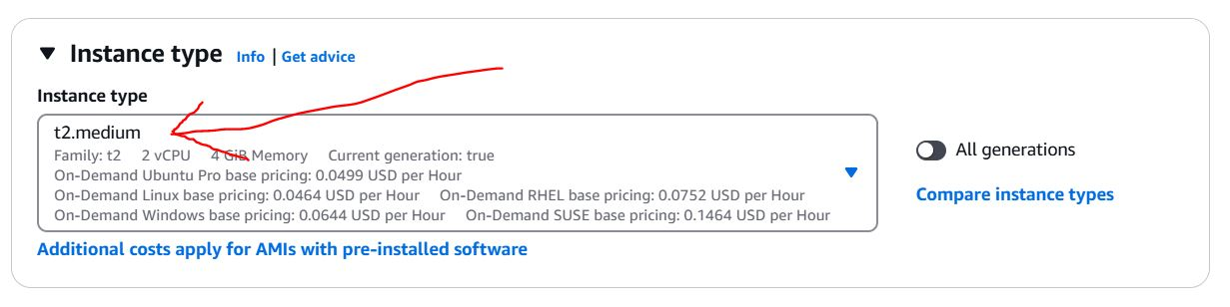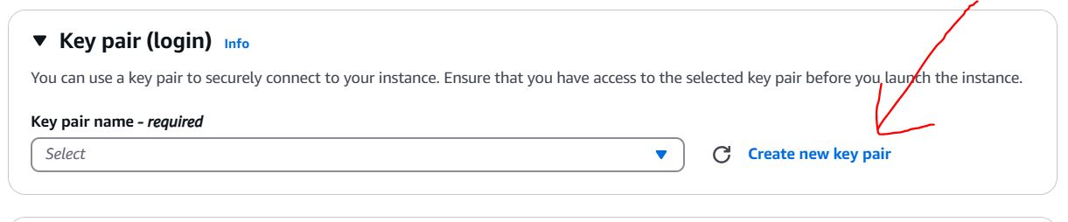

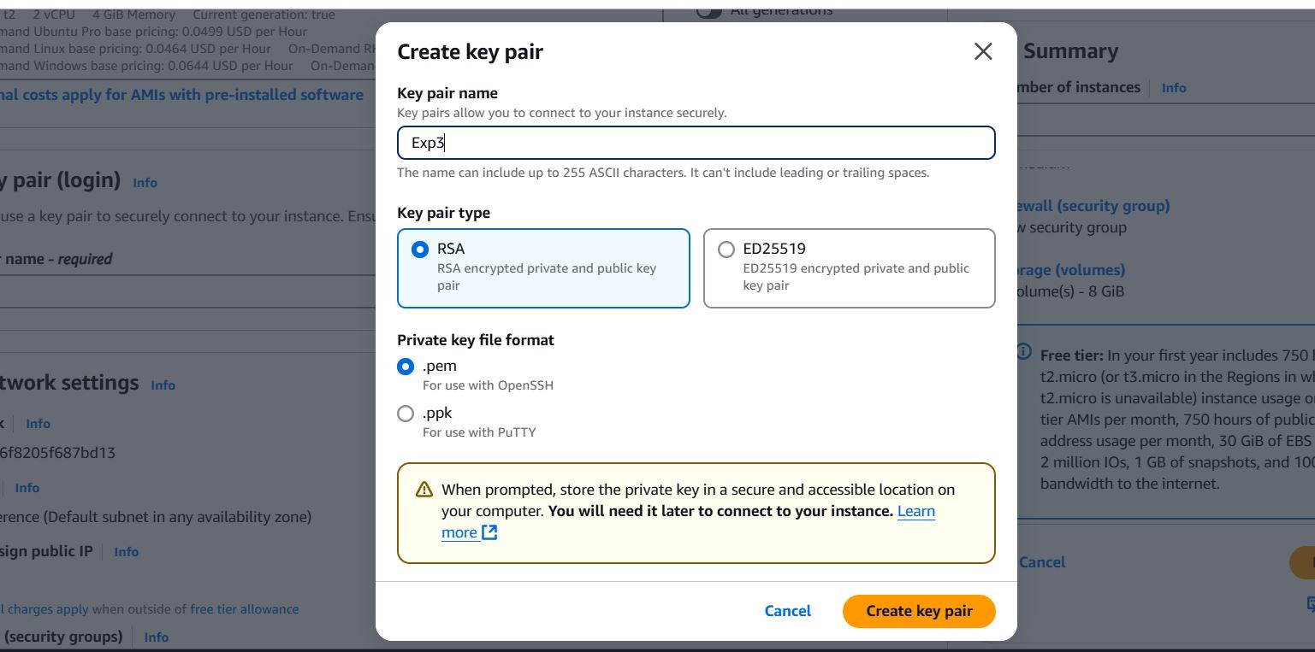

**Step-5**: After Click on Create Key Pair it will download aExp3.pem file ->After that in Right Side we have a Option Number of Instances Select 1 -> Click on Launch Instances (It will take some time and will create an instance).

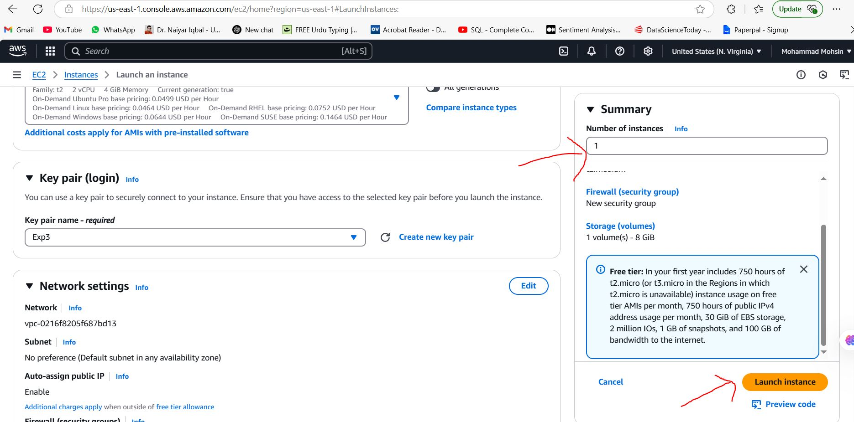

**Step-6**: After that Refresh the page -> Select the Created Instance -> Click on Security.

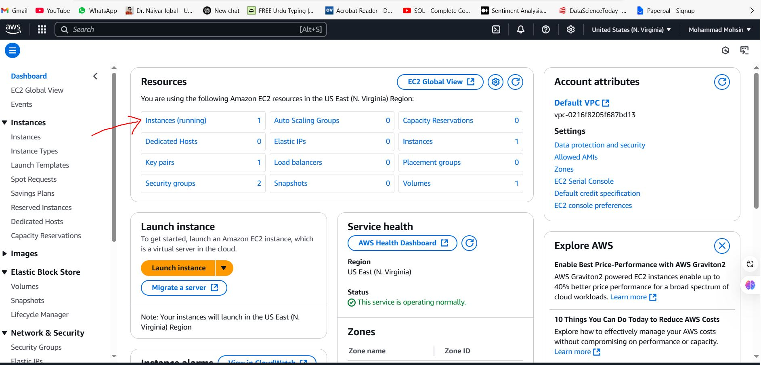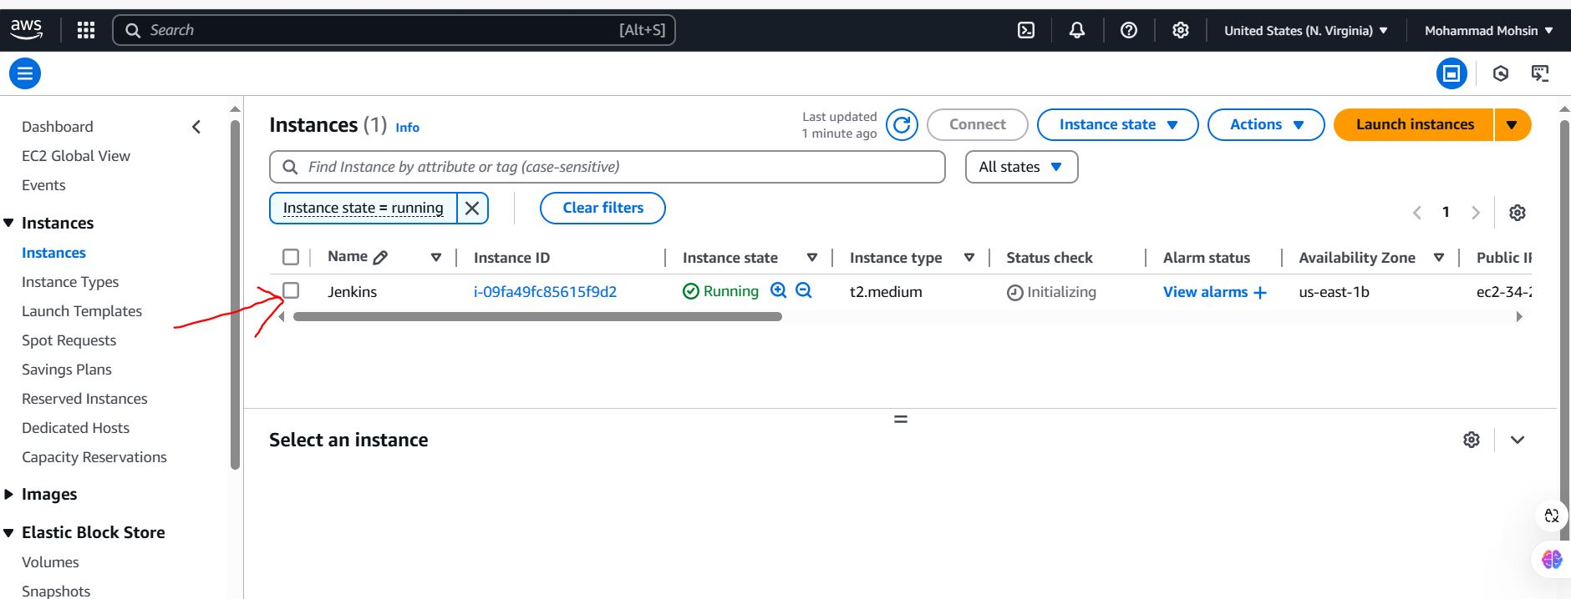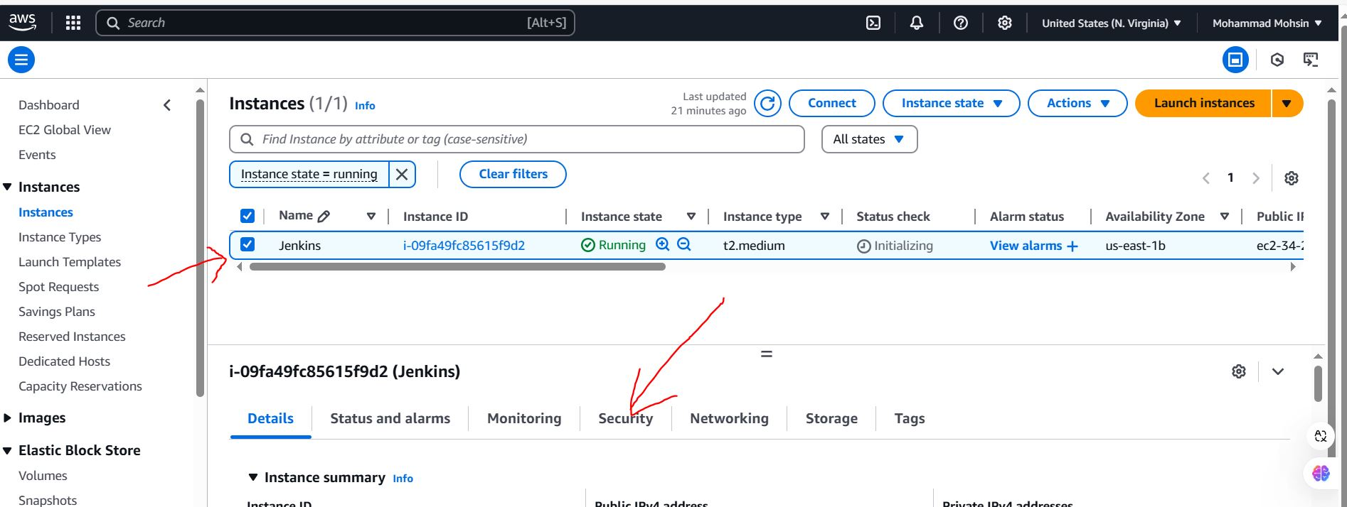

**Step-7**: After Clicking on Security -> It Will Show a Blue Link name as Security Group -> Click on that blue Link it will Open a Page -> Click On Edit Inbounds rule -> Click on Add Rule -> Add one Rule HTTP and Source type Anywhere IPV4 ->Addone More Rule Custom TCP, port range 8080 and Source Anywhere IPV4 -> Click on Save Rule

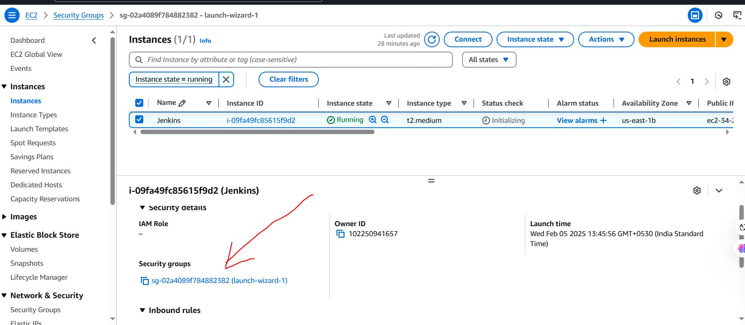

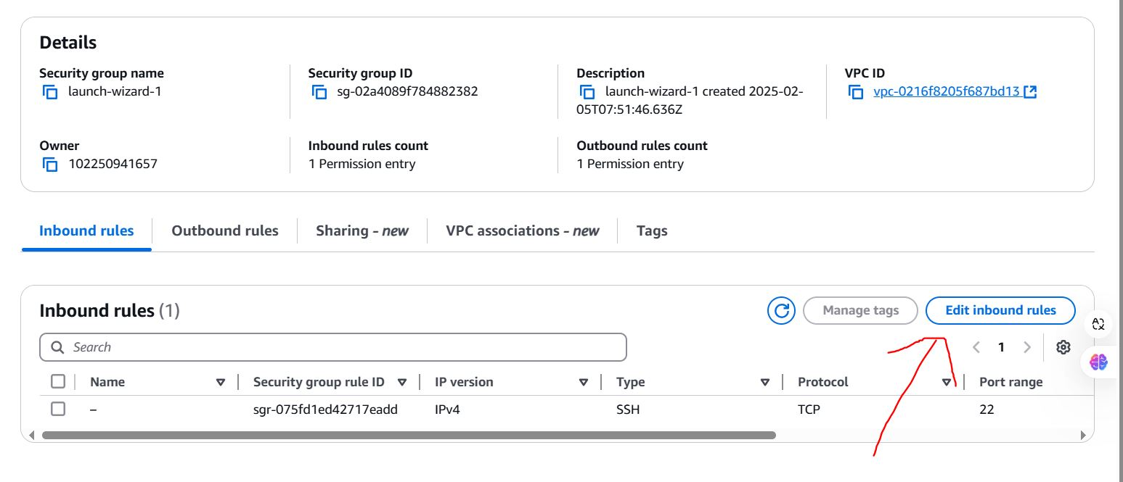

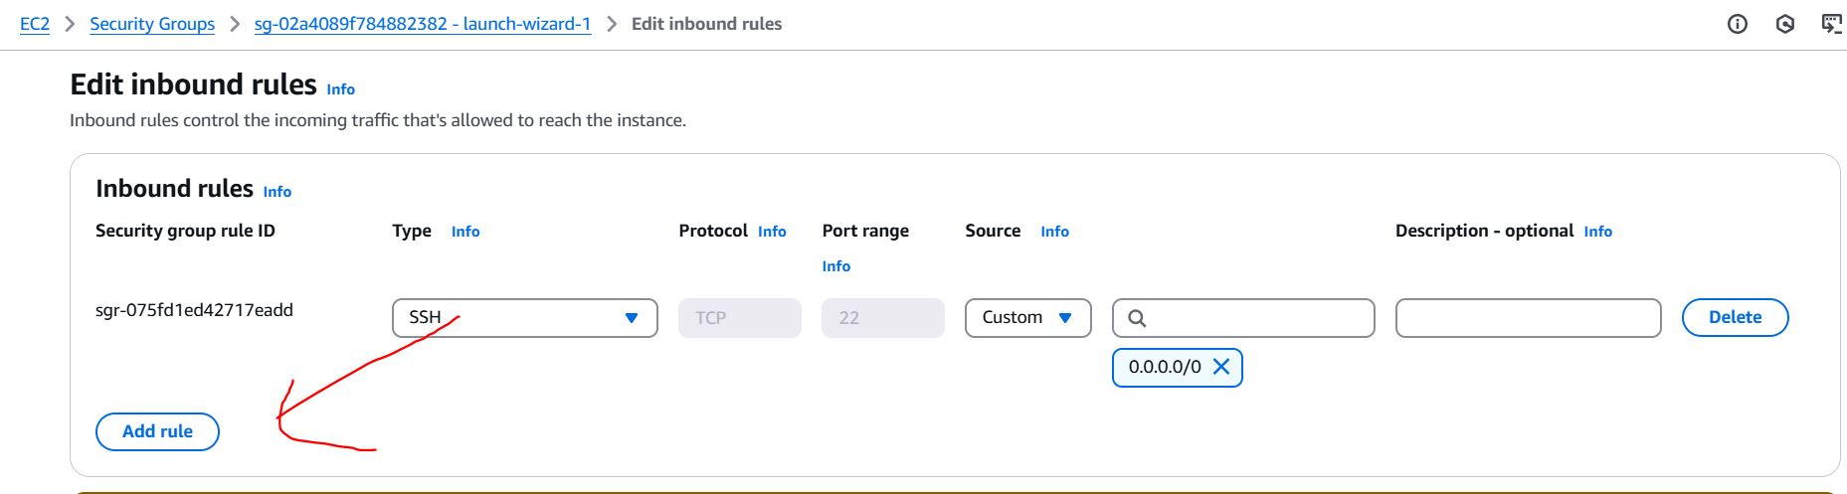

**Step-7**: After that click on Dashboard -> click on instance Running -> select Jenkins -> click on connect.

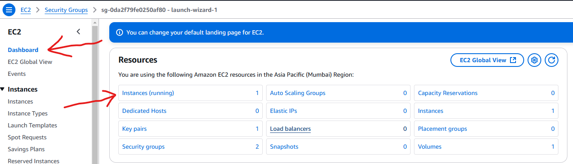

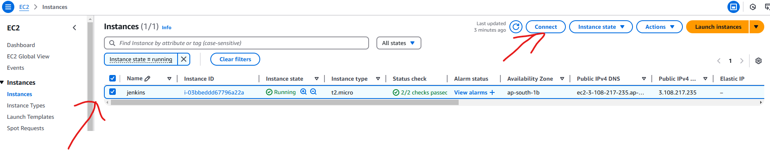

**Step-8**: After that click on connect it will open a Linux terminal -> just type clearcommand and follow the **setp-9** documents.

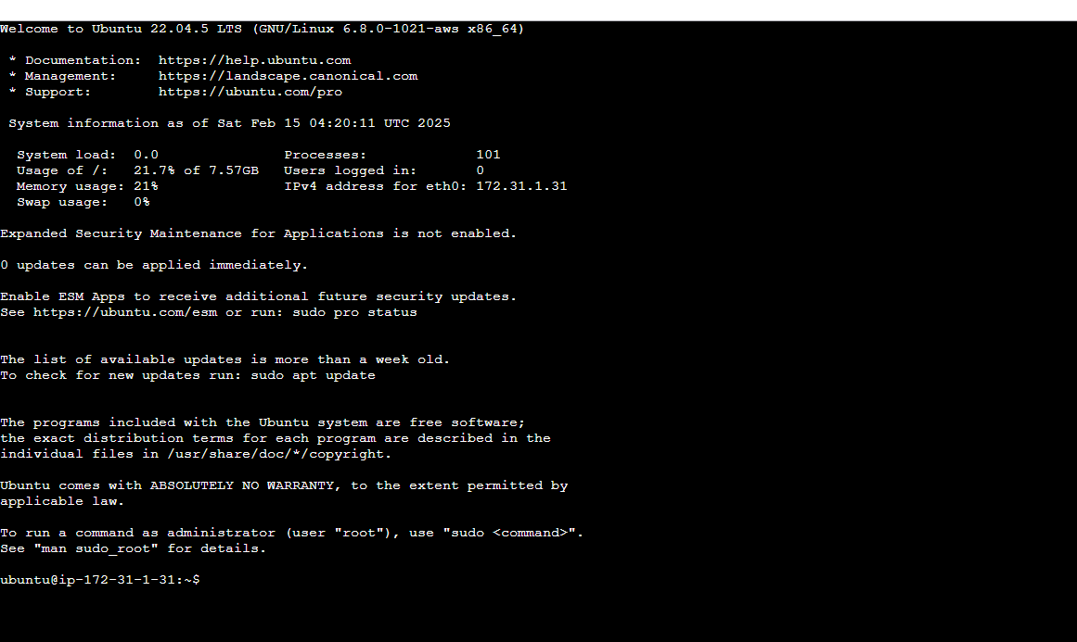

**Step-9**: Now You have to Setup Jenkins -> Search Jenkins Document in Any Browser ->Click on first Jenkins link -> Click on Installing Jenkins -> click on Linux -> Click on Debian/Ubuntu -> After that it will show the Linux Command

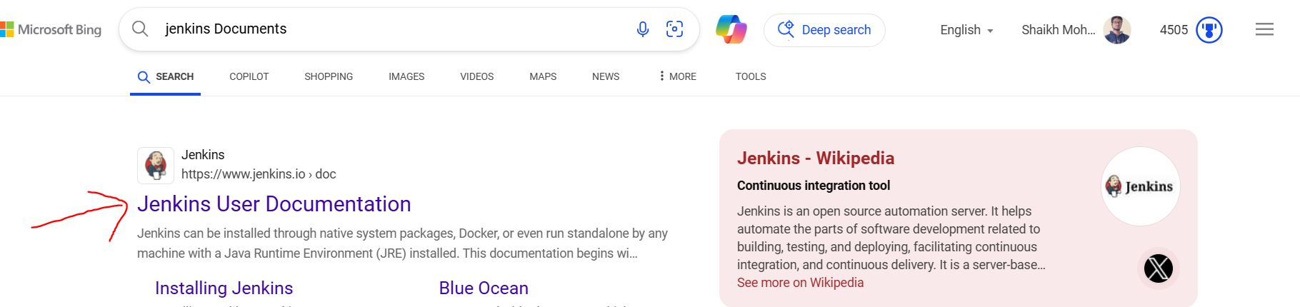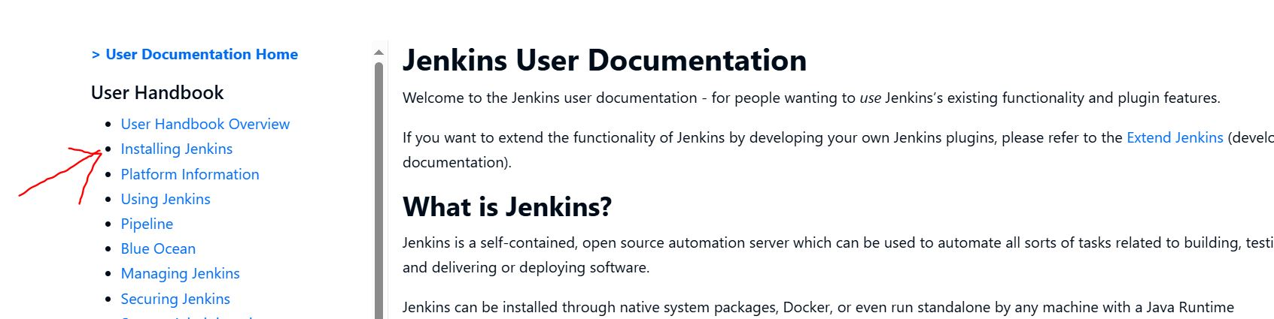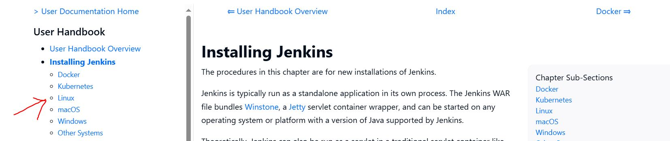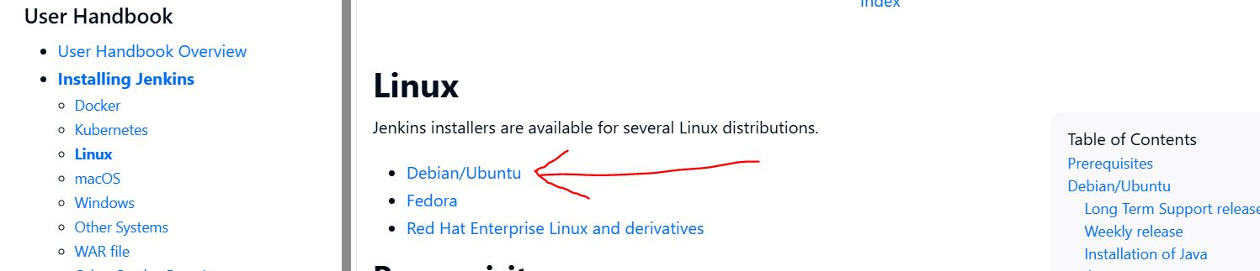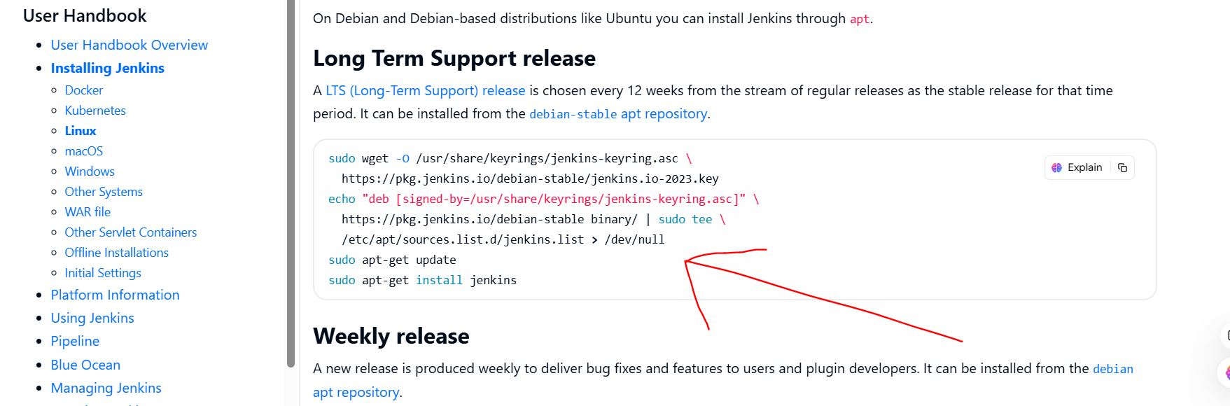

**Step-10**: Now Come on your MobaXtrem Application -> Type Clear and Hit Enter key ->it will clear your Command Screen -> Now copy the theLong Term Support release code till /dev/null -> Paste in your Linux Terminal and hit the Enter Key -> it will Download the Jenkins Support File

sudowget -O /usr/share/keyrings/jenkins-keyring.asc \

https://pkg.jenkins.io/debian-stable/jenkins.io-2023.key

echo "deb [signed-by=/usr/share/keyrings/jenkins-keyring.asc]" \

https://pkg.jenkins.io/debian-stable binary/ | sudo tee \

/etc/apt/sources.list.d/jenkins.list**>** /dev/null

Code:

**Step-11**: Clear your Screen -> Now Update your Project Using Given Code.

sudoapt-get update

Code:

**Step-12**: clear your screen ->Now Check Java version Using Command: java --version

**Step-13**: if It Show Java Not Found then it show the option install Java -> so install java using given Command -> it will ask Y/N just type Y and hit Enter -> It will take some time to download java.

sudoaptinstall fontconfig openjdk-17-jre

Code:

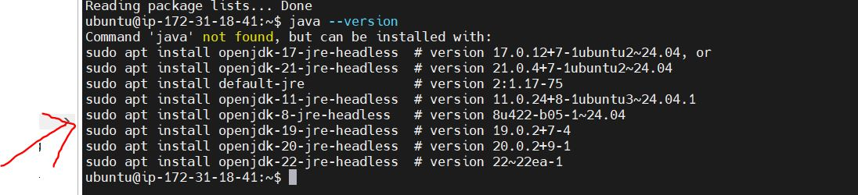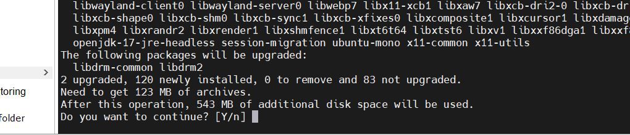

**Step-14**: After Downloading the Java, Clear your Screen using clear command -> Once again Update your Project Using Update Command (follow Step-14 command) -> now Install Jenkins Using Jenkins Command, i.e given code (It will ask again Y/N just type Y and Hit Enter) -> After Installing the Jenkins Once again Update your Project using Update Command Just Check Java and Jenkins Version Using (java –version and Jenkins –version Command)

Code:

Sudo apt-get install jenkins

**Step-15**: Now Enable the Jenkins Server Using Given Command

Command:

Sudo systemctl enable jenkins

**Step-16**: After Enable the Jenkins Server Start Jenkins Server Using Given Command

Sudo systemctl start jenkins

Command:

**Step-17**: After Starting the Jenkins Server Check Jenkins Server Status using Given Command. It will show the Status Active running ans show the status of memory, CPU etc.

Sudo systemctl status jenkins

Command:

**Step-18**: Now Open your Any Browser and Search the Jenkins Server using Instance IP and Custom Port Number (Ip= <your instance ip> port is 8080)follow the given snap

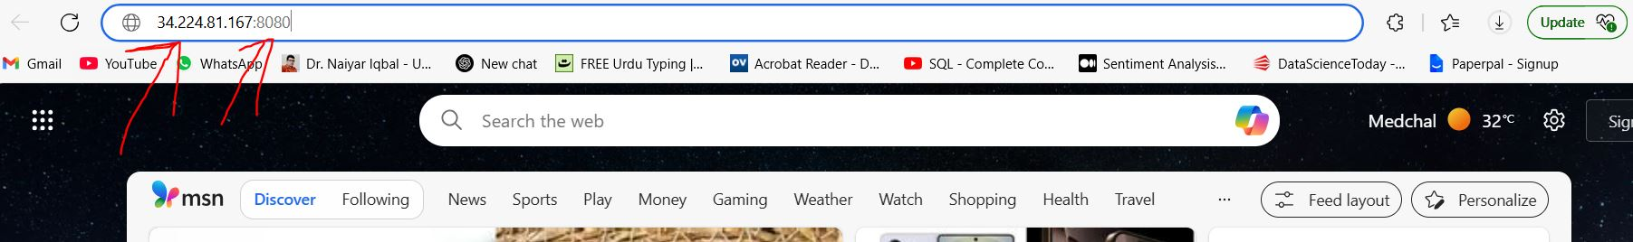

**Step-19**: It will start the Jenkins Server, show some path with red colorand Ask the Administrator Password like Given Image.

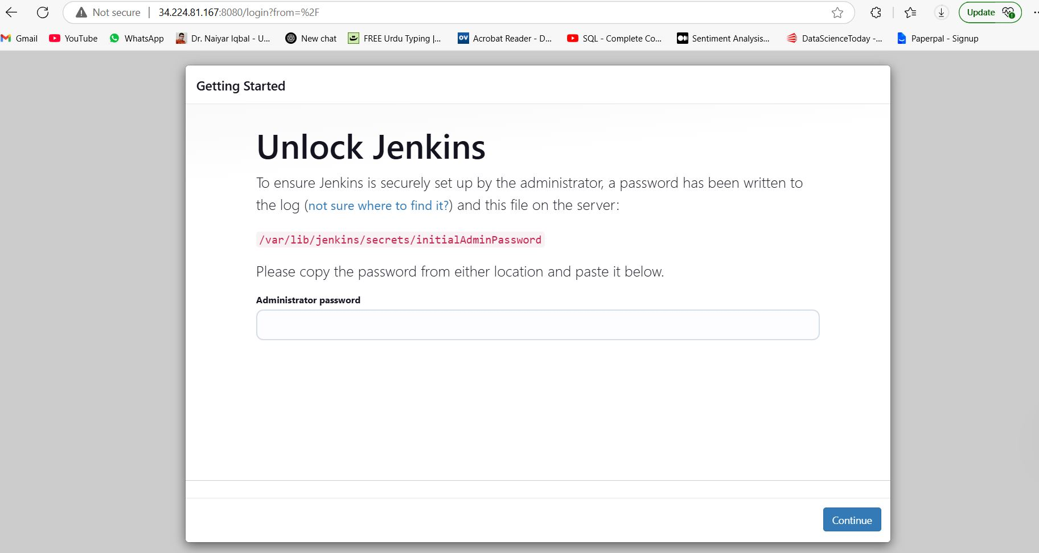

**Step-20**: Copy the RED color path and Paste in your Linux Terminal followed by sudo cat command and hit the Enter it will show 64-bit Alpha-Nemuric code -> Copy that code and paste in the place of password in your browser -> click on continue option.

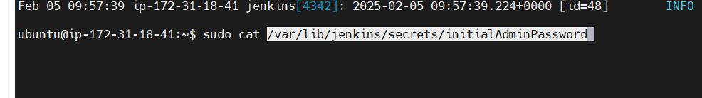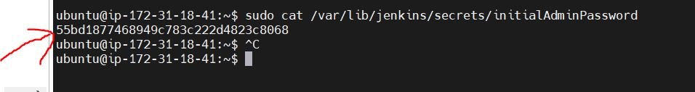

**Step-21**: After clicking on continue option it will show two option for installing the pluging-> Just click on installed suggested plugin -> it will take some time for install all plugins -> After installing all plugins, it will ask Creating an account usinguser ID and password so create an account using user id and password (fill all related field). -> Click on Save and Continue

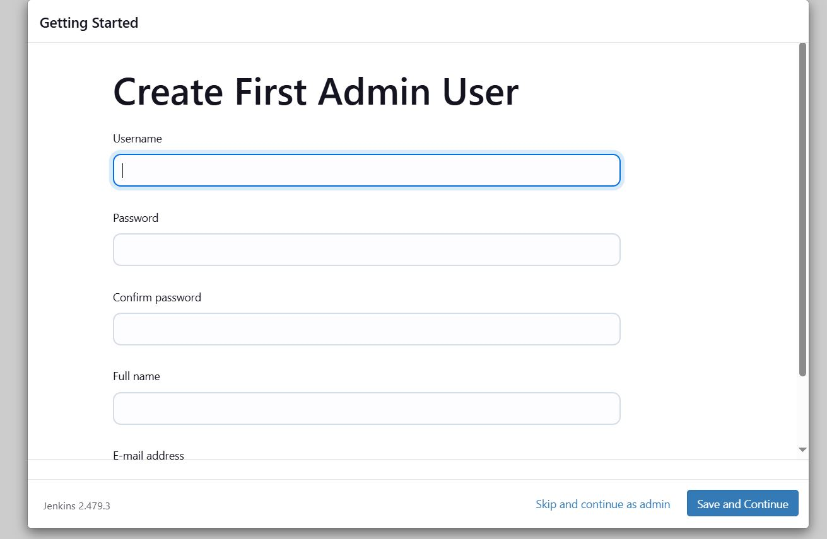

**Step-22**: After click on Save and continue -> it show some links and show the option Save & Finish -> Click on Save & Finish -> After that it show Jenkins in Ready and show a option Start using Jenkins -> just click on it -> It will open a Jenkins Dashboard.

**Output:-**

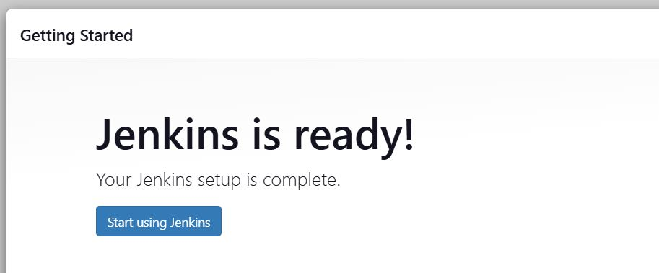

**OUTPUT**

**Your Output is the Jenkins Dashboard**

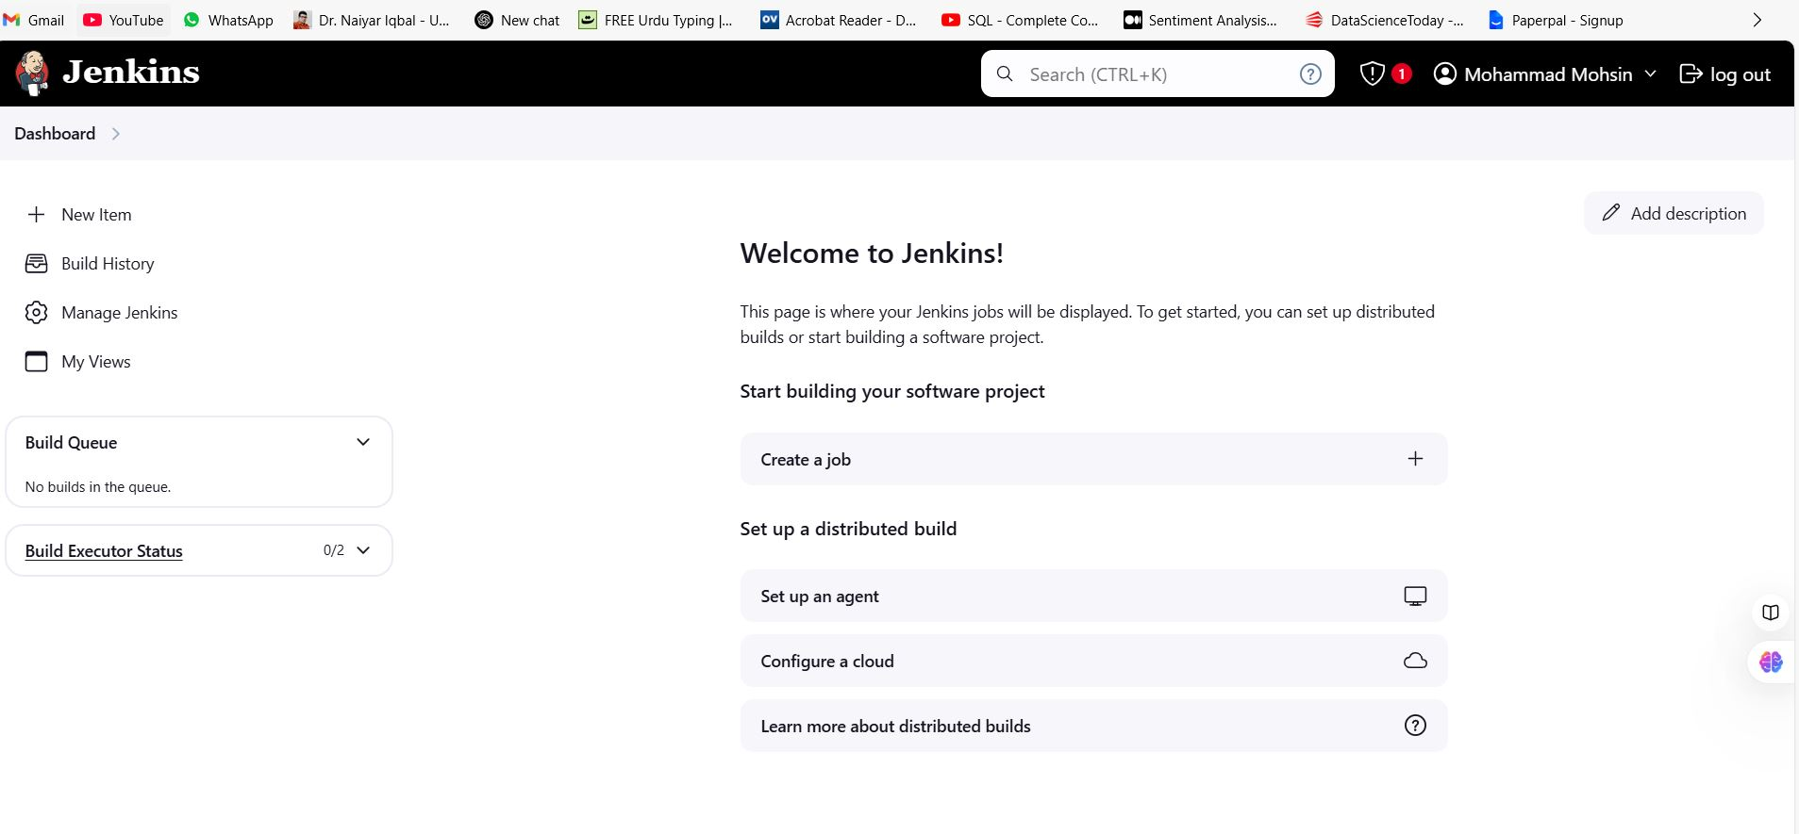

**Experiment-4**

**Aim:Ansible Setup and SSH key**

**(Note:** All Blue Words is a command, just copy and paste**)**

**Require Software & Tools:** AWS Account, Puttygen software, Wincp Software.

**Procedure:**

**Step-1:** Login AWS and Create three Instances on AWS account using ubuntu OS and save key pair also.

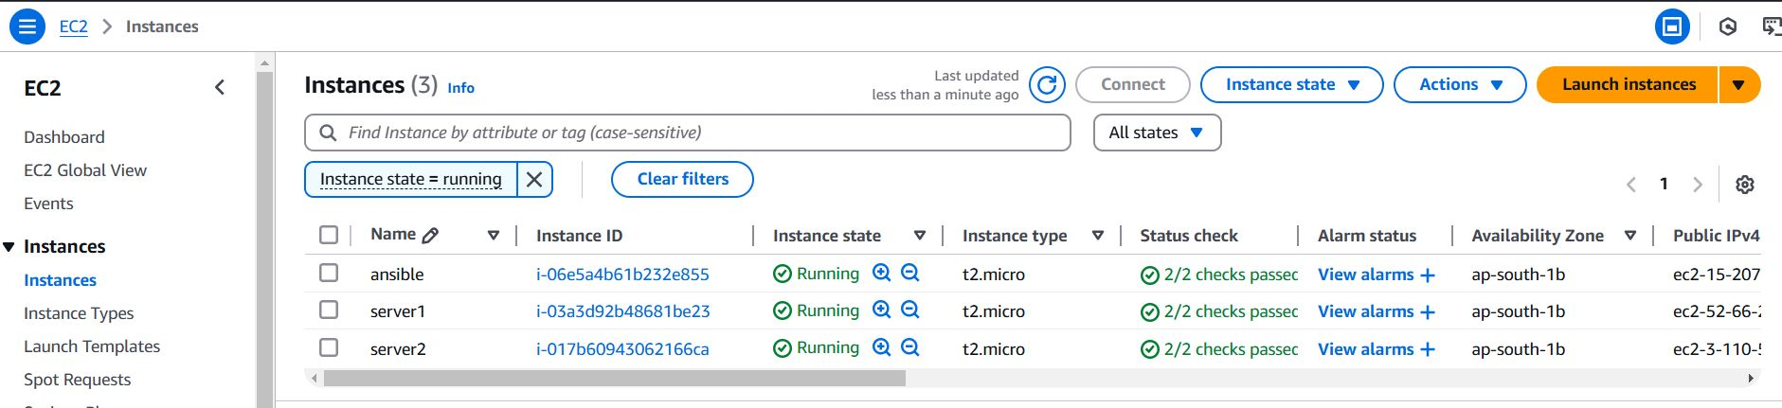

**Step-2:** change the 2nd and 3rd instance name as a server1 and server2 (you can named anything) -> Edit inbound rules of 1st instance (ansible). Edit inbound rules like given details.

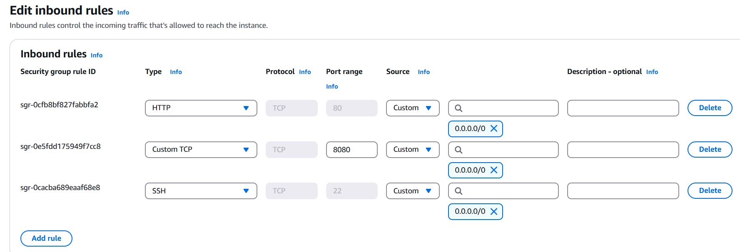

**Step-3:** Now come on instance and select 1st instance (ansible) and click on connect. It will open a linux terminal -> type Clear command.

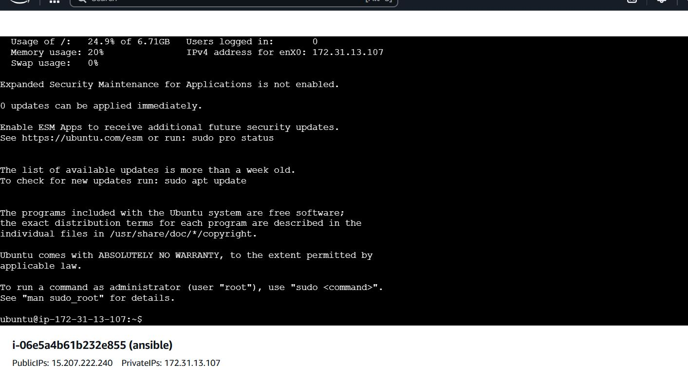

**Step-4:** type command sudo apt update and hit enter.

**Step-5:** type command sudo apt install ansibleand hit enter -> it will ask yes/no type yes and hit enter.

**Step-6:** type command sudo apt install openssh-client and hit enter.

**Step-7:** type command sudo apt install openssh-server and hit enter.

**Step-8:** type command cd ~/.ssh/ and hit enter.

**Step-9:** type command ls and hit enter.

**Step-10:** type command cd and hit enter.

**Step-11:** type command cd - and hit enter. (it will show ssh path)

**Step-12:** now againtype command cd and hit enter.

**Step-13:** open puttygen software -> click on load -> select as all files -> select ansible.pem(your key pair) -> click on save and -> click on save private key and save the file with .ppk extension.

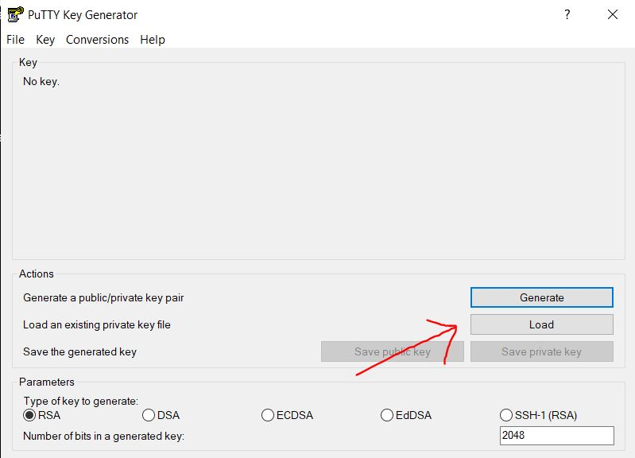

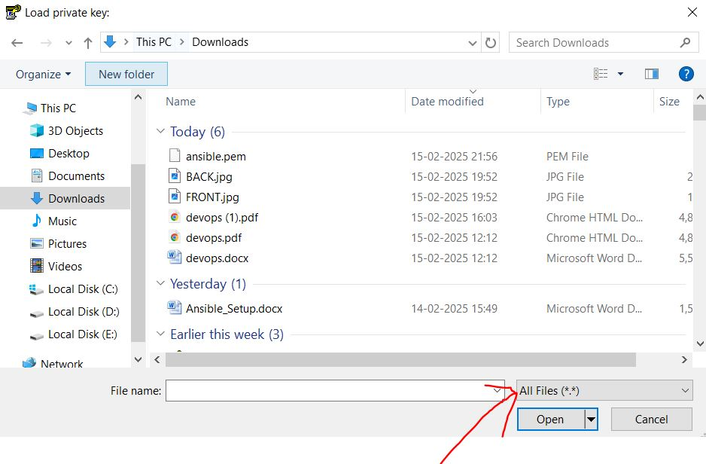

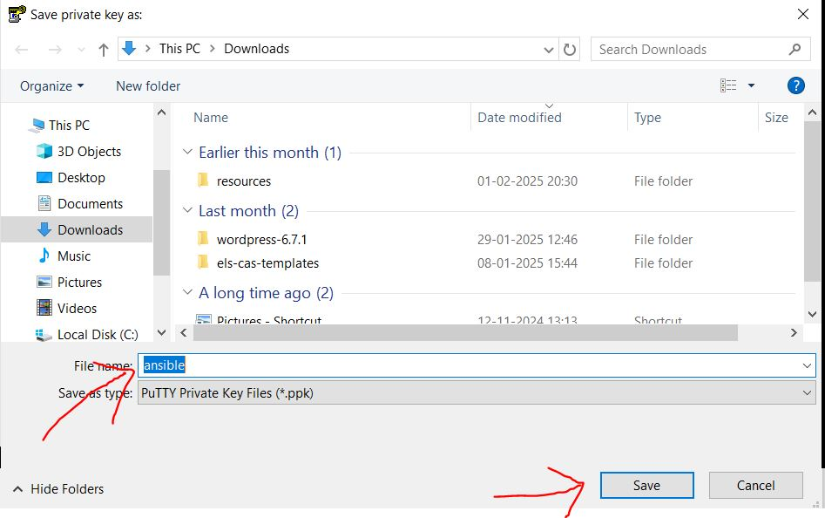

**Step-14:** Now open winCP software -> it will ask for host name just copy and paste your ansibleinstance Ip-> In the place of user name type Ubuntu -> click on advance -> select authentication -> in the place of private key select your downloaded .ppk file - > click on Ok -> click on Login. (it will connect to your server and show a Ubuntu wincp window)

Note: follow 1 -> 2 -> 3 -> 4 -> 5 arrow.

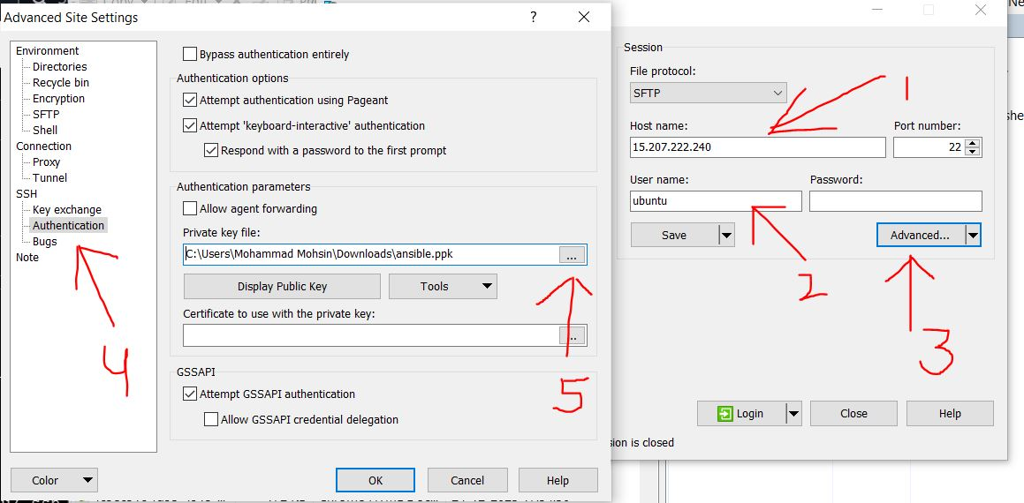

**Step-15:** after connecting to your server it will show two directory (one is your local disk, another is ssh directory) -> right click in ssh directory -> click on new -> select directory -> create a folder name as key -> now select your .pemfile from left side local disk directory and drag in your key folder.

**Step-16:** Now come on in your terminal -> type cd command and hit enter -> type lscommand hit enter, you will see key.

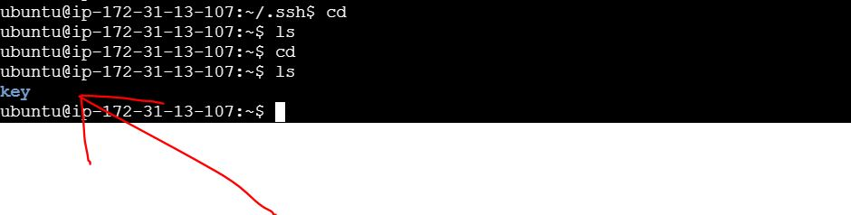

**Step-17:** Now type cd key/ and hit enter, you will see ansible.pem

**Step-18:** Now type cpansible.pem ~/.ssh/ command and hit enter -> after that type cd hit enter -> after that ls ~/.ssh/ and hit enter, you will see ansible.pem and authorized_key

**Step-19:** Now create one more directory using mkdiransible-script command and hit enter-> select directory using cd ansible-script/ command and hit enter.

**Step-20:** Now write vi inventory.ini command and hit enter -> it will open your Vim Editor -> copy the given command and paste in your Vim editor -> after that in the place of [server1-ip] copy and paste server1 instance public ip and in the place of [server2-ip] copy and paste server2 instance public ip -> after that save this vim editor using :wq! Command and hit enter

Command:

[webservers]

server1 ansible_host=[server1-ip] ansible_user=ubuntuansible_ssh_private_key_file= /home/ubuntu/.ssh/ansible.pem

server2 ansible_host=[server2-ip] ansible_user=ubuntuansible_ssh_private_key_file= /home/ubuntu/.ssh/ansible.pem

**Step-21:** Now write the command vi playbook.ymland create a yml file -> it will again open your Vim editor -> copy and paste the given command in your vim editor after save and exit using command :wq! and hit enter.

Command:

-- name: Install Nginx on AWS EC2

hosts: webservers

become: yes

tasks:

- name: Install Nginx

apt:

name: nginx

state: present

when: ansible_os_family == "Debian"

- name: start and enable nginx server

systemd:

name: nginx

state: started

enabled: yes

**Step-22:** Now you can check your .ini file and .yml file using cat inventory.ini command and cat playbook.ymlcommand.

**Step-23:** Now type ansible-playbook –i playbook.ymlcommand and hit enter.

**Step-24:** Now type ansible-playbook –i inventory.ini playbook.ymlcommand and hit enter -> it will ask for type yes and again yes and again yes or may be it will show server Unreachable.

**Step-25:** Now type cd and hit enter -> after that cd ~/.ssh/ hit enter, you will see ansible.pemauthorized_key and known_hosts.

**Step-26:** Now again run the command ansible-playbook –i inventory.ini playbook.yml. it will run your server or may be it will show again an error server unreachable.

**Step-27**: If server is reachable is then check your server using server ip otherwise -> write command chmod 400 ~/.ssh/ansible.pemhit enter -> after that ls –l ~/.ssh/ and hit enter, it will show Ubuntu file.

**Step-28:** Now again run the command ansible-playbook –i inventory.ini playbook.yml. nowit will run your server properly. After that you can check your server in any browser using server ip.

**OUTPUT:-**

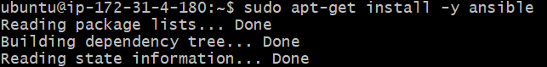

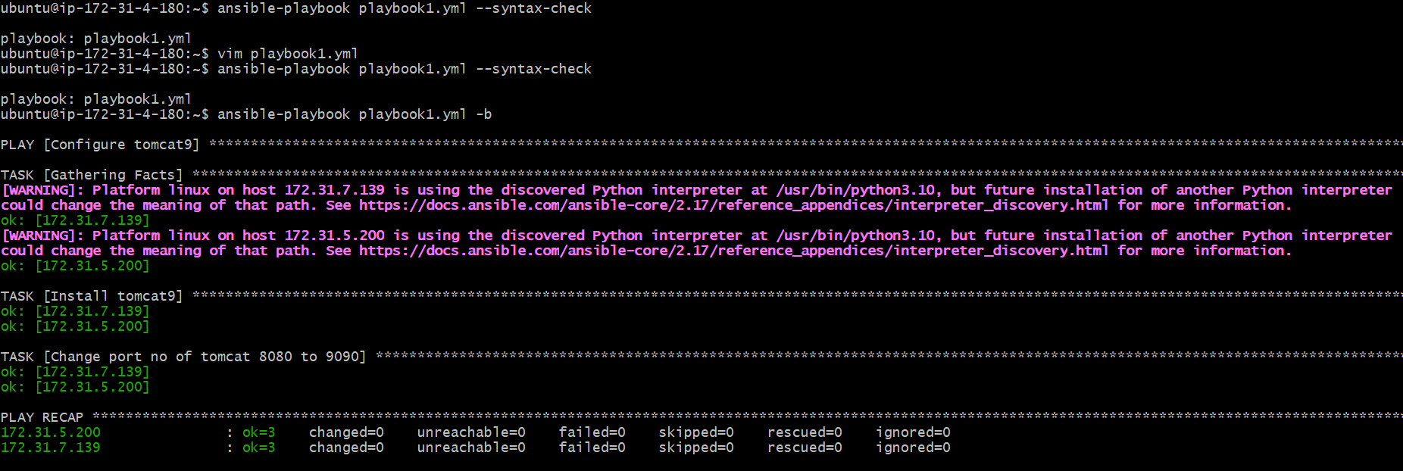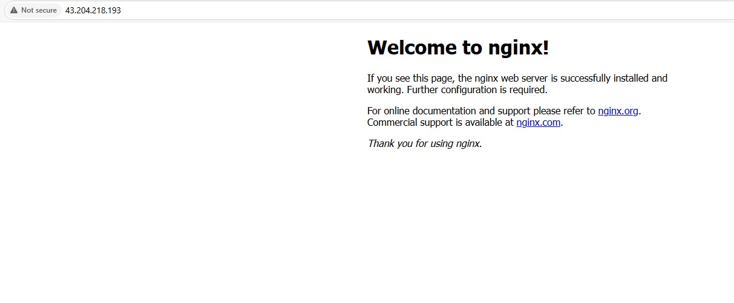

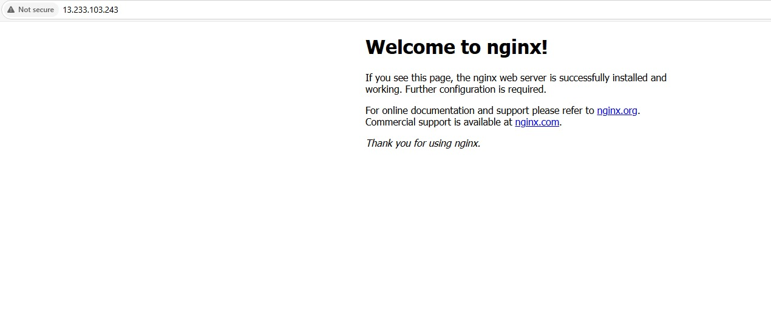

**Experiment-5**

**(Note:** All Blue Words is a command, just copy and paste**)**

**Aim:**Build War file in Devops

**Require Software & Tools:** Jenkins, Jdk-17 or jdk-21, Git bash.

**Procedure:**

**Step-1:** First open any browser and Search download Jenkins -> click on first link -> scroll down and click on windows logo -> download will be started.

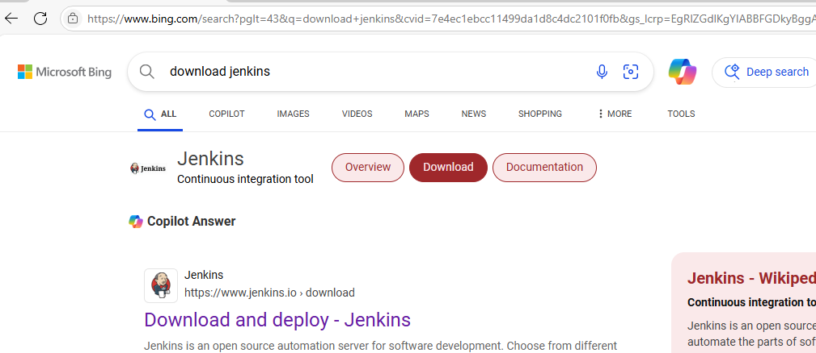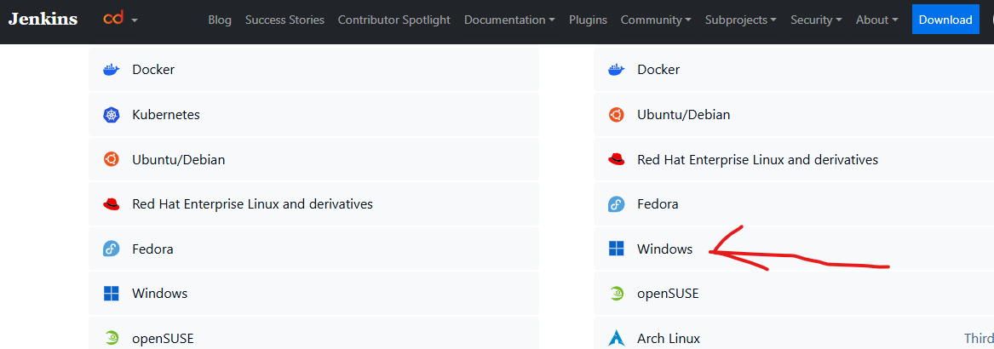

**Step2:** First check java jdk in your system, if java is available check the java version using cmd. otherwise download and install jdk-17.

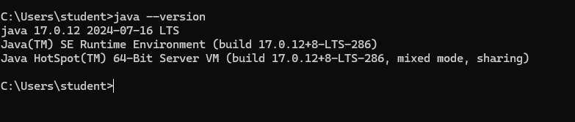

#### Step-3: Download Git Bash 64-bit Standalone Installer, and install git bash in your system. After installation set the git.exe path in your runtime environment.

#### 54.png

#### Step-4: Now install Jenkins in your system -> click on next and again next -> select run service as a local system -> click on next and click on Test port -> click on next and click on change and set the java jdk path -> click on next and again next and click on install.

#### 56.png57.png

#### Step-5: After that install Git Bash in your system (no need to change anything just click on next next and next till last).

#### Step-6: Now open a browser -> search localhost:8080

#### Step-7: It will open your Jenkins server -> Copy red line location and search it to in your File manager.

#### Step-7: It will show open with option just select notepad -> after that copy the password and paste in Jenkins server -> click on continue -> click on suggested plugin -> it will take some time for installation -> create admin user using given details and click on save and continue -> after that click on save and finish -> Click on start using jenkins It will show Jenkins Dashboard.

#### 58.png59.png60.png

#### 61.png

#### Step-8: After that click on manage Jenkins -> click on plugin -> click on available plugin -> search maven -> select maven integration -> click on install -> scroll down and check maven integration and and loading plugin is green and success or not -> After success click on go back to the top page

#### 62.png

#### 63.png64.png

#### Step-9: Now again click on Manage Jenkins -> click on tools -> scroll down and check Git path -> after that scroll down and in a Maven installation section -> click on add maven -> write maven name and click on apply -> click on save.

#### 65.png67.png

#### 66.png

#### Step-10: now click on dashboard -> click on create a job -> type your buildwar name (i.e. myWar) -> select Maven Project -> click on OK

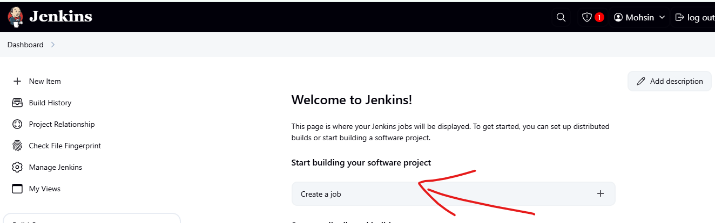

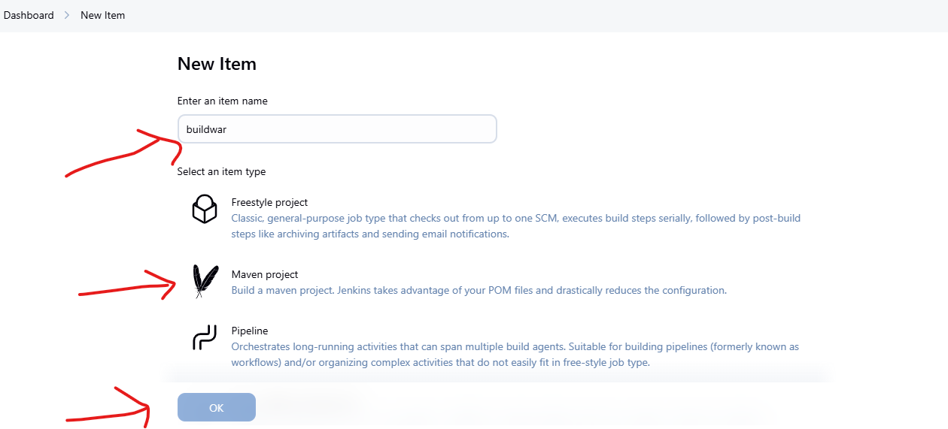

#### Step-10: Now take a new page -> login your GitHub -> check second experiment repository like Devops_pipeline -> copy the git link of second experiment.

#### 70.png

#### Step-11: scroll down and go to Source code management section -> select git -> paste git link -> scroll down go to build option and type clean install package in goals option -> click on apply -> click on save.

#### 71.png

#### 72.png

#### Step-12: After save the file -> it will show an option in left side build now -> click on build now -> It will take two to five minute for creating build file.

#### 73.png

#### Step-12: After building it will show success with green mark -> click on that section -> it will open new section -> click on console output -> scroll down and check status, build success or not.

#### 74.png

#### 75.png

**Output:-**

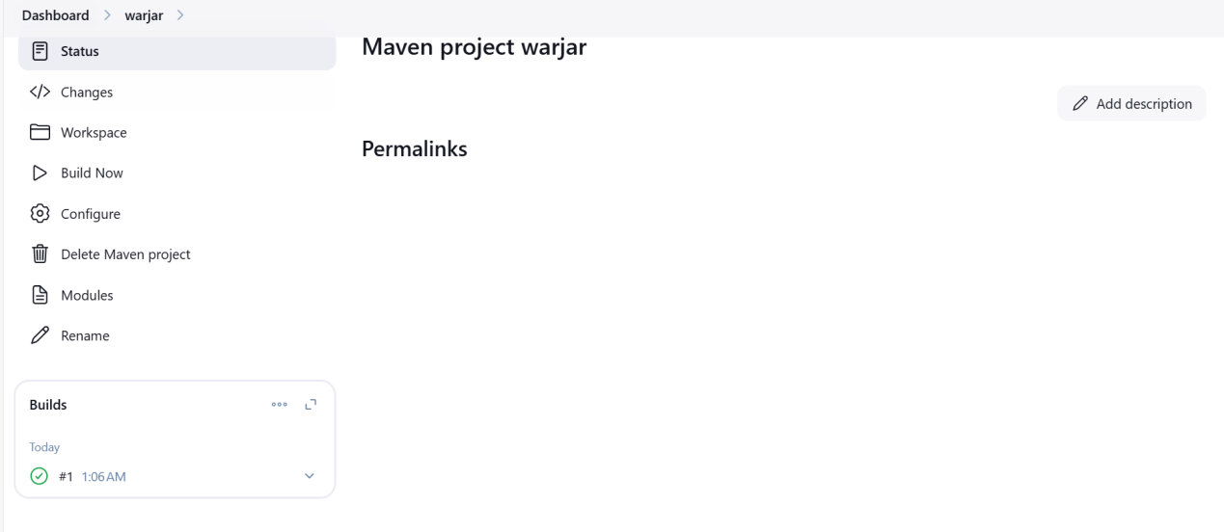

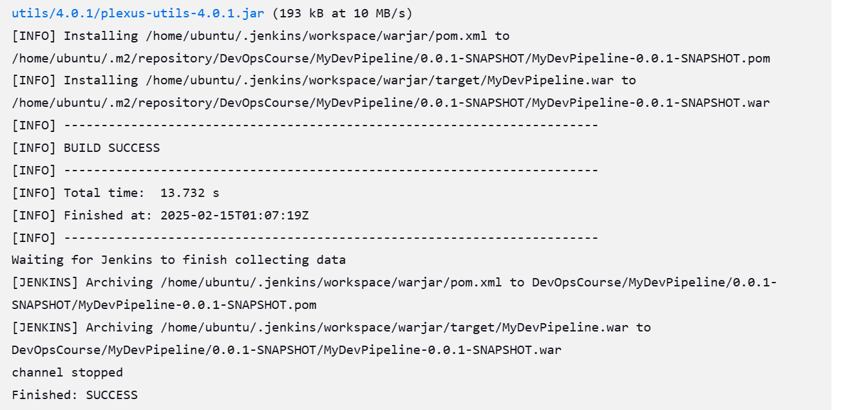

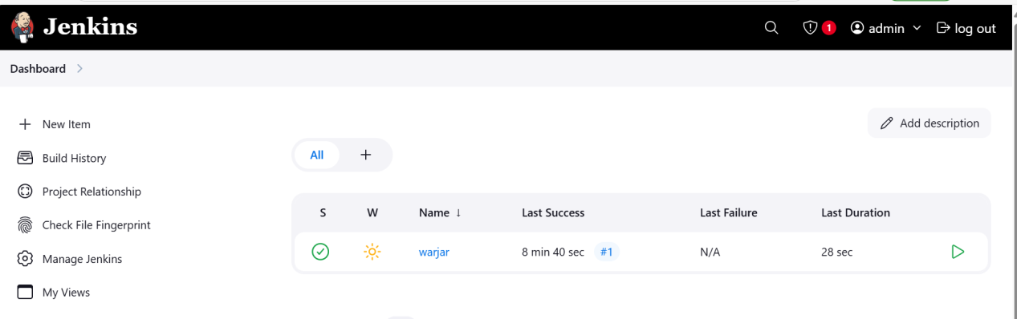

**Experiment-6**

**AIM:-Deploy the artifact on the Test Server**

Softwares:Jenkins(port:8080),JDk 17 or 21,Tomcat 9 (port:9090),Gitbash

(Here we are creating one artifact war file. That war file we are deploy to test server(Tomcat server) using Jenkins Server)

(**Note:-**Images are purpose of understanding only don’t paste it in records but output images paste it in output area)

**Step1:-**Lunch Jenkins and Login(Use AWS or Software)

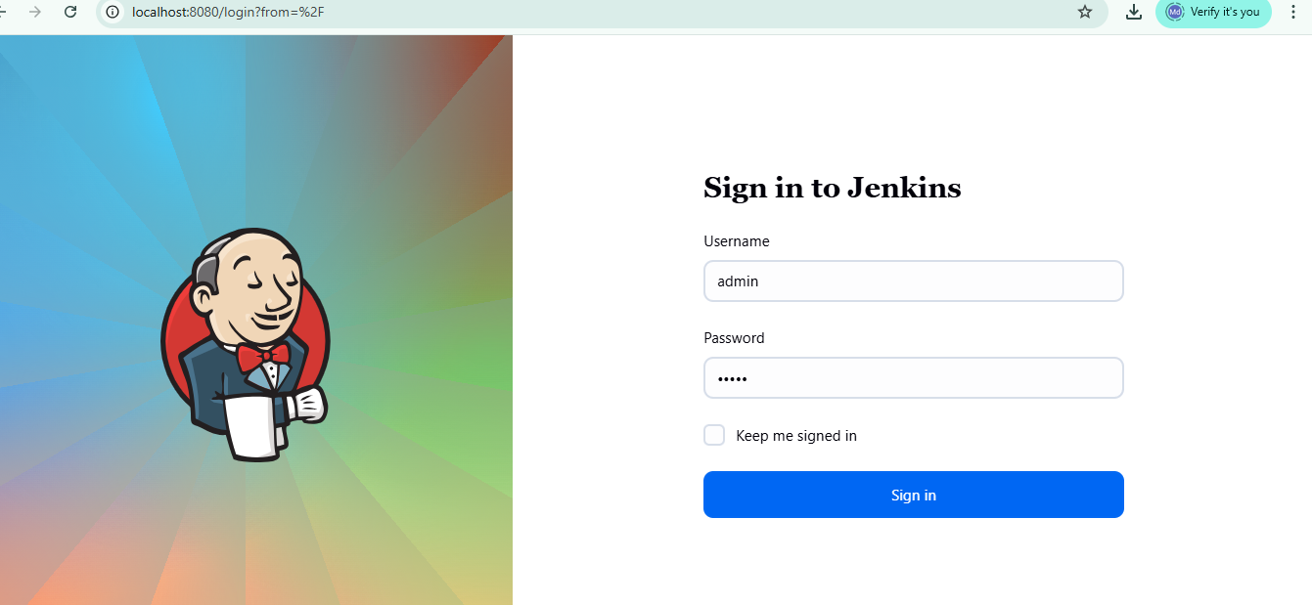

**Step2:**-Lunch Tomcat Server and login(use AWS or Software)

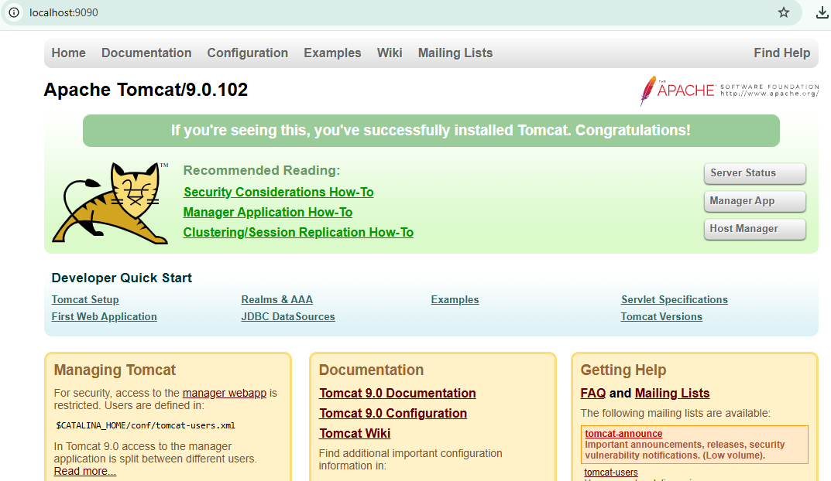

Open Jenkins do following steps

**Step 3:-**Install plugins

Go to Manage Jenkins🡪Plugins🡪Install Plugin select verify Git🡪Go to Available plugins install Maven integration and Deploy to container install.

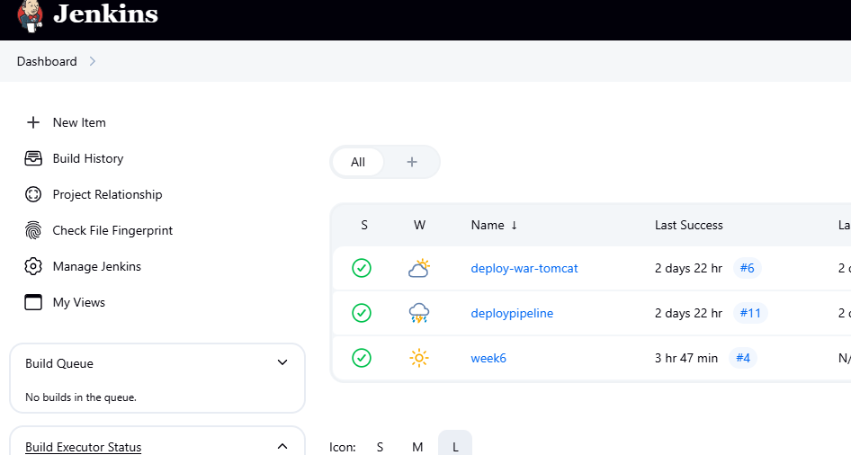

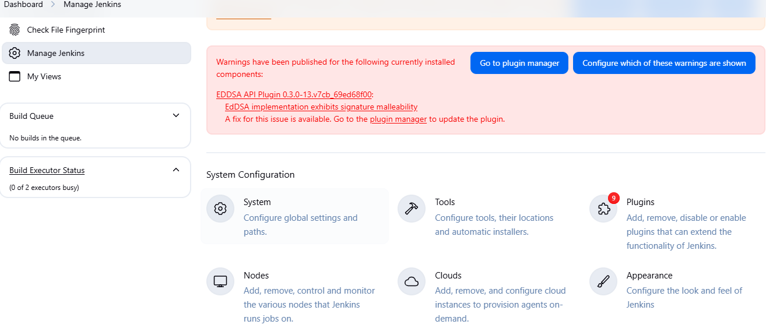

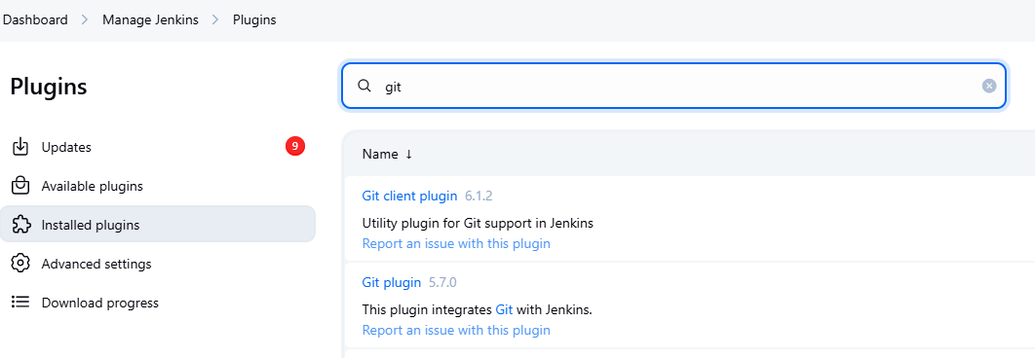

Above picture three plugins are installed , If not showing please go to available plugins install it.

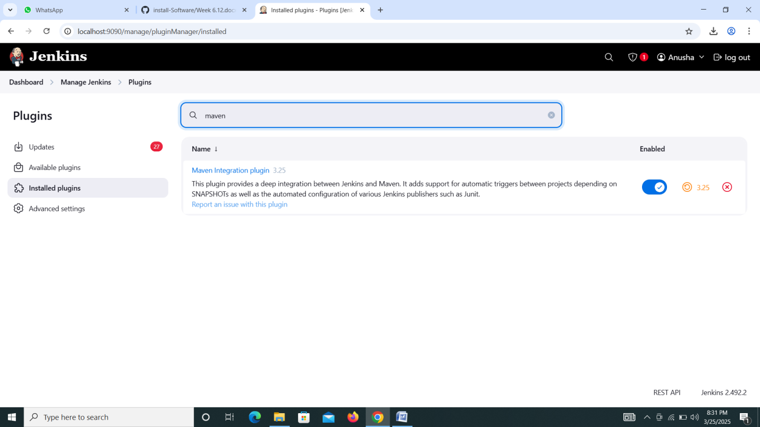

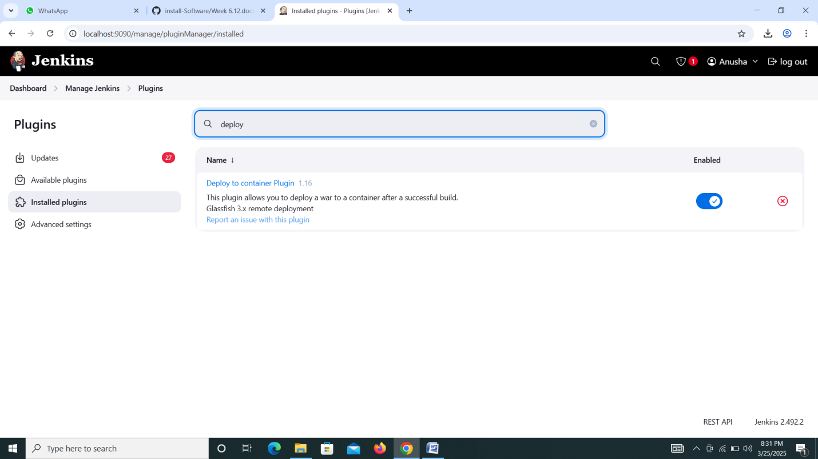

**Step 4:-**set up git path and maven installation in Tools

Go to manage Jenkins🡪Tools🡪In git installation select path(Git bash) if your using Jenkins software or AWS leave it 🡪In maven Enter name Maven and default installation🡪Apply and Save.

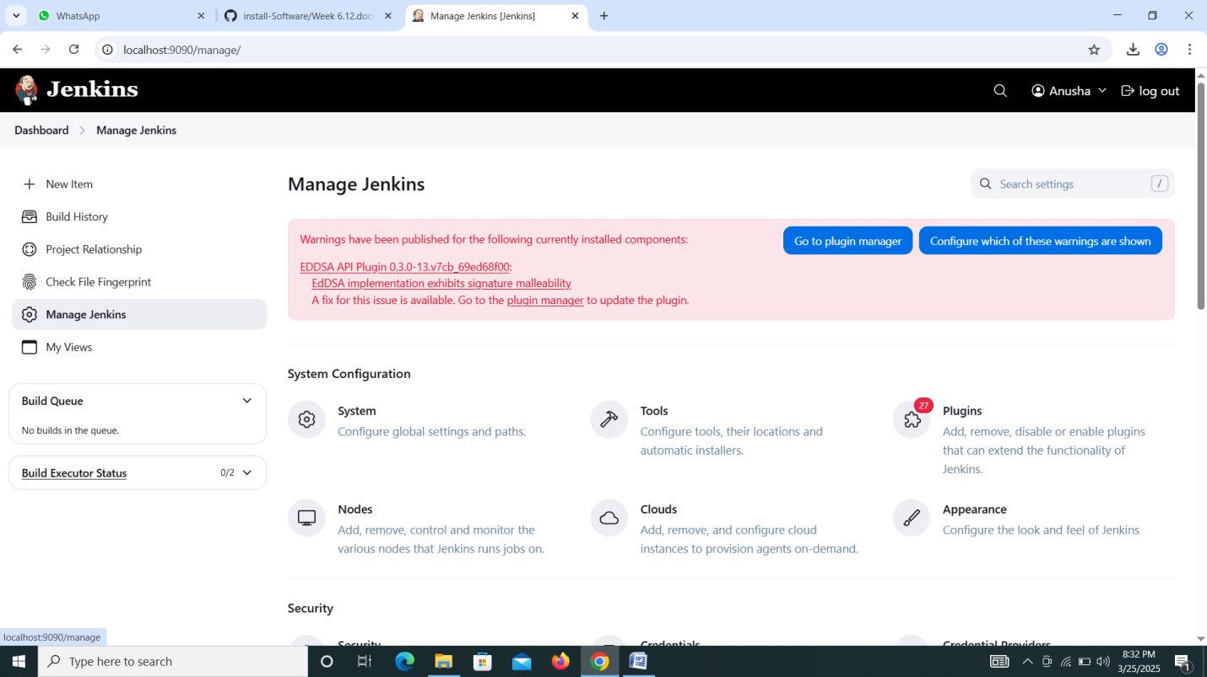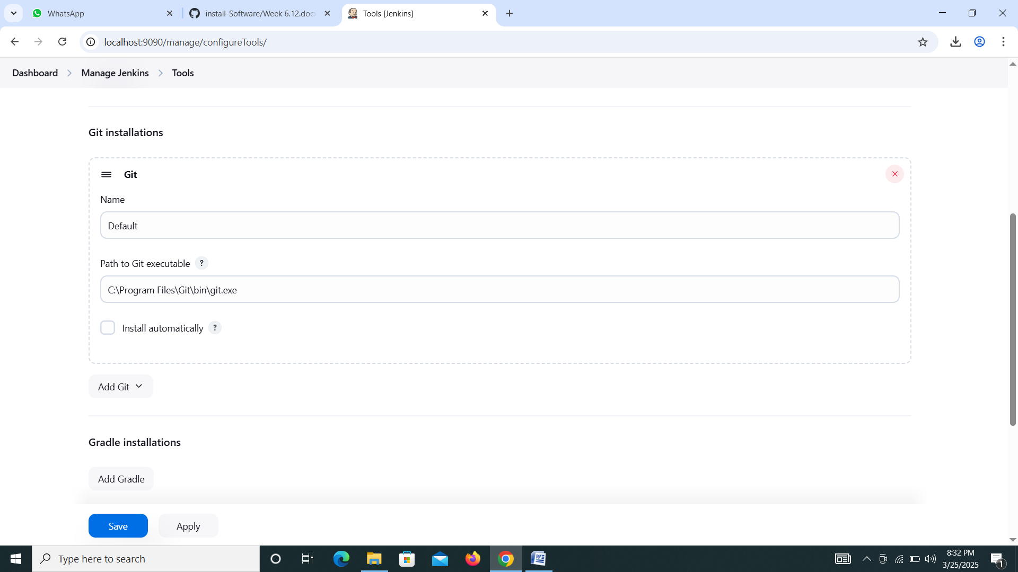

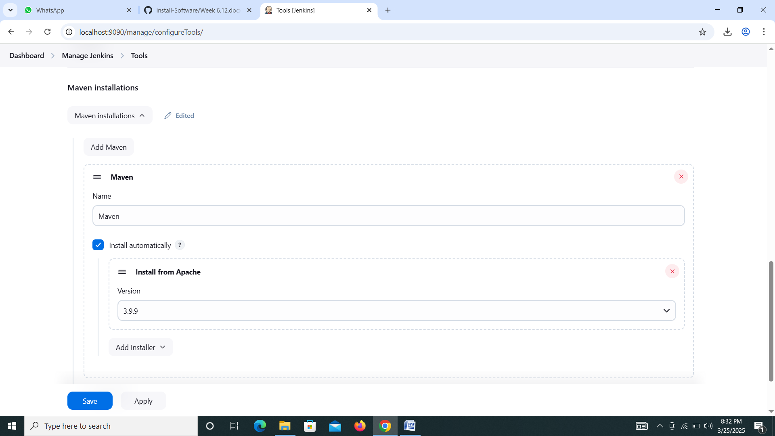

**Step 5:-**Creating New Job for deploy artifact in tomcat test server

1. Create New Item🡪 Enter name DeploytoTestServer 🡪select freestyle project🡪click ok

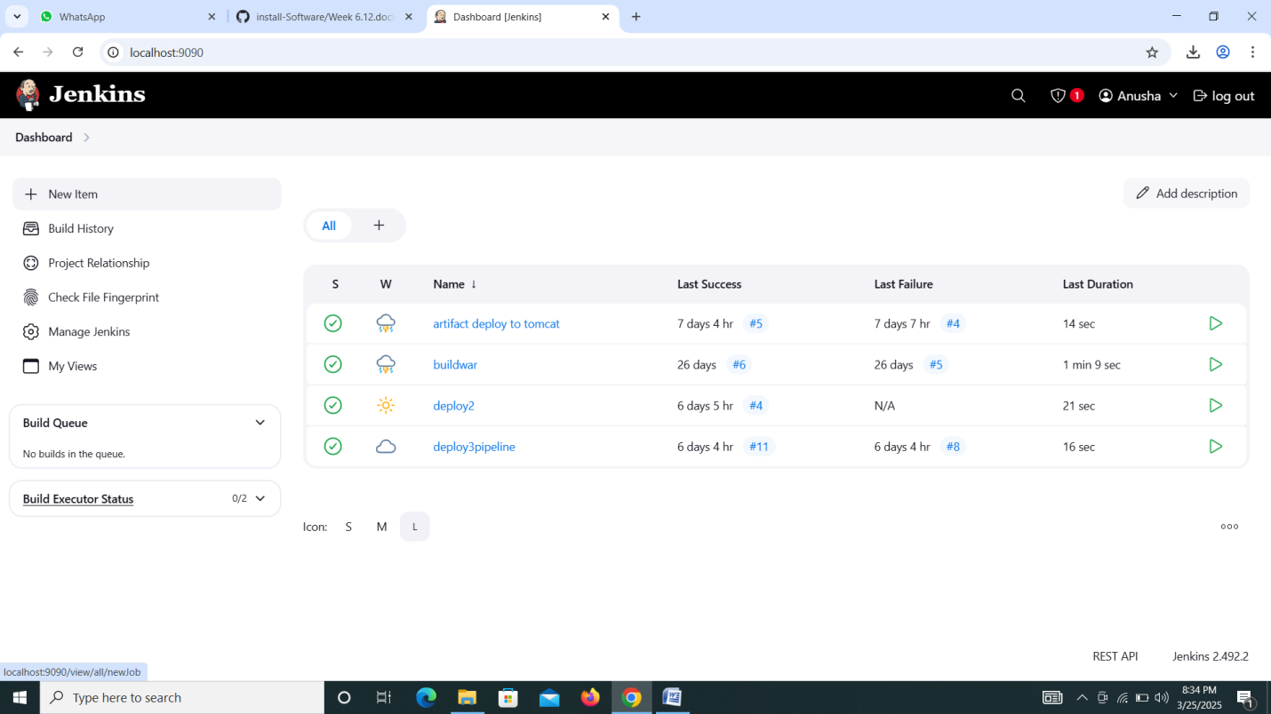

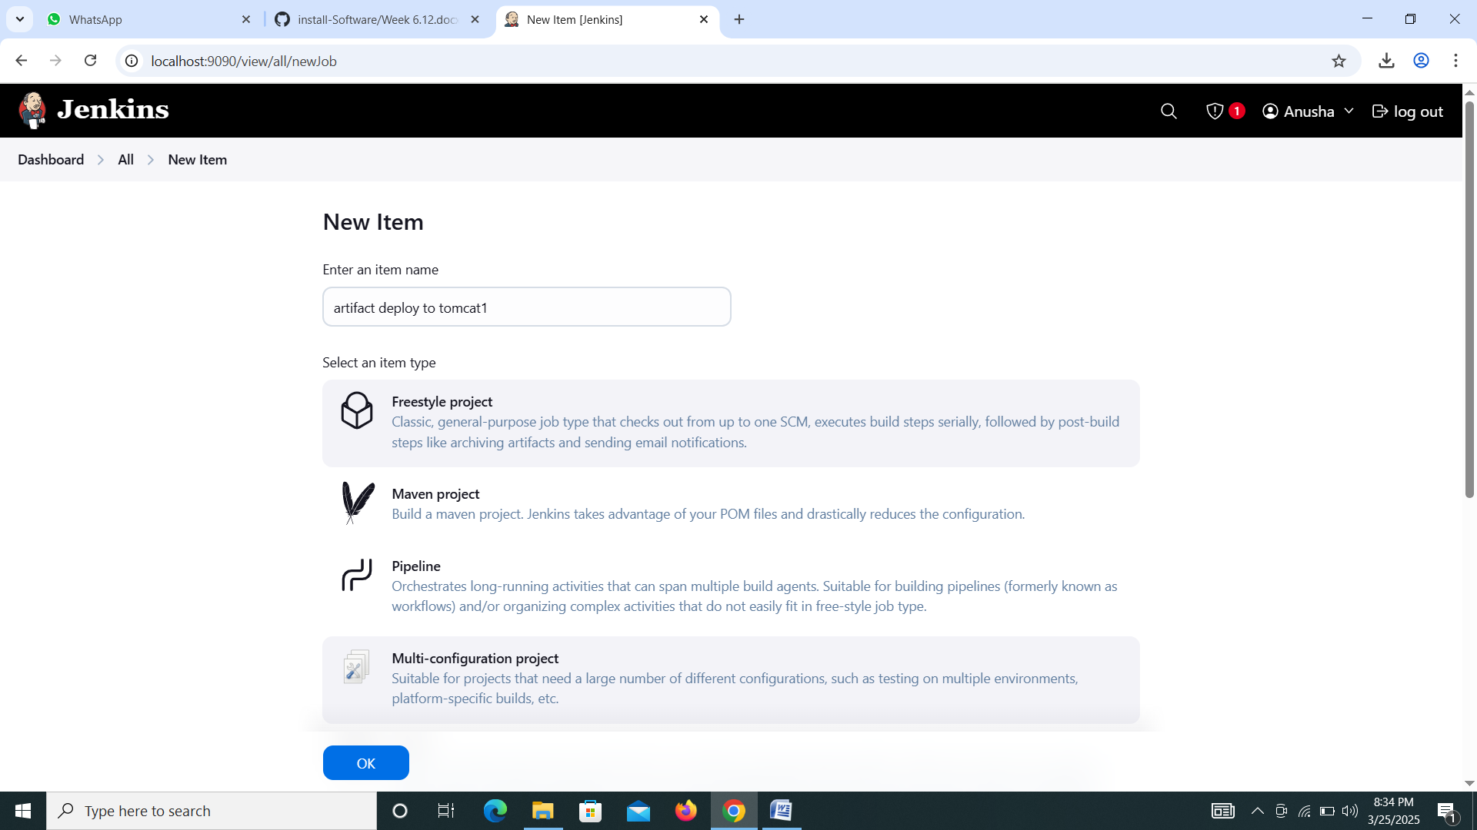

1. Select git 🡪paste maven project url form Github🡪Must and should match branches

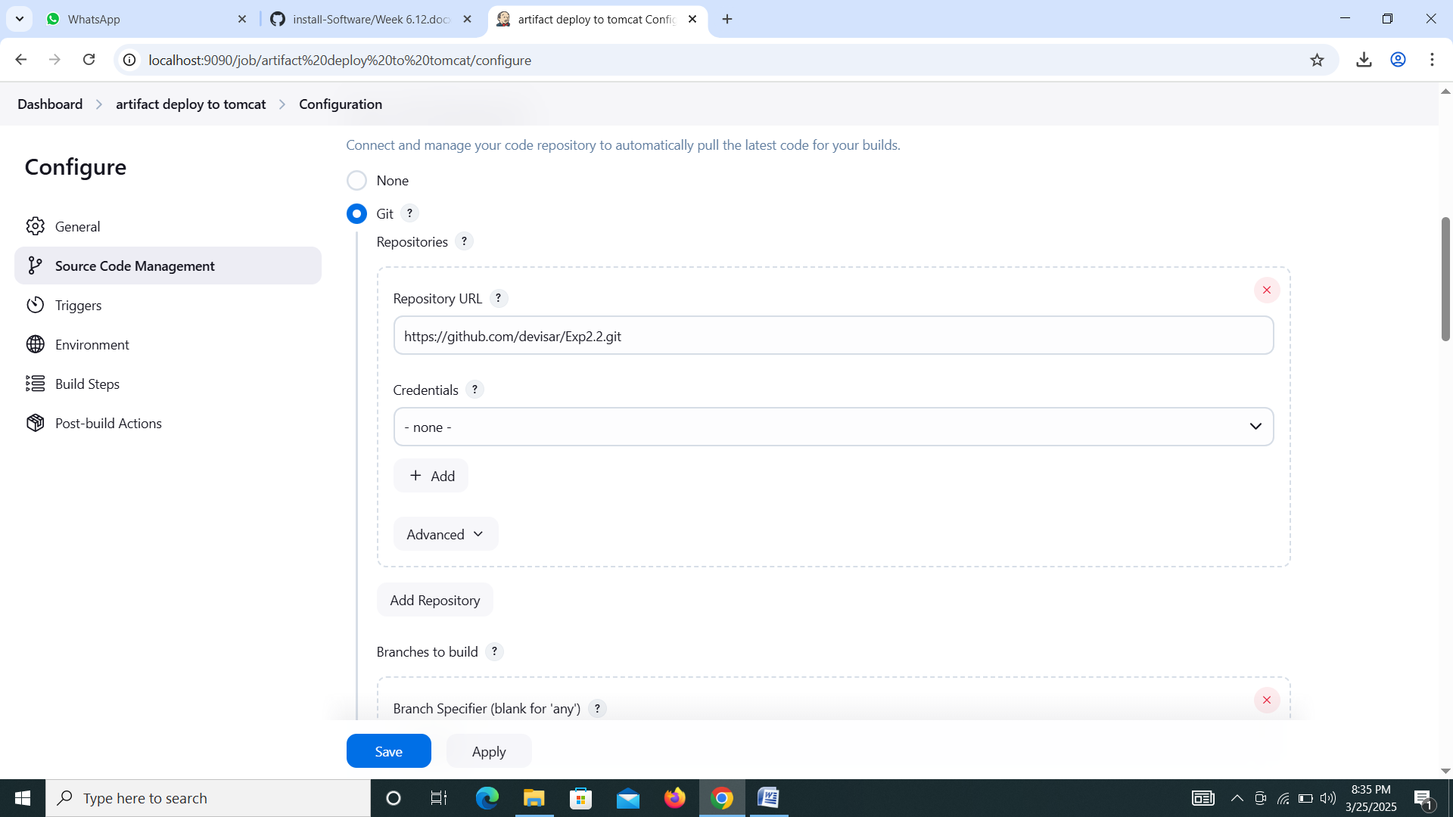

1. Go to Environment 🡪Select Add timestamps to the Console Output

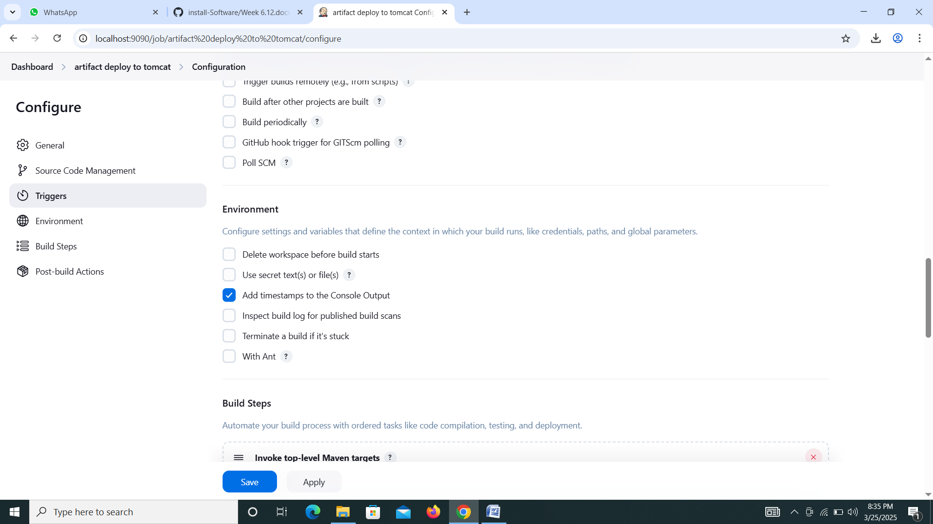

1. Go to Build Setups🡪Select **Invoke top-level Maven targets🡪Maven Version enter maven 🡪Goals clean install**

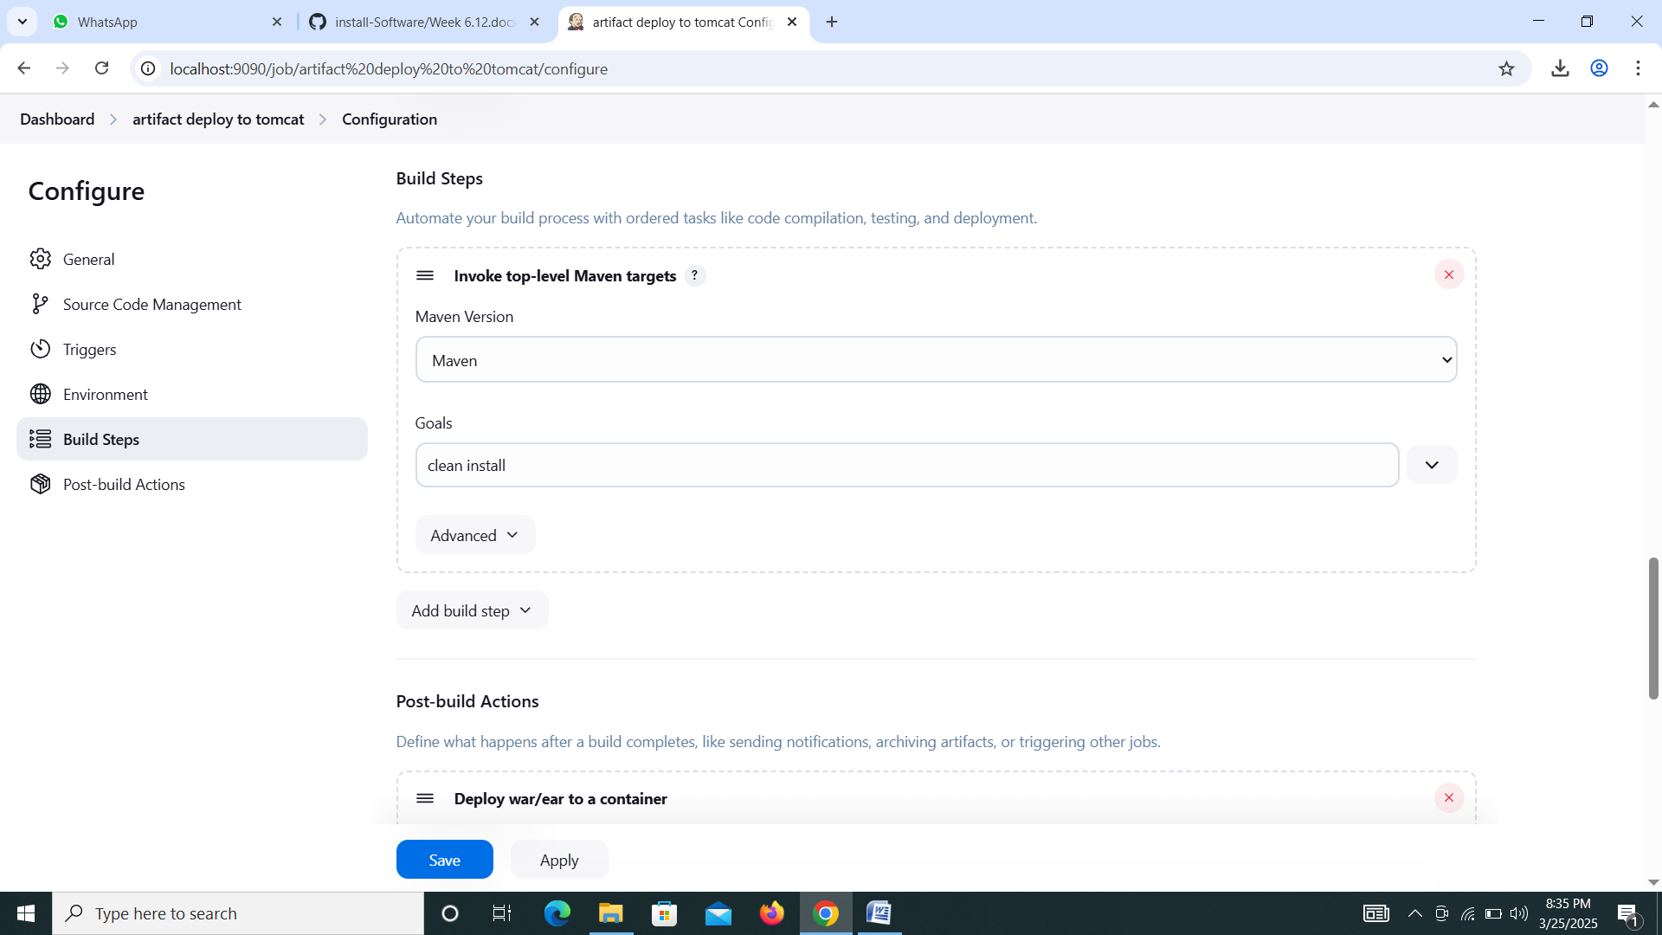**.**

1. **Go to** Post-build Actions🡪Select **Deploy war/ear to a container🡪**WAR/EAR files enter **/*.war🡪select Containers **Tomcat 9.x Remote🡪Add credentials like username, password, Id and description.-->Tomcat URL http://localhost:9090 🡪Apply and save.**

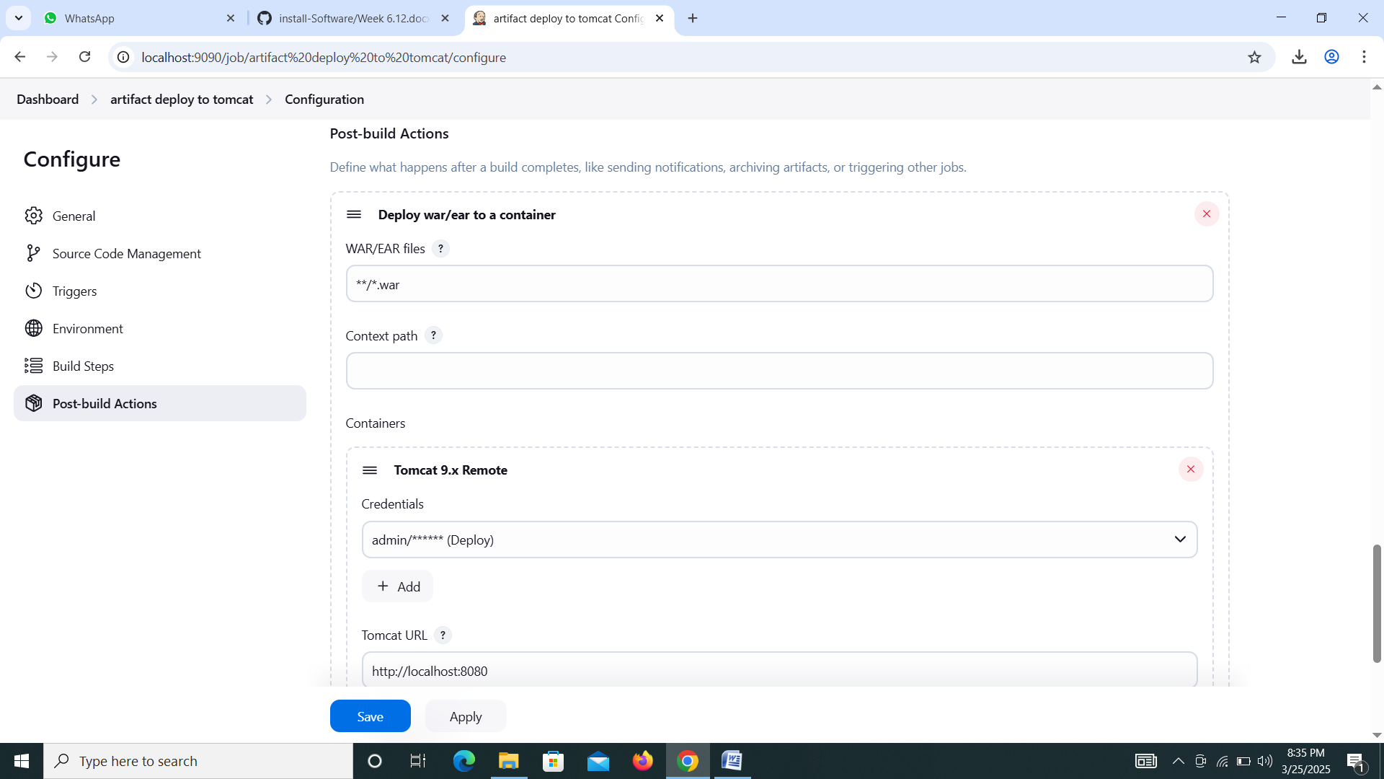

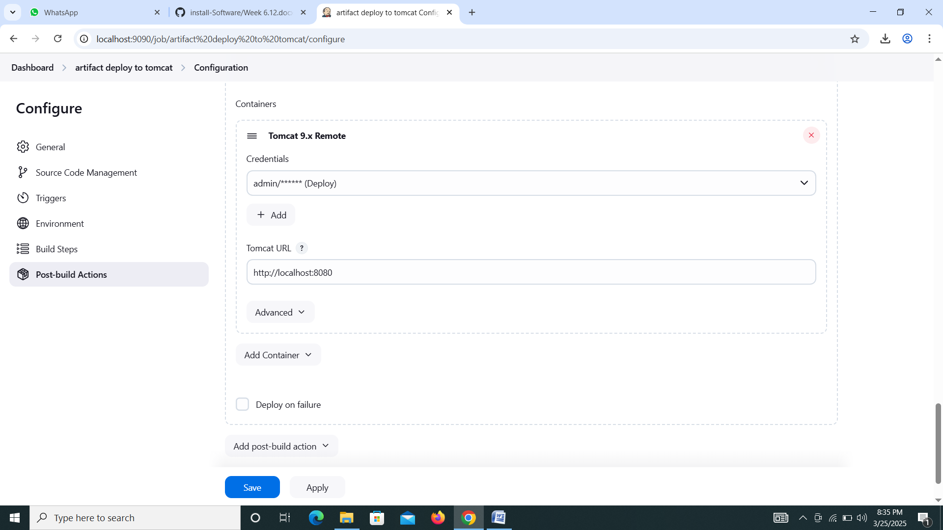

**Step 6:-** Build war File

1. Click Build now 🡪Go to Build select console output now you got Successfully Finish.

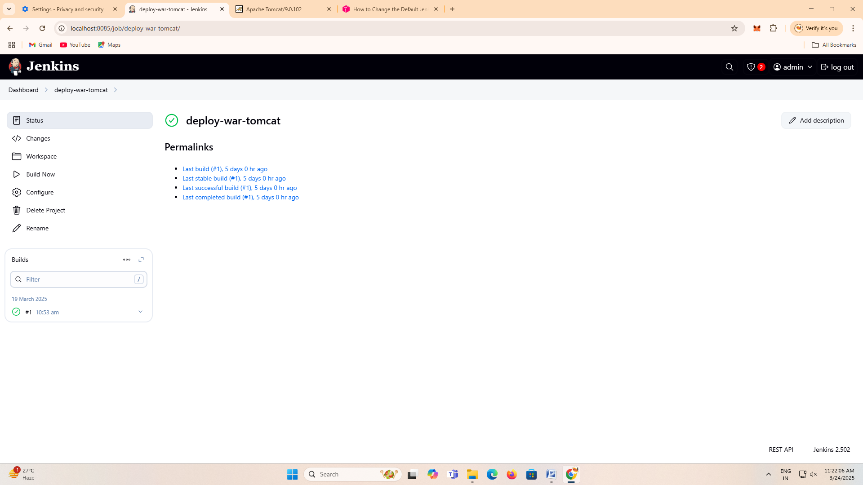

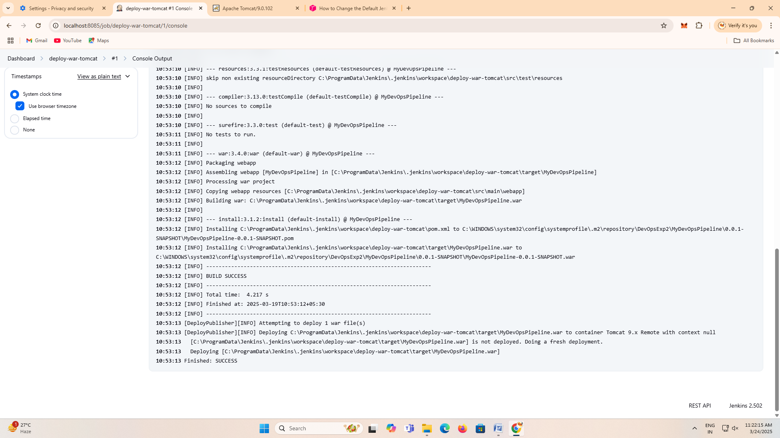

**Output:-**

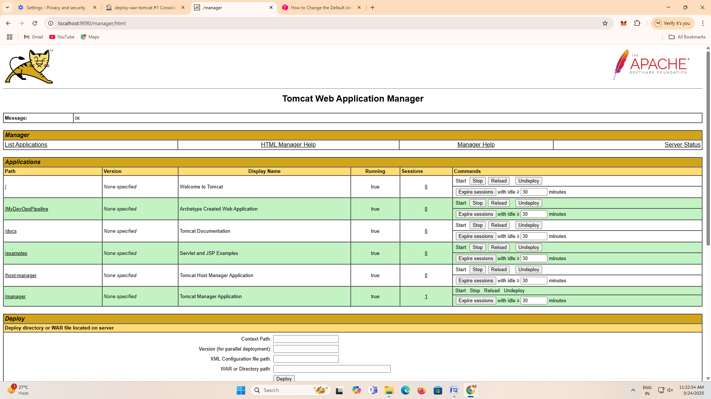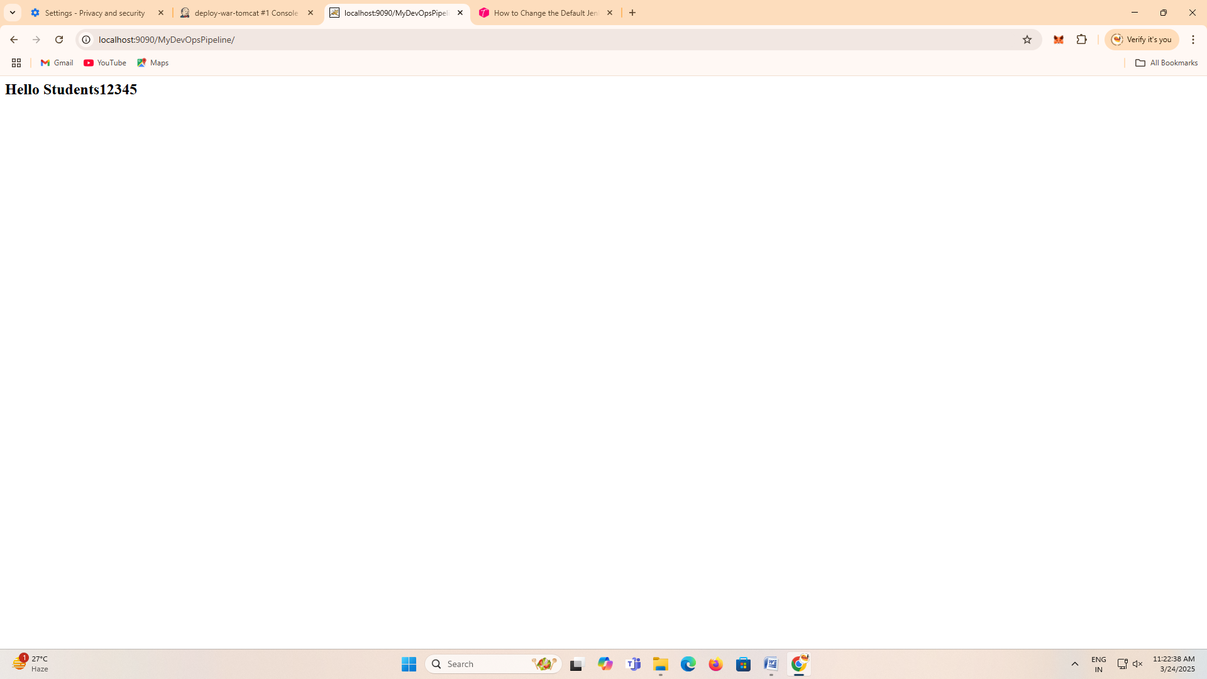

**Experiment-7**

**AIM:-Perform Automation using Jenkins.**

Softwares:Jenkins(port:8080),JDk 17 or 21,Tomcat 9 (port:9090),Gitbash

(Here we are creating one artifact war file. That war file we are deploy to test server(Tomcat server) using Jenkins Server)

(**Note:-**Images are purpose of understanding only don’t paste it in records but output images paste it in output area)

**Step1:-**Lunch Jenkins and Login(Use AWS or Software)



**Step2:**-Lunch Tomcat Server and login(use AWS or Software)



Open Jenkins do following steps

**Step 3:-**Install plugins

Go to Manage Jenkins🡪Plugins🡪Install Plugin select verify Git🡪Go to Available plugins install Maven integration and Deploy to container install.







Above picture three plugins are installed , If not showing please go to available plugins install





**Step 4:-**set up git path and maven installation in Tools

Go to manage Jenkins🡪Tools🡪In git installation select path(Git bash) if your using Jenkins software or AWS leave it 🡪In maven Enter name Maven and default installation🡪Apply and Save.





**Step 5:-**Creating New Job for deploy artifact in tomcat test server

1. Create New Item🡪 Enter name DeployPipeline 🡪select pipeline project🡪click ok



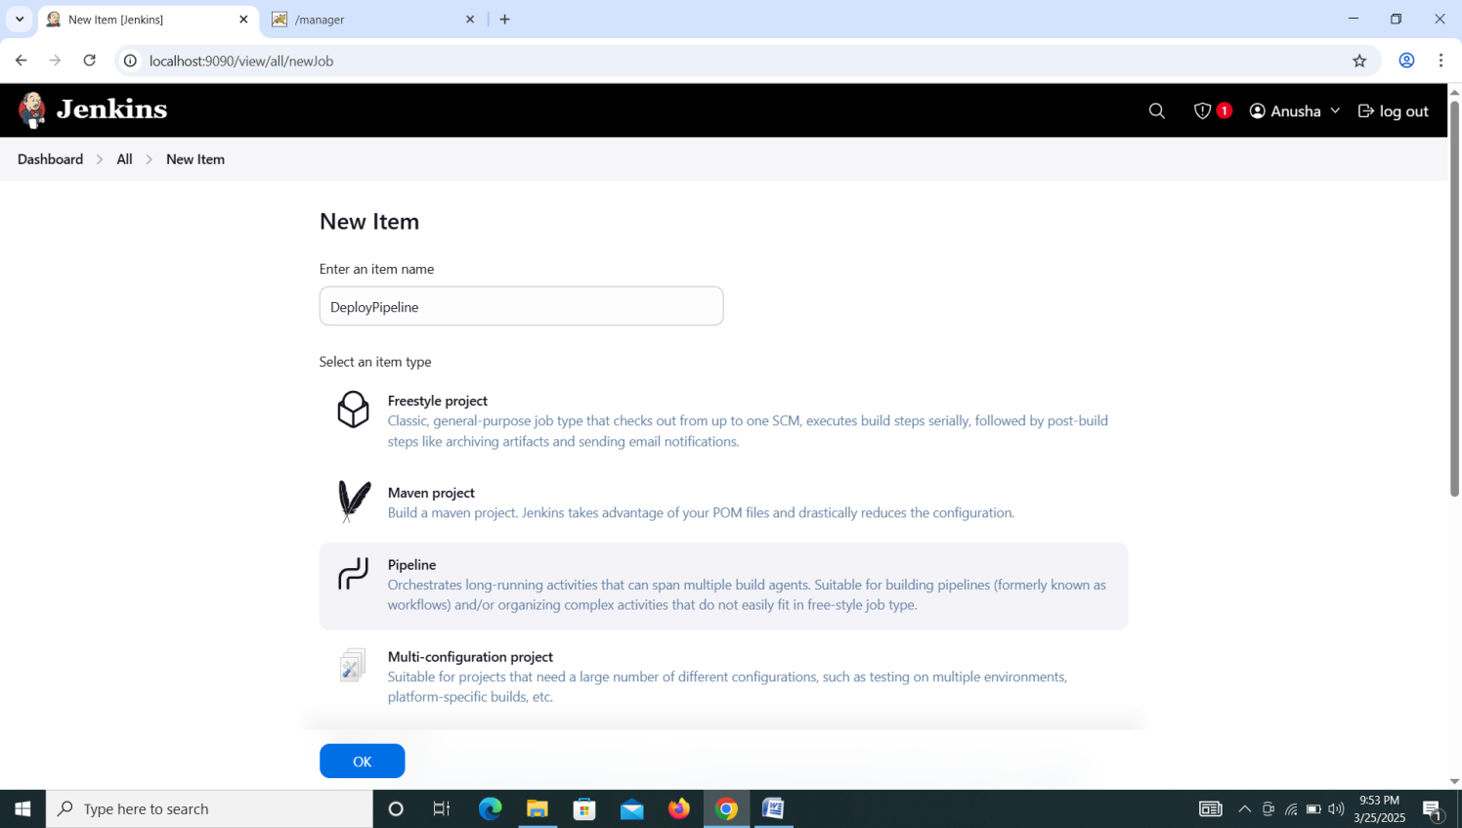

**Step 2:-Copy paste below commands pipeline script**

pipeline{

agent any

tools{

maven 'Maven'

}

stages{

stage('clone the repository'){

steps{

git url: 'https://github.com/devisar/Exp2.5.git'

}

}

stage('Build the code'){

steps{

bat 'mvn clean install'

}

}

stage('deploy to tomcat'){

steps{

deploy adapters: [tomcat9(credentialsId: 'Deploy', path: '', url: 'http://localhost:8080')], contextPath: null, war: '**/*.war'

}

}

}

}

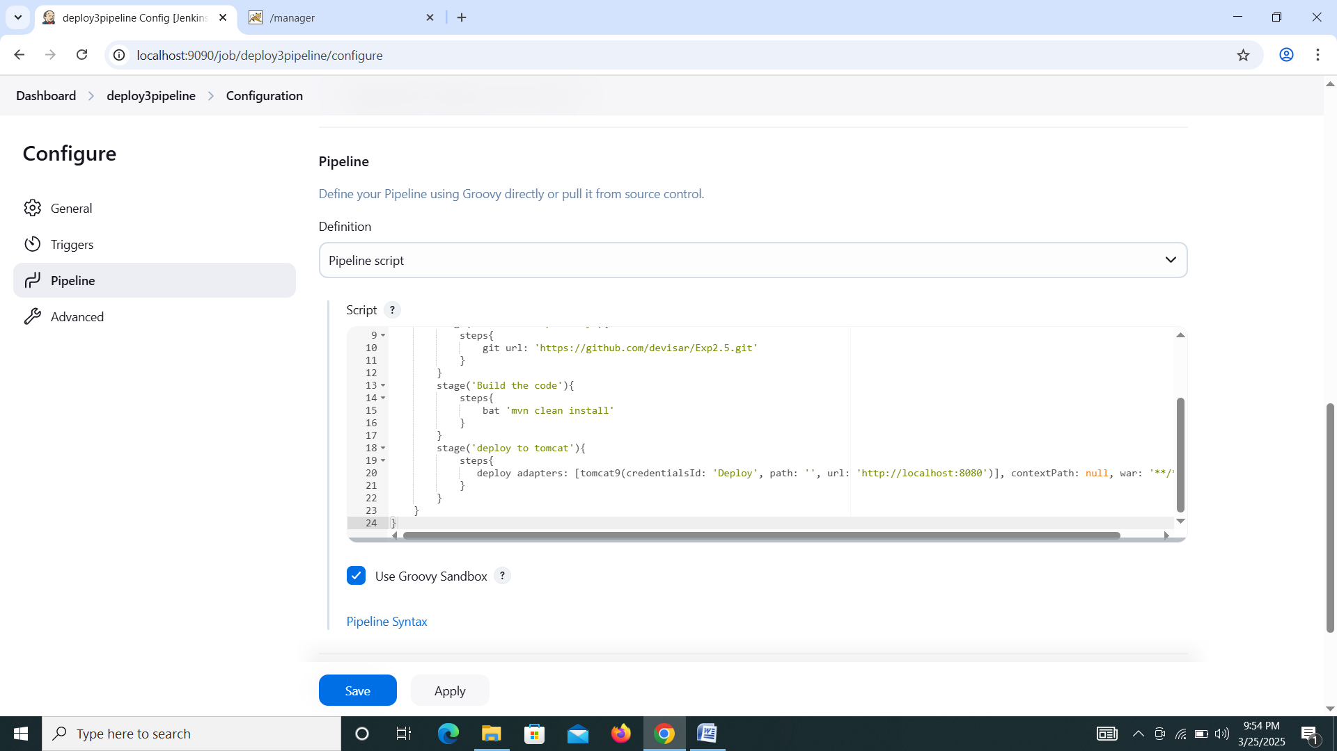

Step 6:-deploy to tomcat you want to create pipeline script go to 🡪pipeline syntax🡪Select in sample step deploy: Deploy war/ear to a container 🡪enter war/ear files:**/*.war🡪Select Containers tomcat 9🡪select credentials tomcat user name and password. 🡪Enter Tomcat Url like http://localhost:9090. 🡪Click Generate Pipeline Script copy and paste it original pipeline deployment stage.

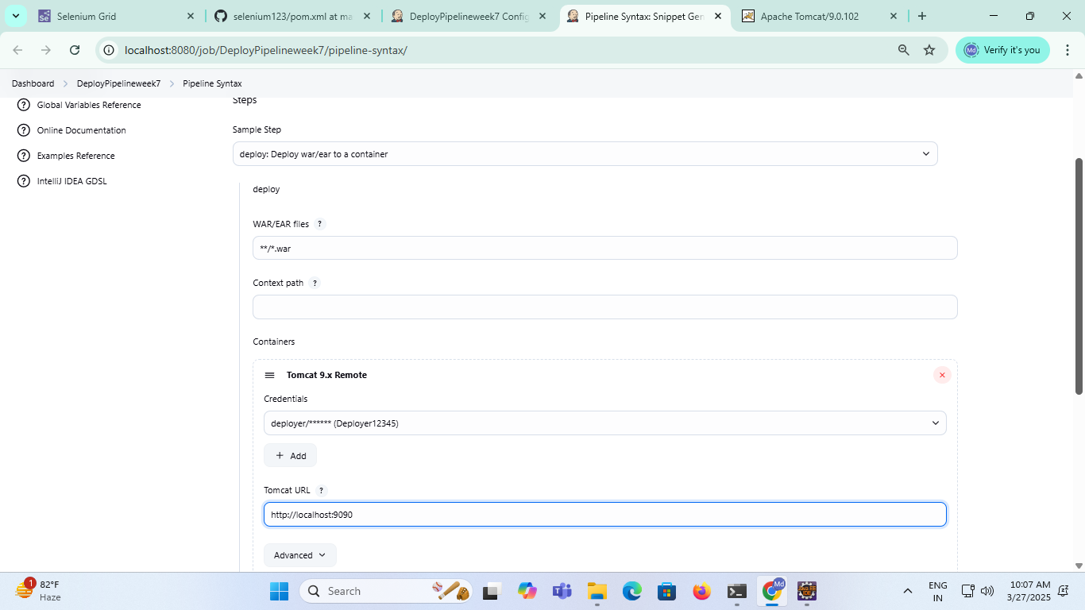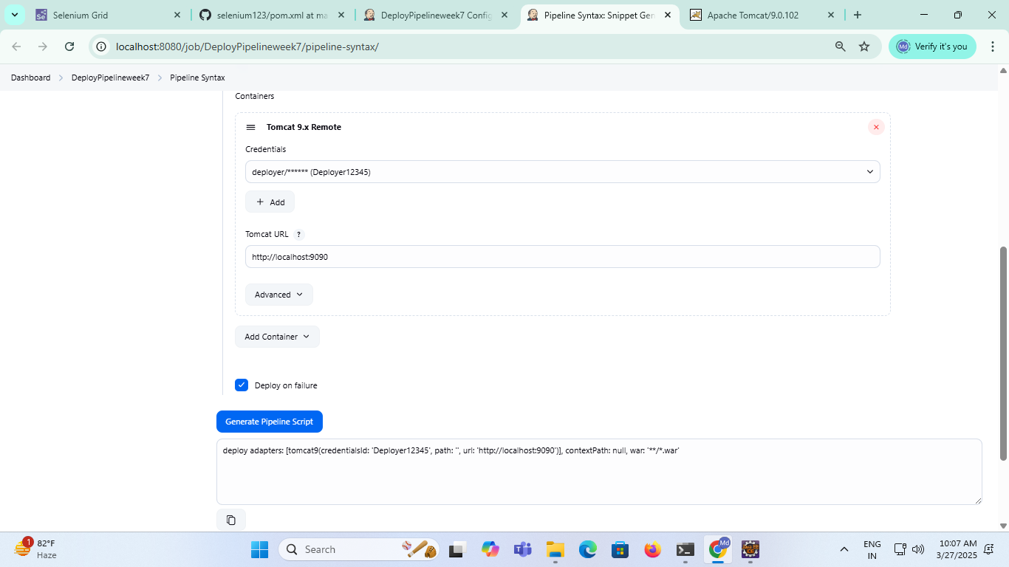



**Step 7:-** Build war File

1. Click Build now 🡪Go to 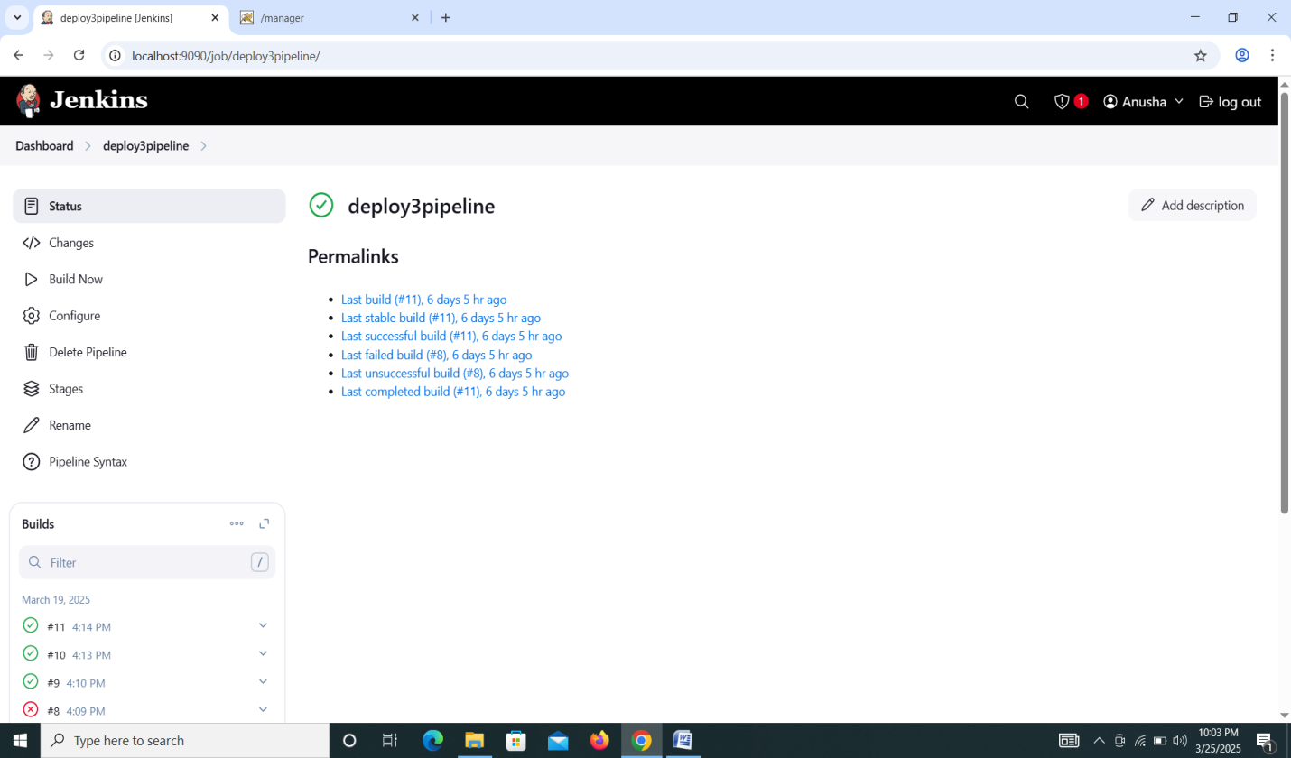Build select console output now you got Successfully Finish.

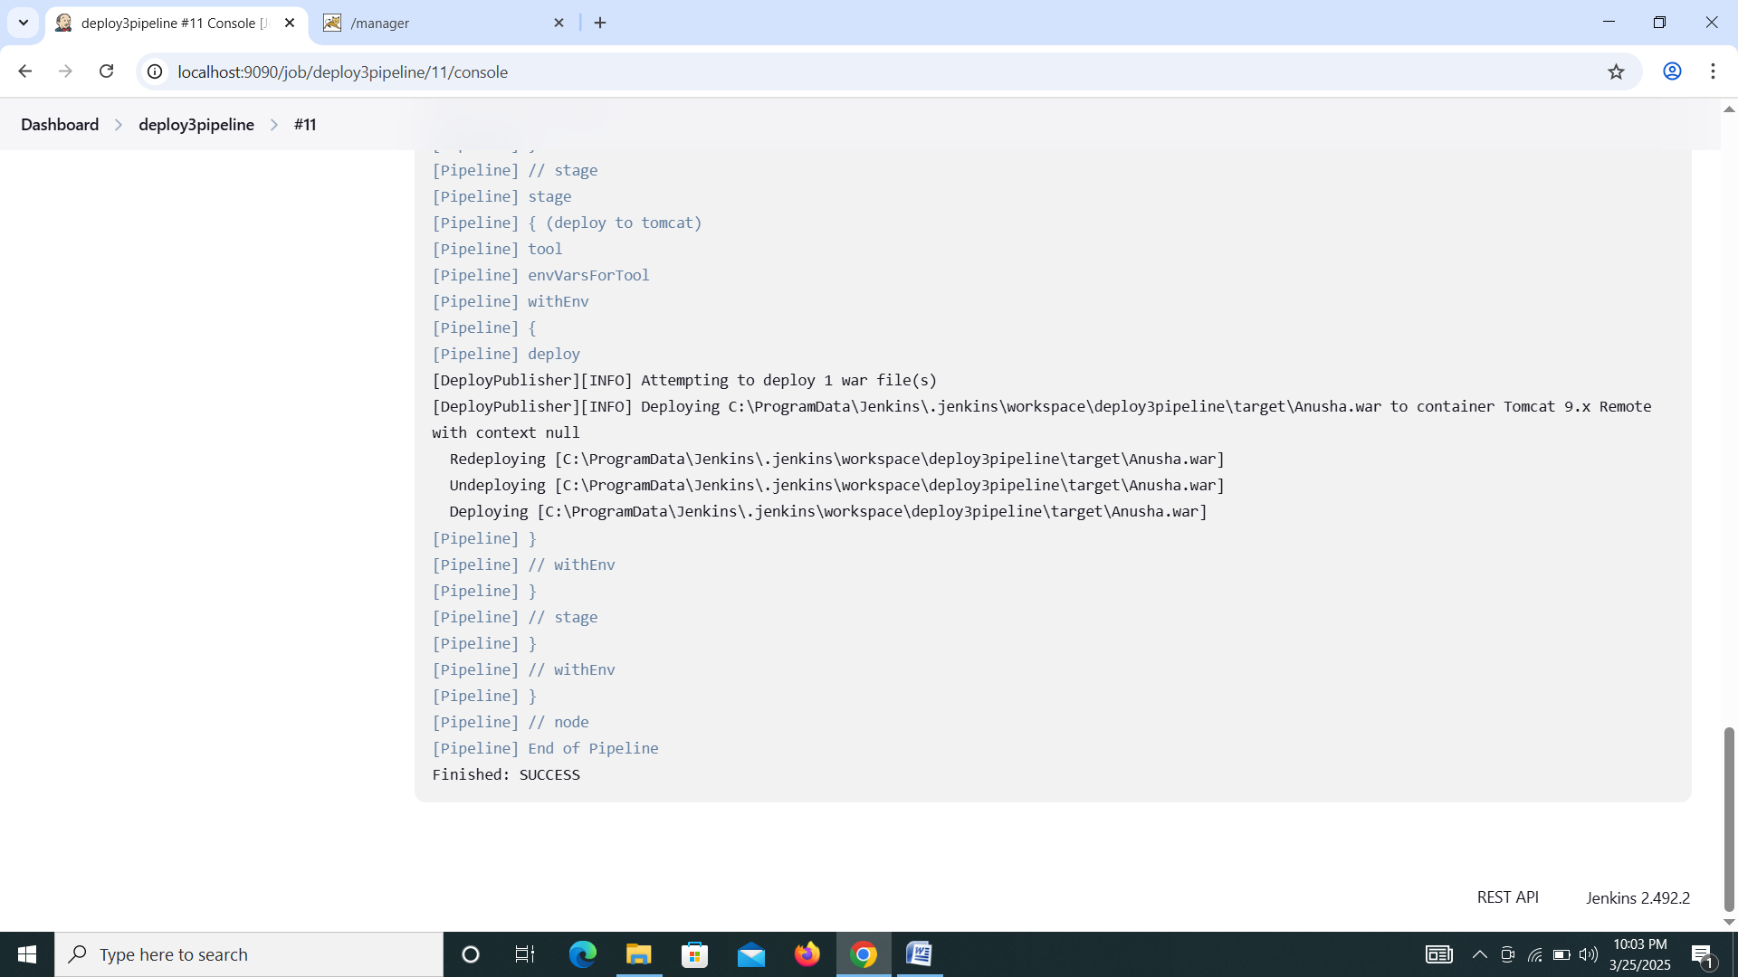

**Output:-**

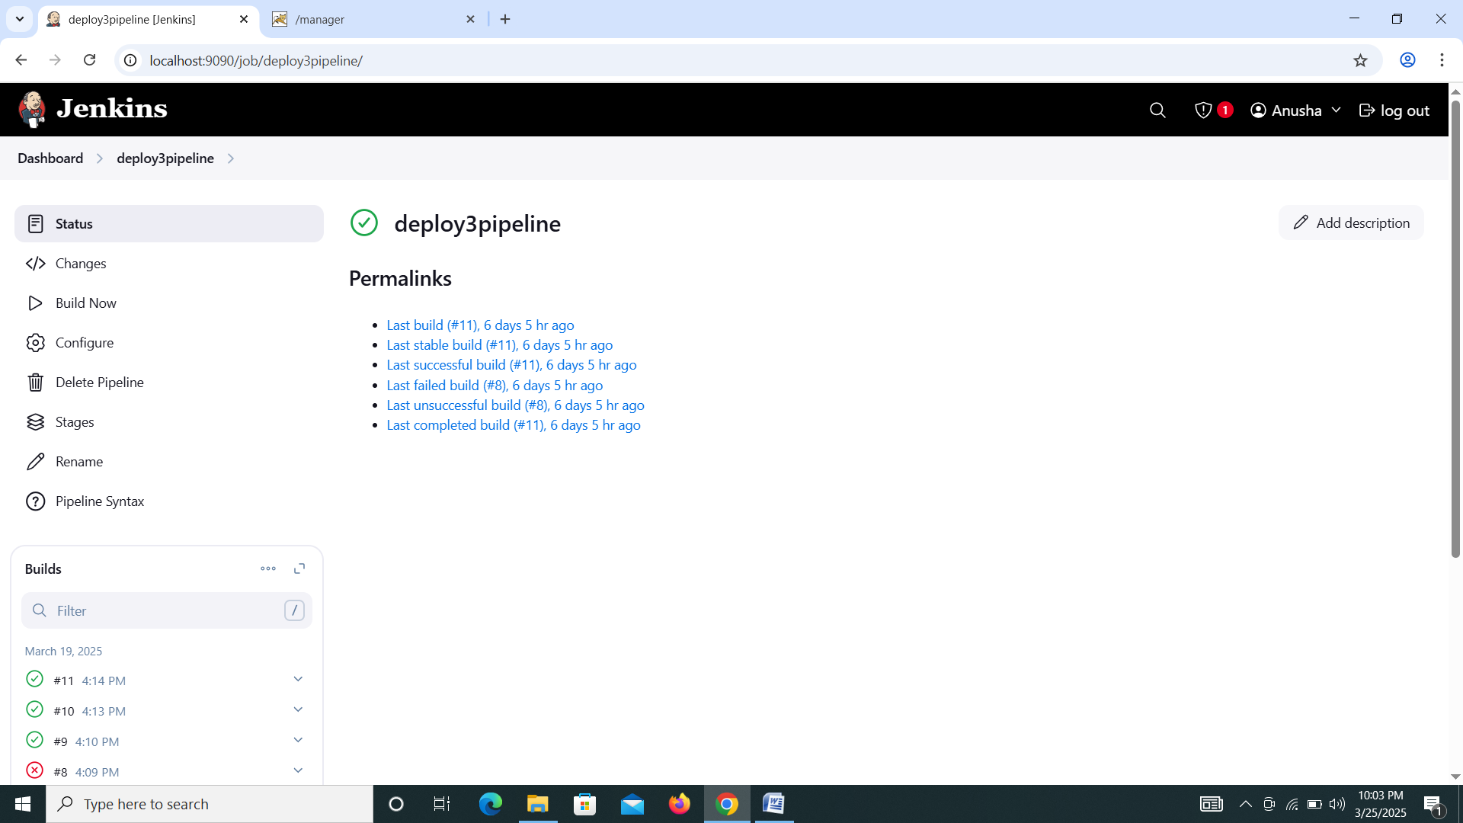



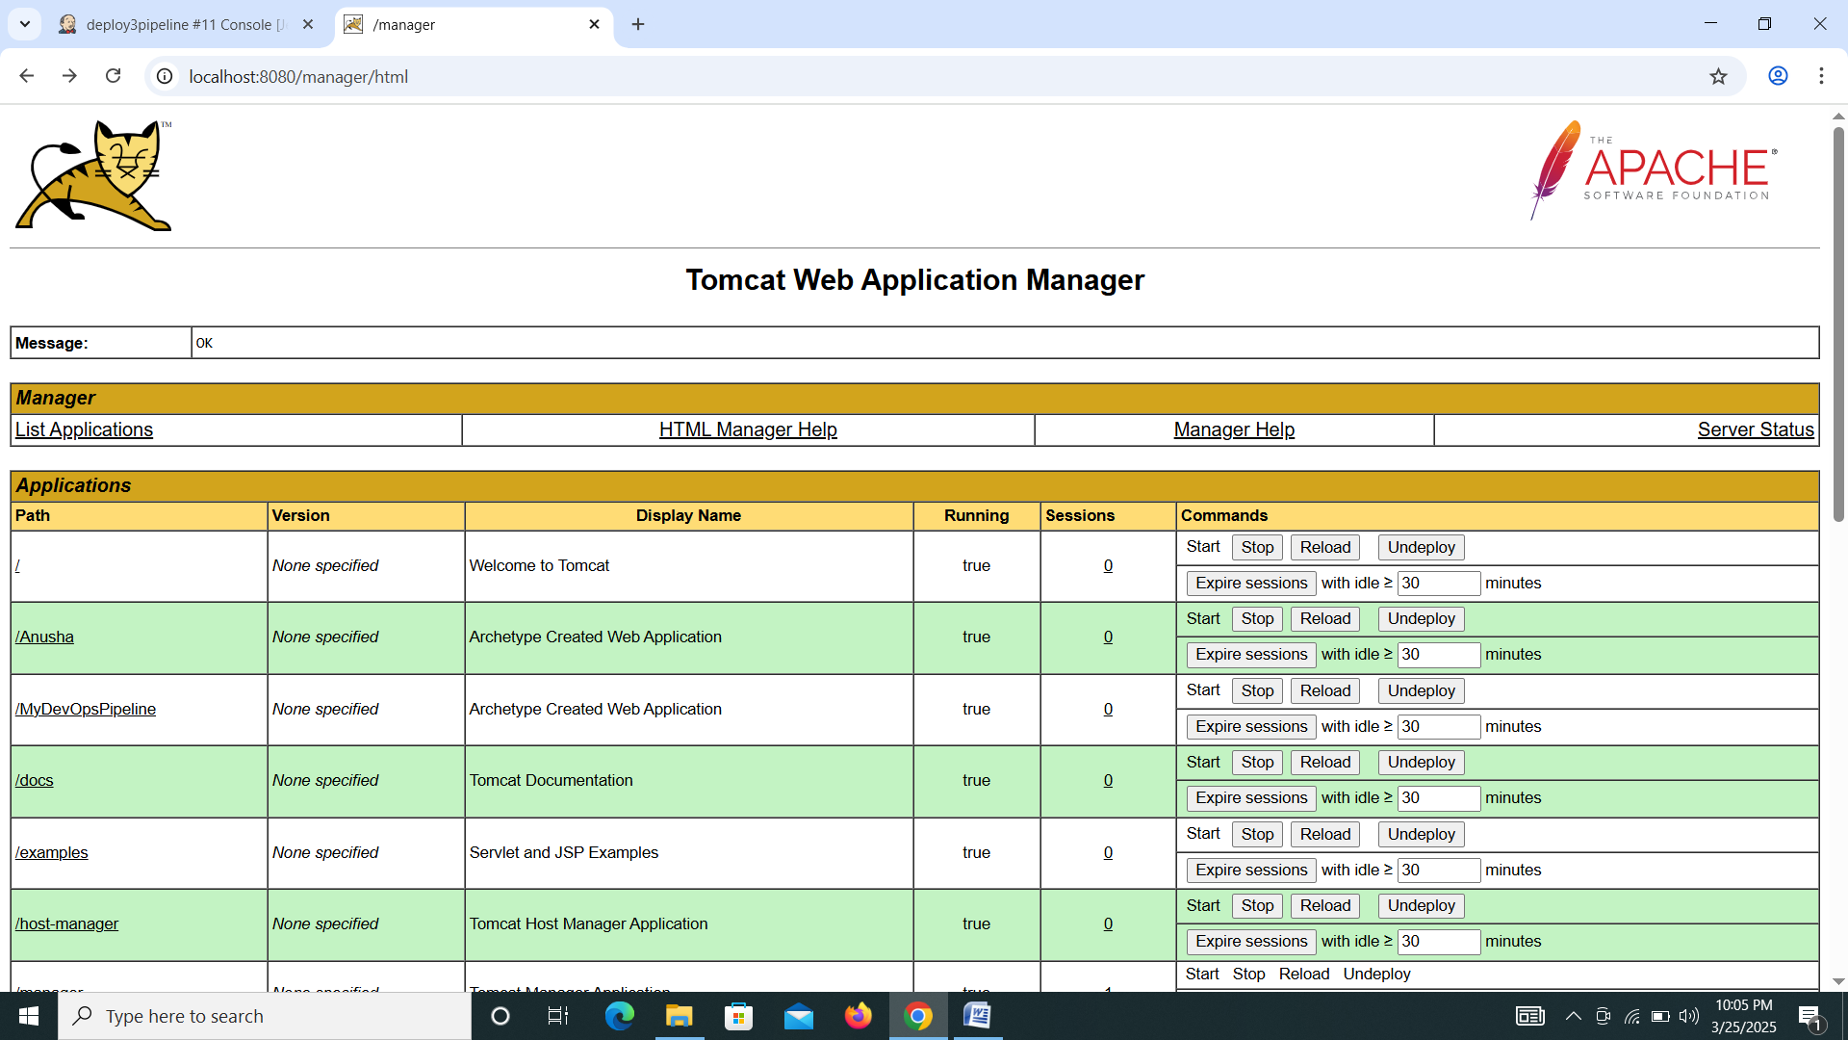

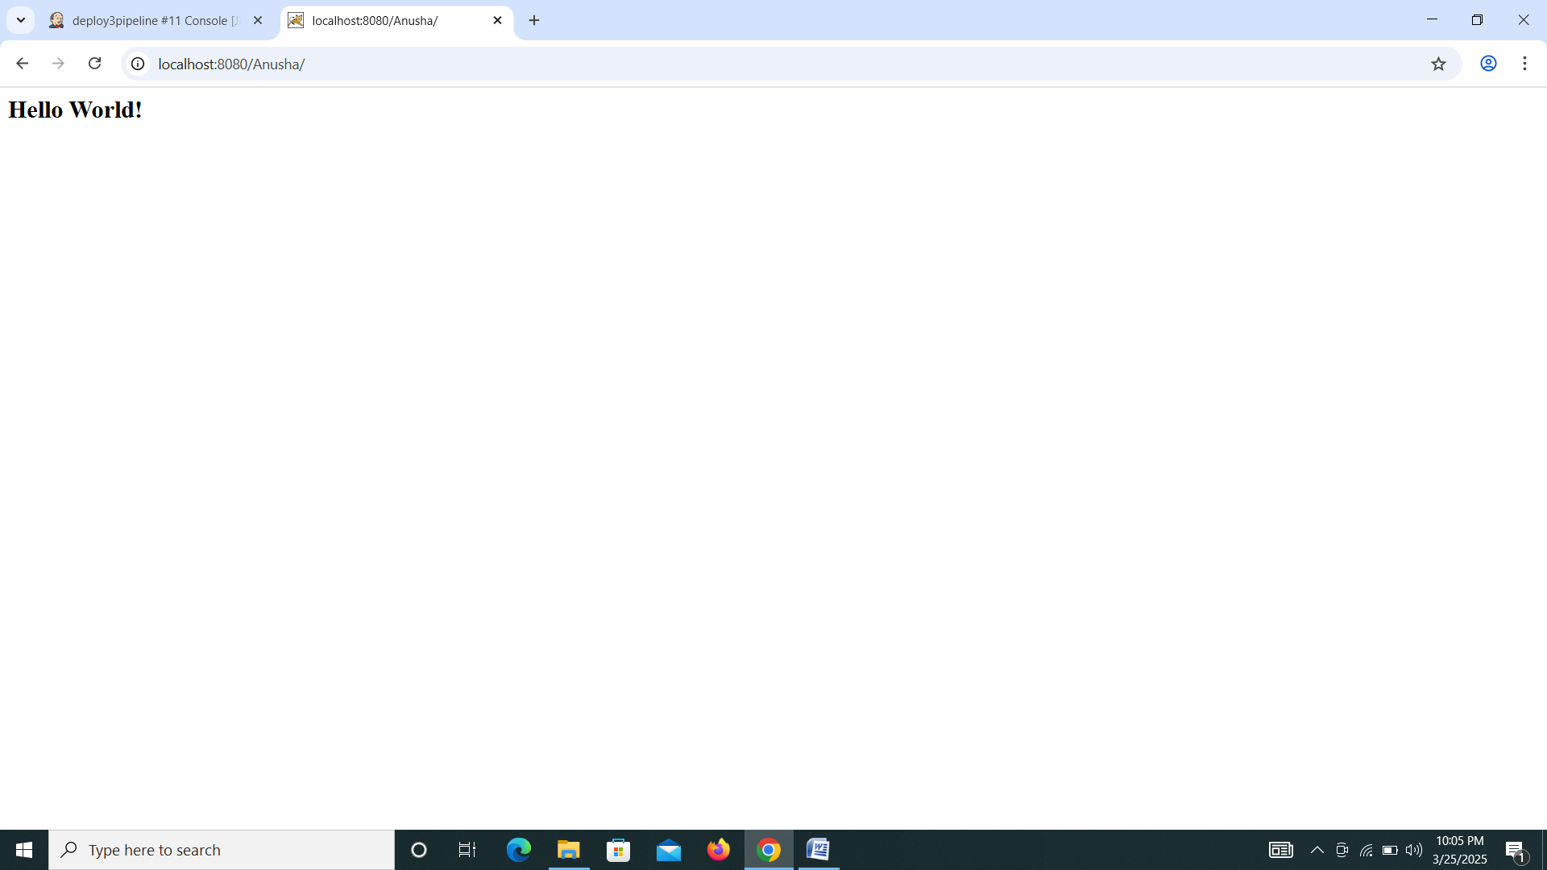

**Experiment 8**

**Week 8**

**AIM:-Build and deploy a grid for Chrome and Firefox based testing.**

**Step1:- Download Selenium Grid**

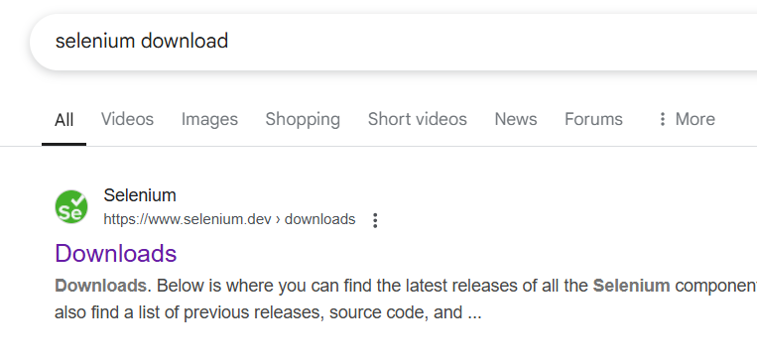

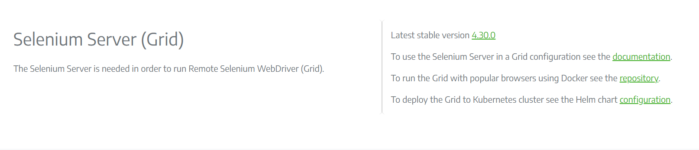

**Step2:-Download Chrome Driver**

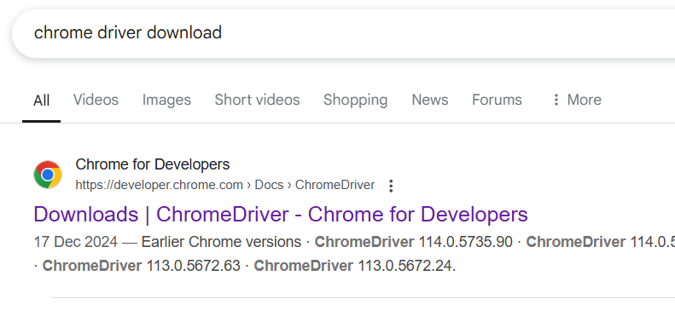

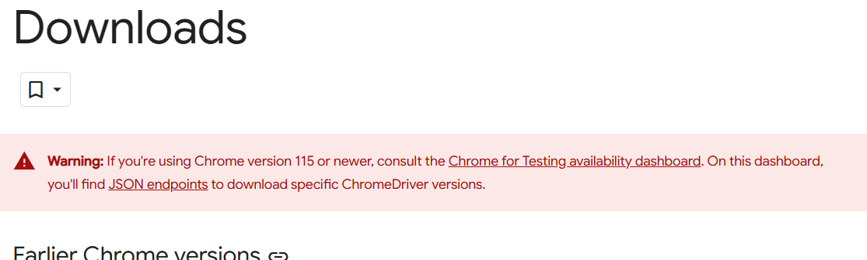

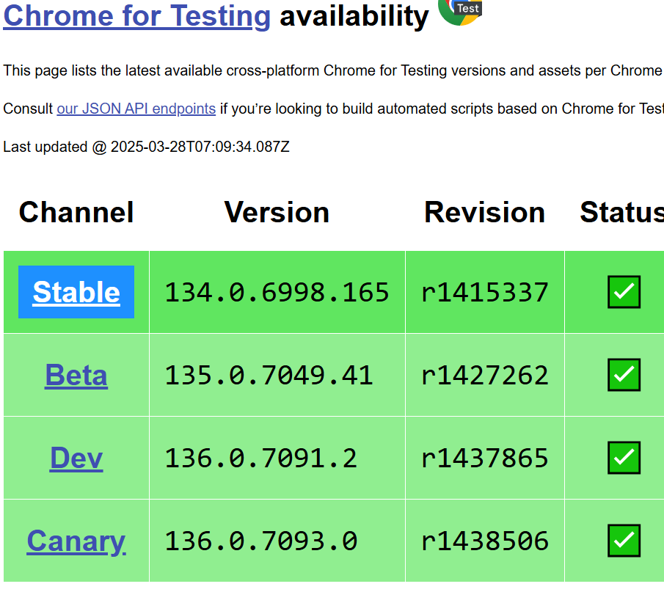

**Below picture address copy and paste it new tab. Automatically chrome driver downloded**

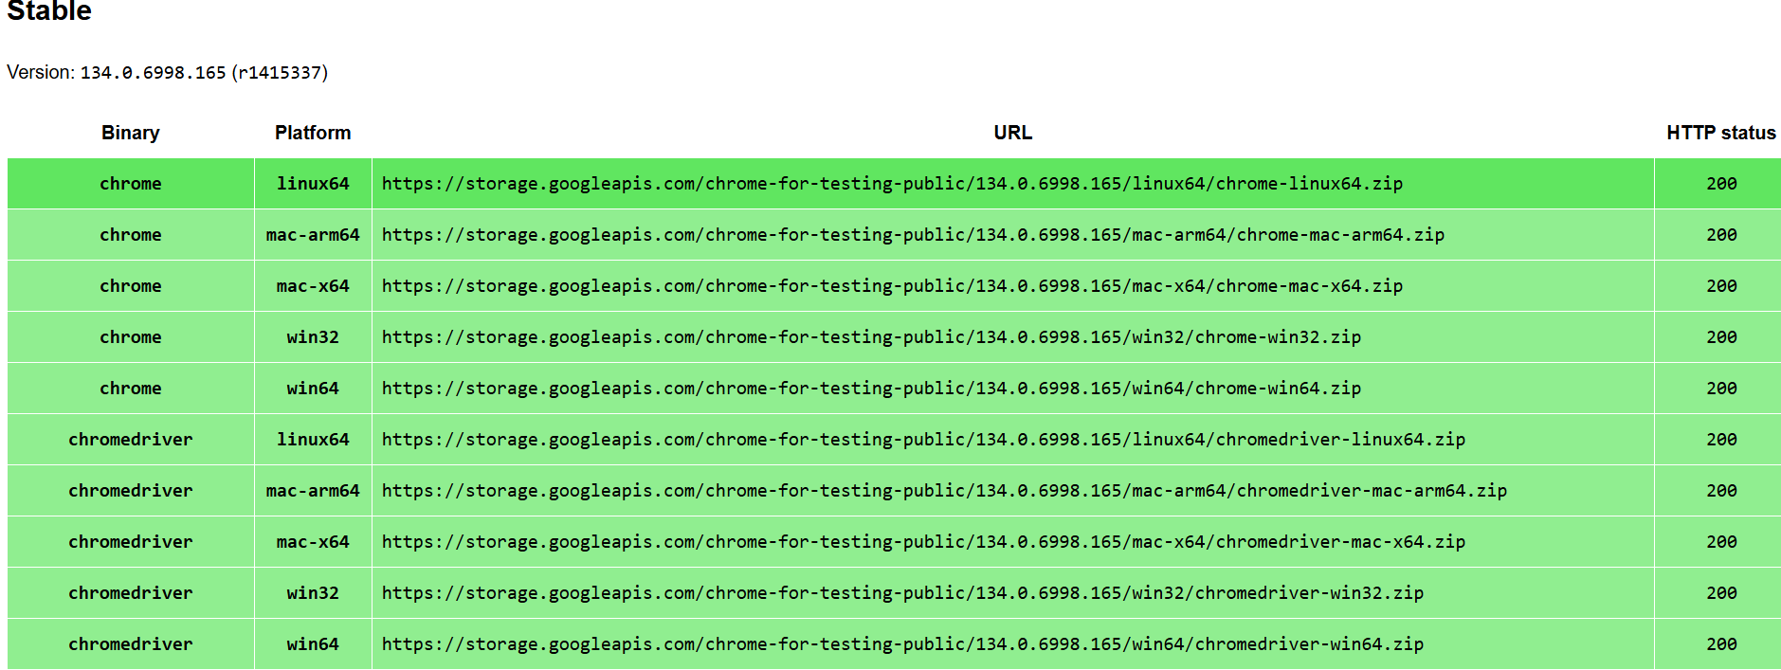

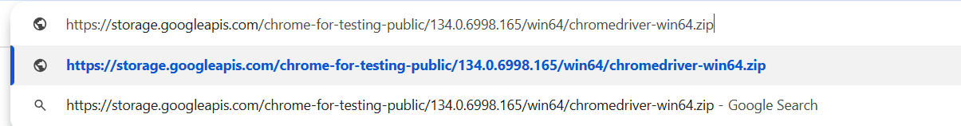

**Step3:-Download Gecko Driver**

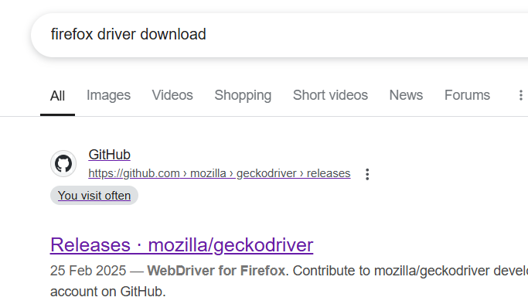

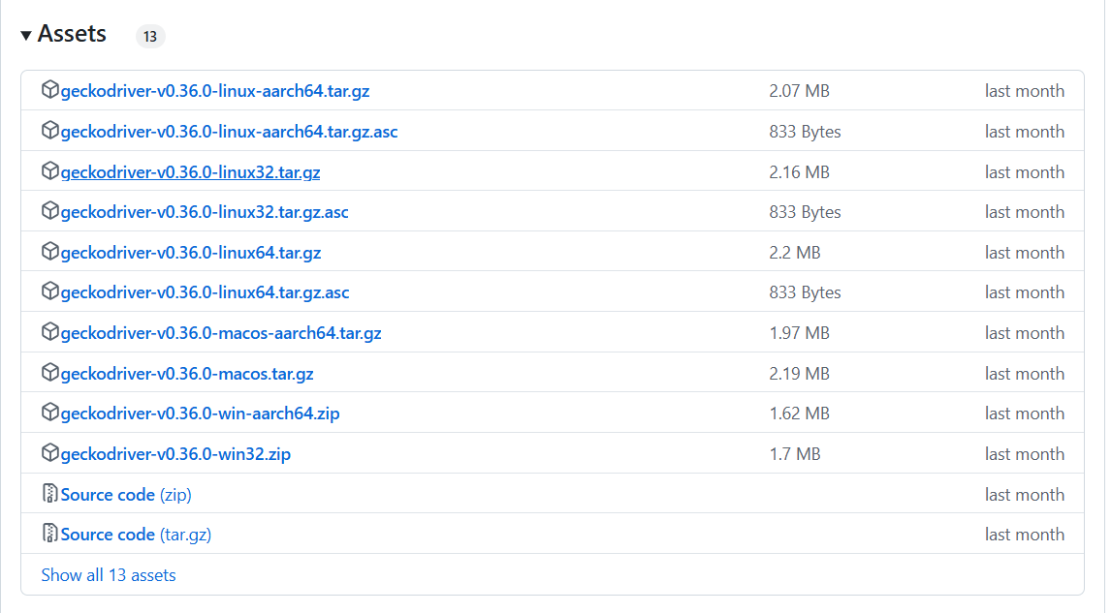

**Step 4:-Put all drivers one folder**

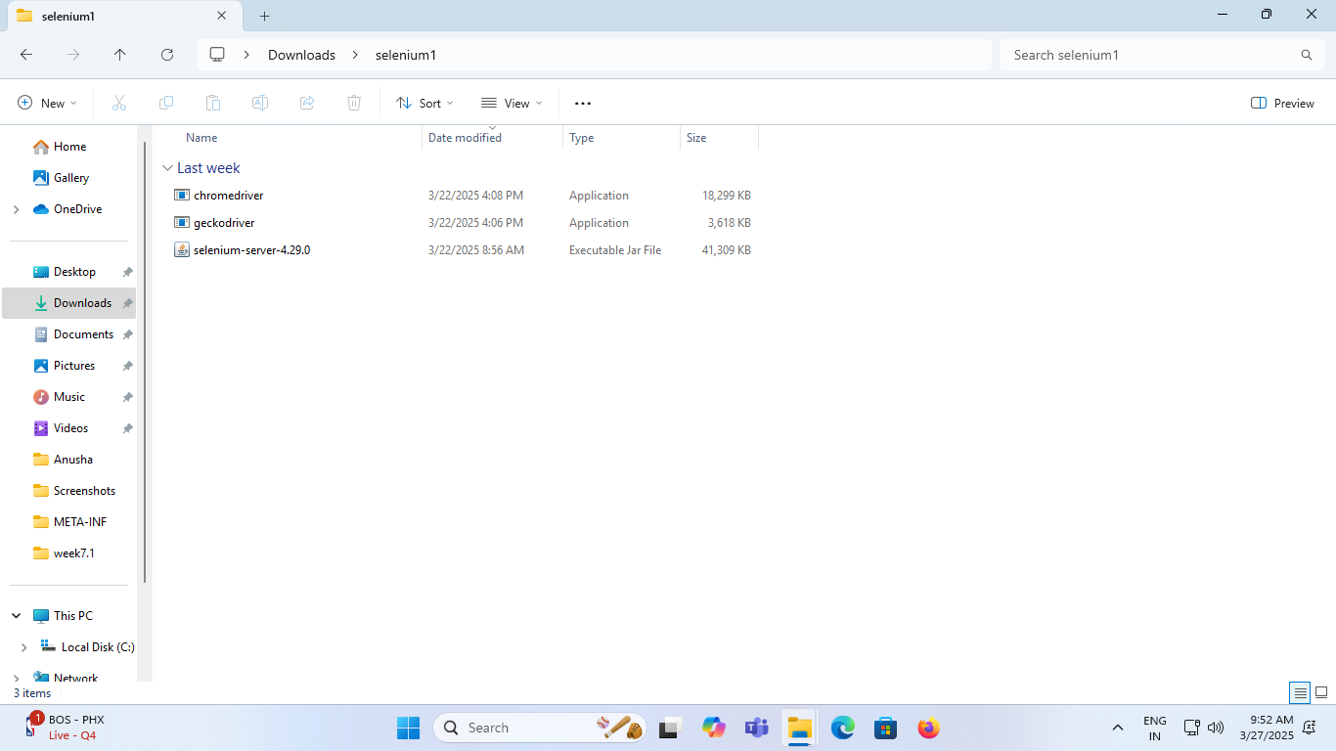

**Step 5:-Run hub use following command and node also separate cmd. In cmd change directory where available all drivers**

1. java -jar selenium-server-4.29.0.jar hub
2. java -jar selenium-server-4.29.0.jar node --detect-drivers true

**Also run chrome using ip address path it will generate after running hub and verify**

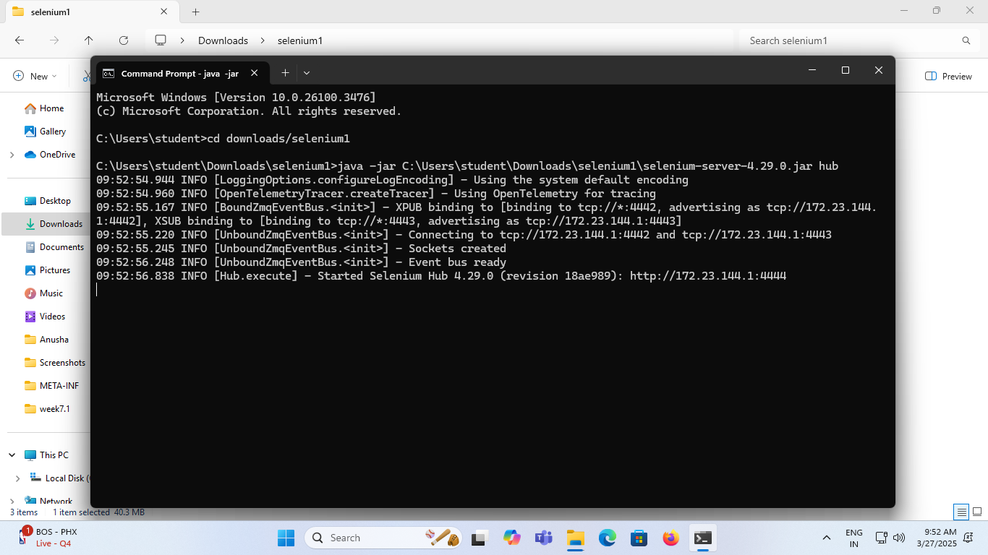

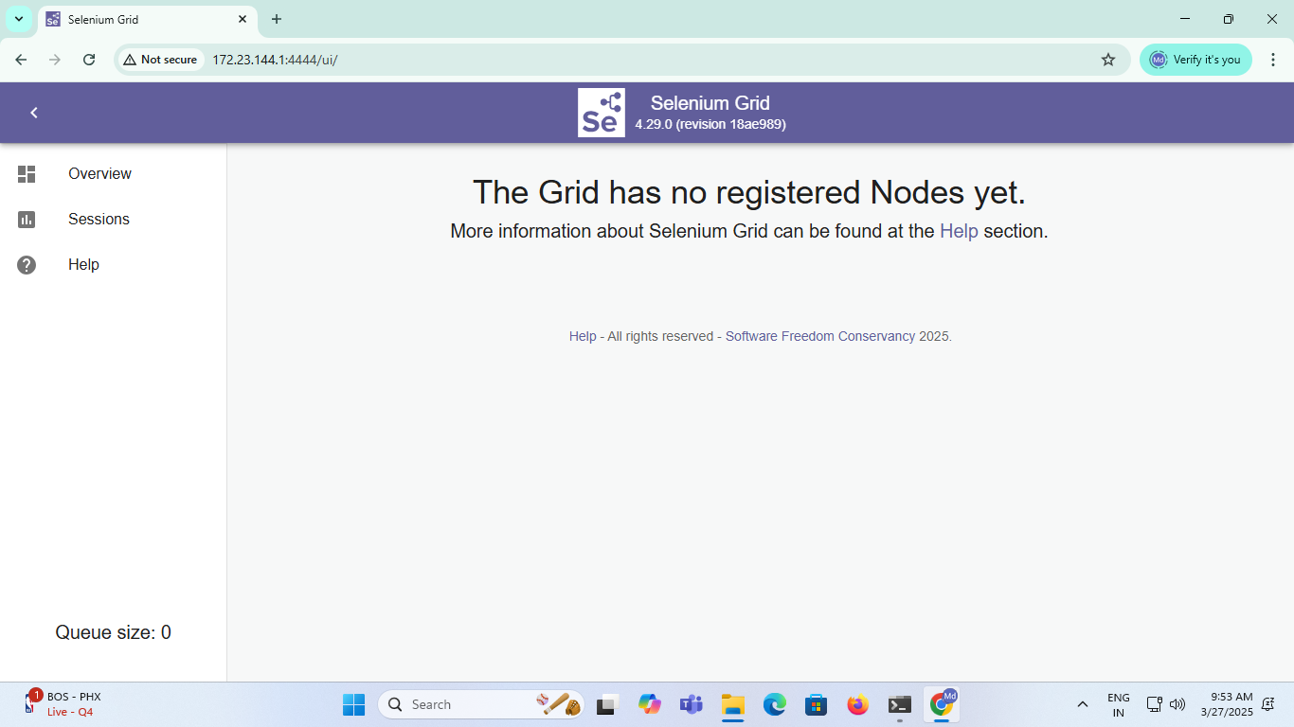

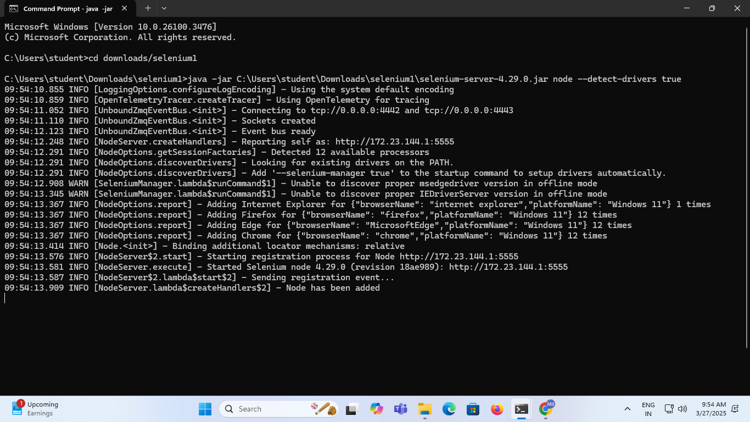

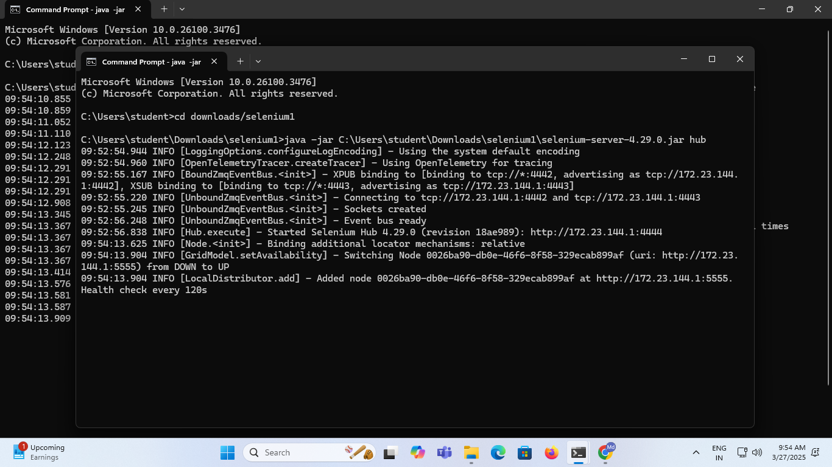

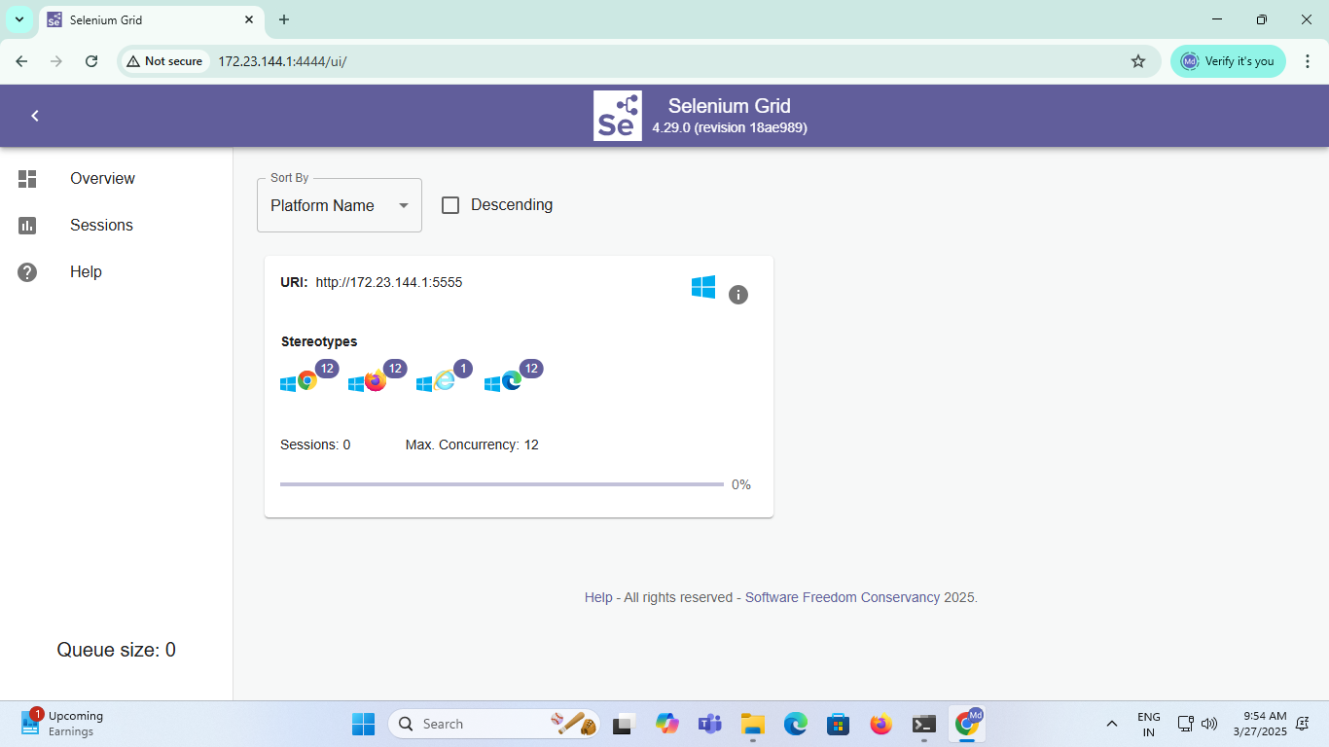

**Step 6:-Open Eclipse Attach Apache Tomcat and TestNG**

1. **Store Apache and eclipse folders only single folder and lunch Eclipse same folder**

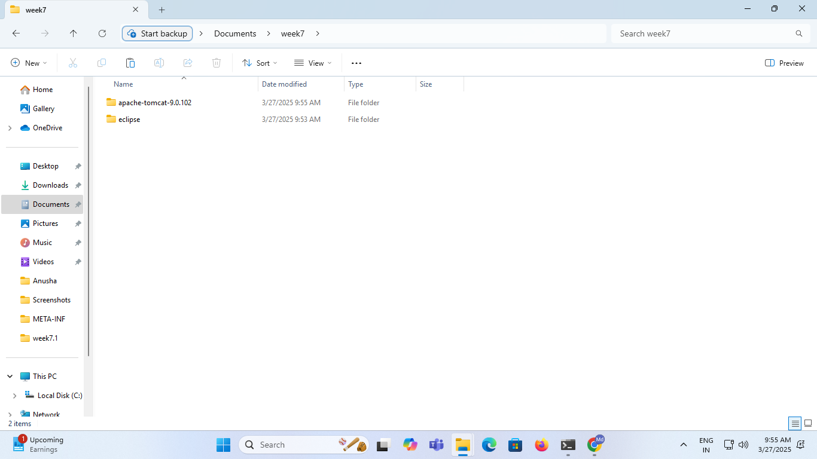

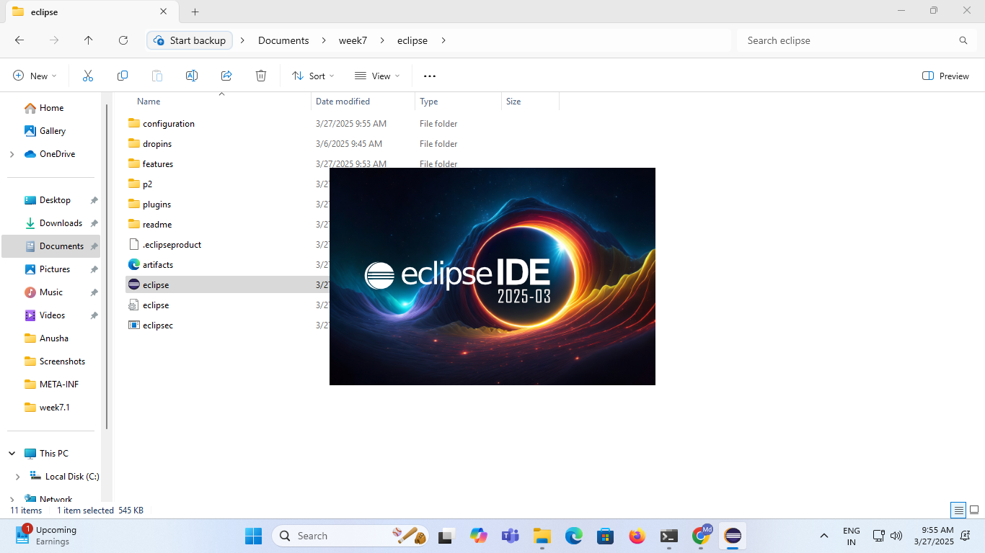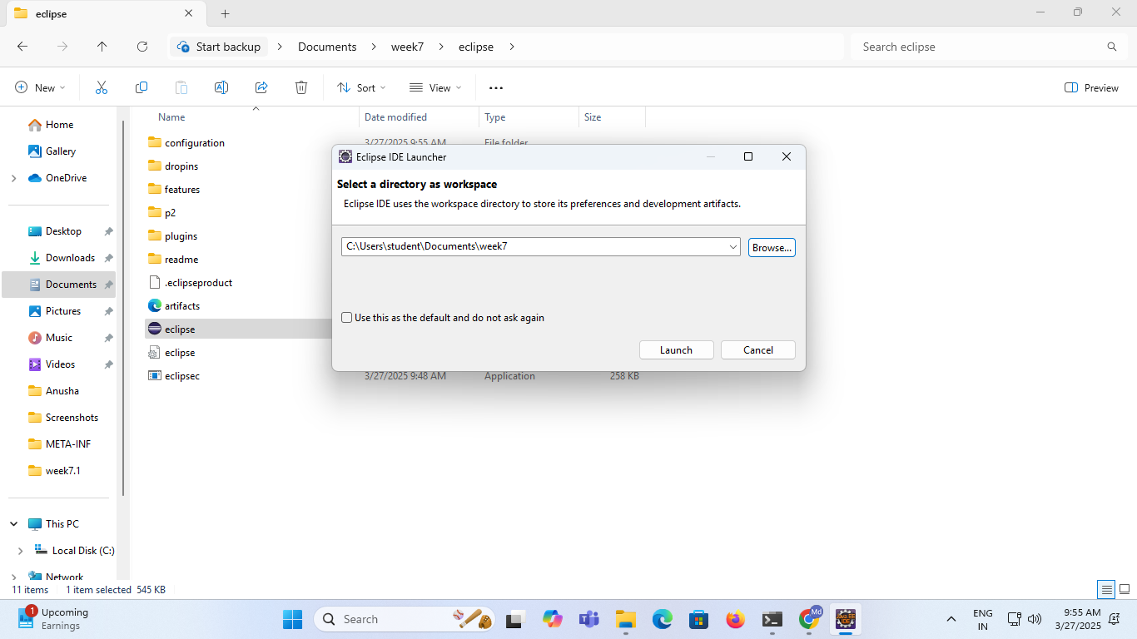

**3.Create maven project goto File🡪New🡪Maven Project Select🡪Next🡪select org.apache.maven.archetypes select webapp🡪Enter Group Id:week7 ArtifactId:selenium Package:war🡪Finish. Enter Y you get Build Success in console.** 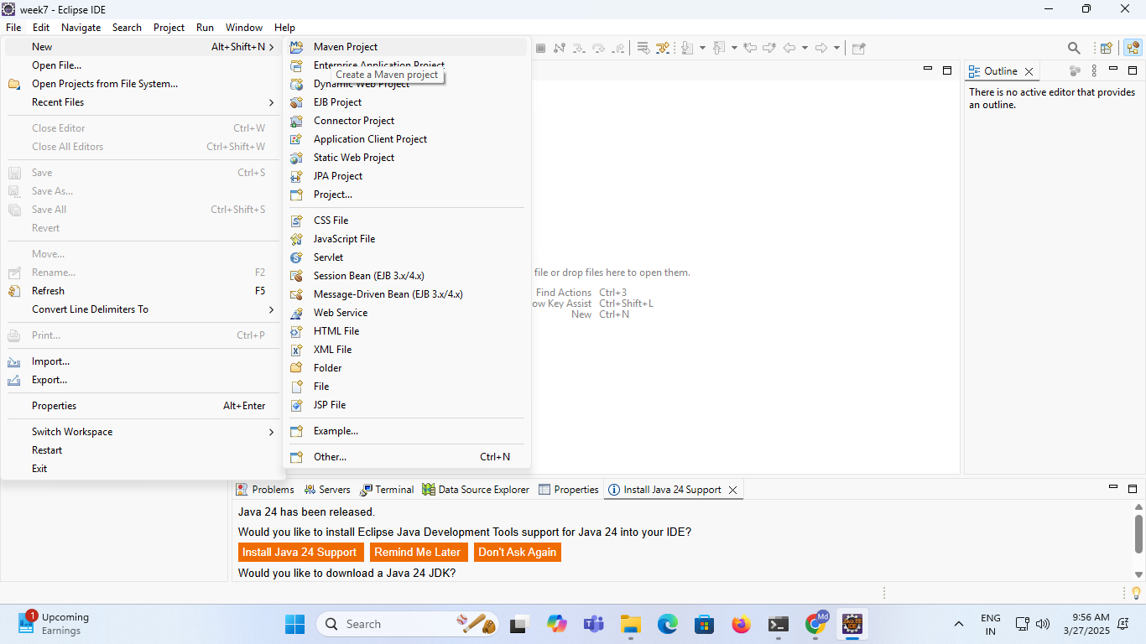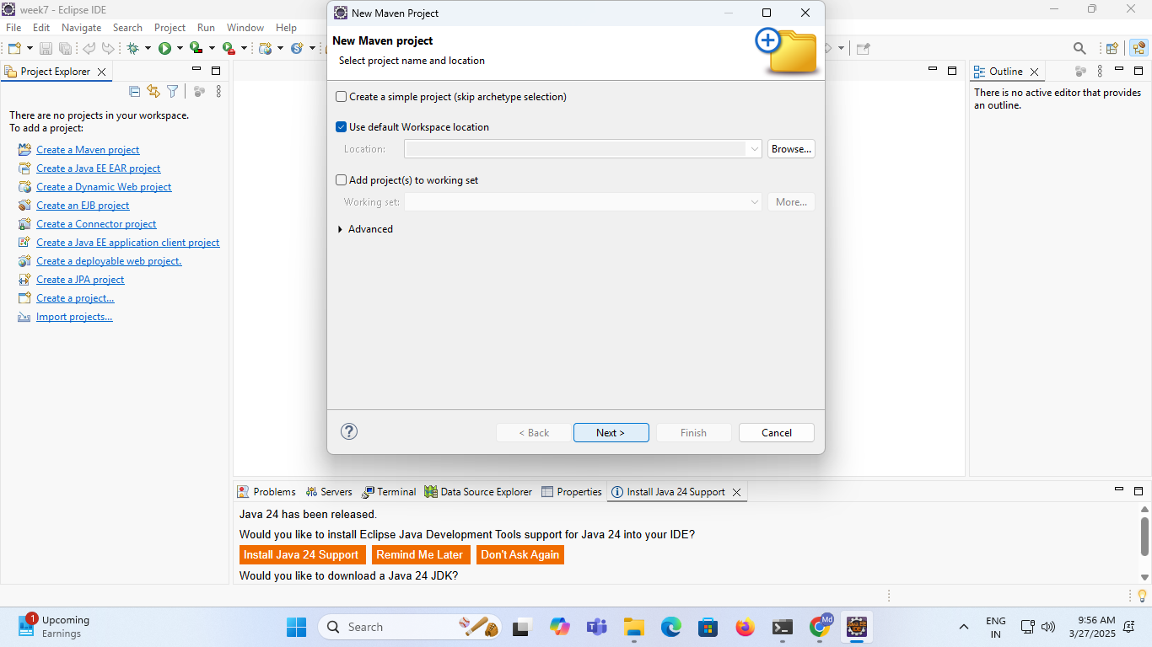

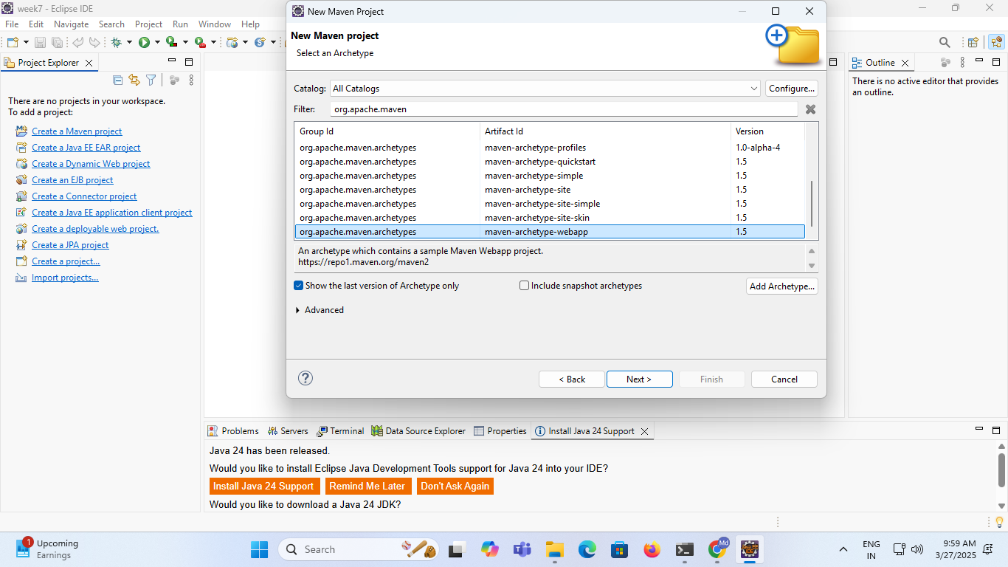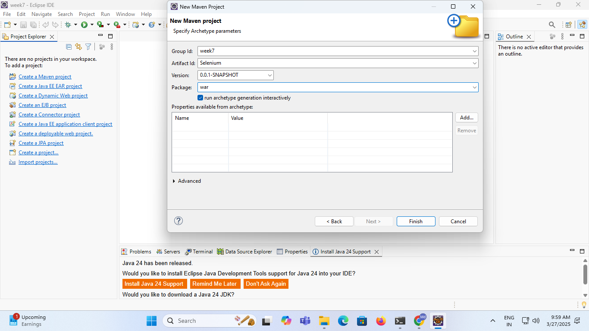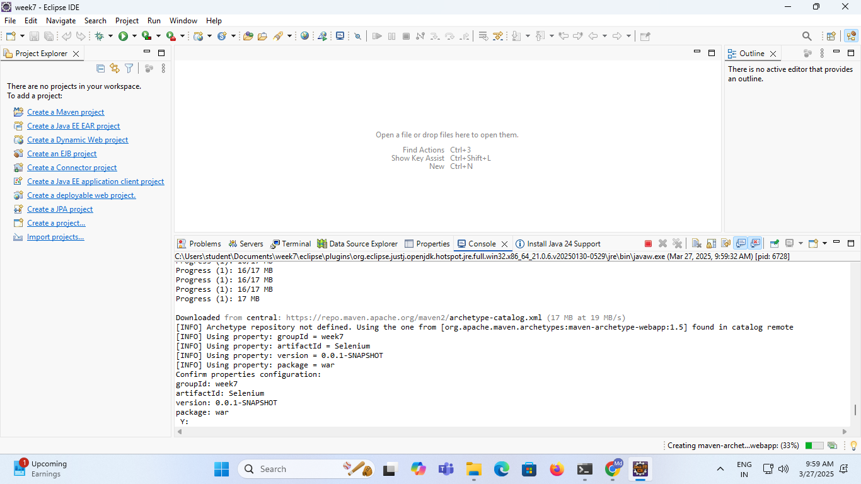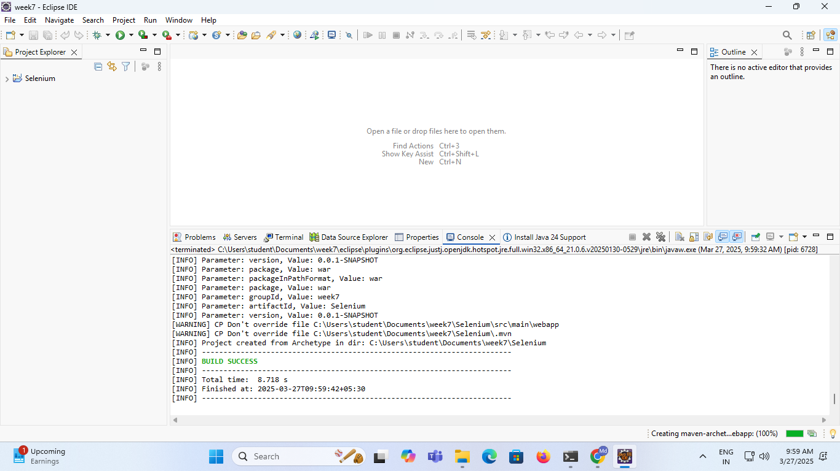

1. **Open Pom.xml copy paste below code this all I added dependies and plugins. Next Right click Project🡪Maven🡪Update project🡪ok.**

**(Note:If you not update every changes it will not save.)**

**<project xmlns="http://maven.apache.org/POM/4.0.0"**

**xmlns:xsi="http://www.w3.org/2001/XMLSchema-instance"**

**xsi:schemaLocation="http://maven.apache.org/POM/4.0.0 http://maven.apache.org/maven-v4_0_0.xsd">**

**<modelVersion>4.0.0</modelVersion>**

**<groupId>DevOps</groupId>**

**<artifactId>MyDevPipeline</artifactId>**

**<packaging>war</packaging>**

**<version>0.0.1-SNAPSHOT</version>**

**<name>MyDevPipeline Maven Webapp</name>**

**<url>http://maven.apache.org</url>**

**<dependencies>**

**<dependency>**

**<groupId>junit</groupId>**

**<artifactId>junit</artifactId>**

**<version>3.8.1</version>**

**<scope>test</scope>**

**</dependency>**

**<!-- https://mvnrepository.com/artifact/javax.servlet/javax.servlet-api -->**

**<dependency>**

**<groupId>javax.servlet</groupId>**

**<artifactId>javax.servlet-api</artifactId>**

**<version>3.1.0</version>**

**<scope>provided</scope>**

**</dependency>**

**<!--**

**https://mvnrepository.com/artifact/org.seleniumhq.selenium/selenium-api -->**

**<dependency>**

**<groupId>org.seleniumhq.selenium</groupId>**

**<artifactId>selenium-server</artifactId>**

**<version>3.141.59</version>**

**</dependency>**

**<!-- https://mvnrepository.com/artifact/org.testng/testng -->**

**<dependency>**

**<groupId>org.testng</groupId>**

**<artifactId>testng</artifactId>**

**<version>6.14.3</version> <!-- Use the latest version available(7.11.0) -->**

**<scope>test</scope>**

**</dependency>**

**<dependency>**

**<groupId>io.github.bonigarcia</groupId>**

**<artifactId>webdrivermanager</artifactId>**

**<version>5.3.0</version>**

**</dependency>**

**</dependencies>**

**<build>**

**<finalName>MyDevPipeline</finalName>**

**<pluginManagement>**

**<plugins>**

**<plugin>**

**<groupId>org.apache.maven.plugins</groupId>**

**<artifactId>maven-clean-plugin</artifactId>**

**<version>3.4.0</version>**

**</plugin>**

**<plugin>**

**<groupId>org.apache.maven.plugins</groupId>**

**<artifactId>maven-resources-plugin</artifactId>**

**<version>3.3.1</version>**

**</plugin>**

**<plugin>**

**<groupId>org.apache.maven.plugins</groupId>**

**<artifactId>maven-compiler-plugin</artifactId>**

**<version>3.13.0</version>**

**<configuration>**

**<source>17.0.12</source>**

**<target>17.0.12</target>**

**</configuration>**

**</plugin>**

**<plugin>**

**<groupId>org.apache.maven.plugins</groupId>**

**<artifactId>maven-surefire-plugin</artifactId>**

**<version>3.3.0</version>**

**</plugin>**

**<plugin>**

**<groupId>org.apache.maven.plugins</groupId>**

**<artifactId>maven-war-plugin</artifactId>**

**<version>3.4.0</version>**

**</plugin>**

**<plugin>**

**<groupId>org.apache.maven.plugins</groupId>**

**<artifactId>maven-install-plugin</artifactId>**

**<version>3.1.2</version>**

**</plugin>**

**<plugin>**

**<groupId>org.apache.maven.plugins</groupId>**

**<artifactId>maven-deploy-plugin</artifactId>**

**<version>3.1.2</version>**

**</plugin>**

**</plugins>**

**</pluginManagement>**

**</build>**

**</project>**

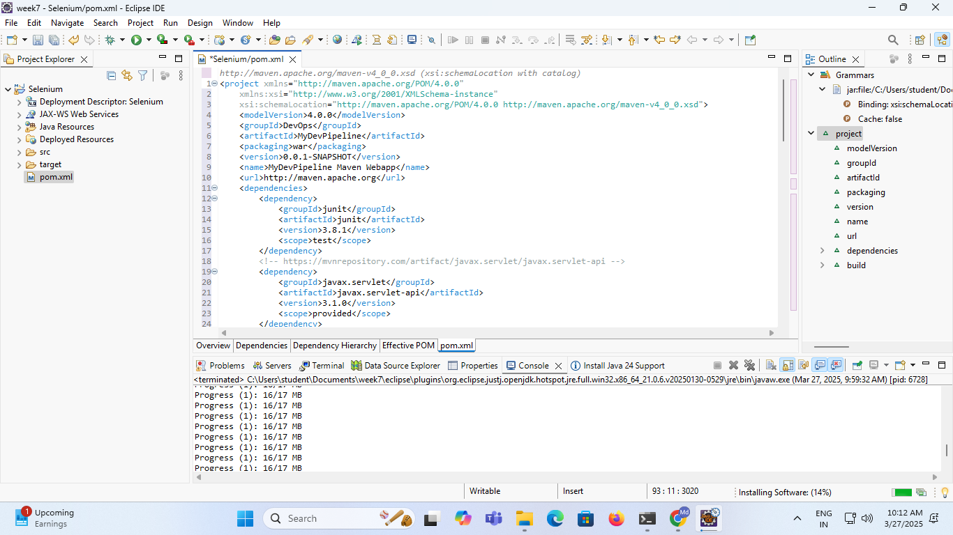

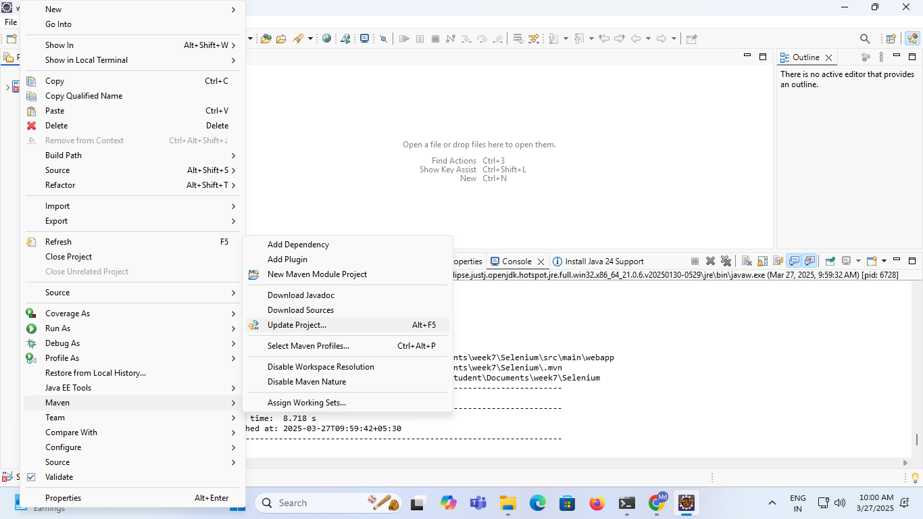

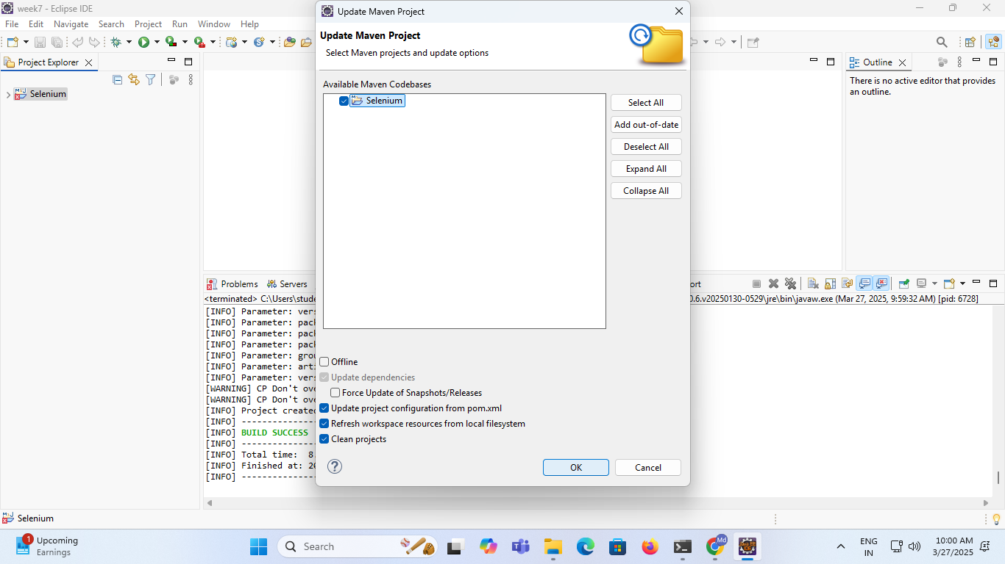

**4.Adding Apache tomcat server**

**Go to Project🡪Properties🡪Maven🡪Targeted Runtimes🡪new🡪select apache tomcat 9🡪next🡪browse apache folder address🡪finish🡪click check box apache 9 and apply🡪apply and close.**

**(Note:-because running src🡪index.js file running purpose if you not adding it will show errors.)**

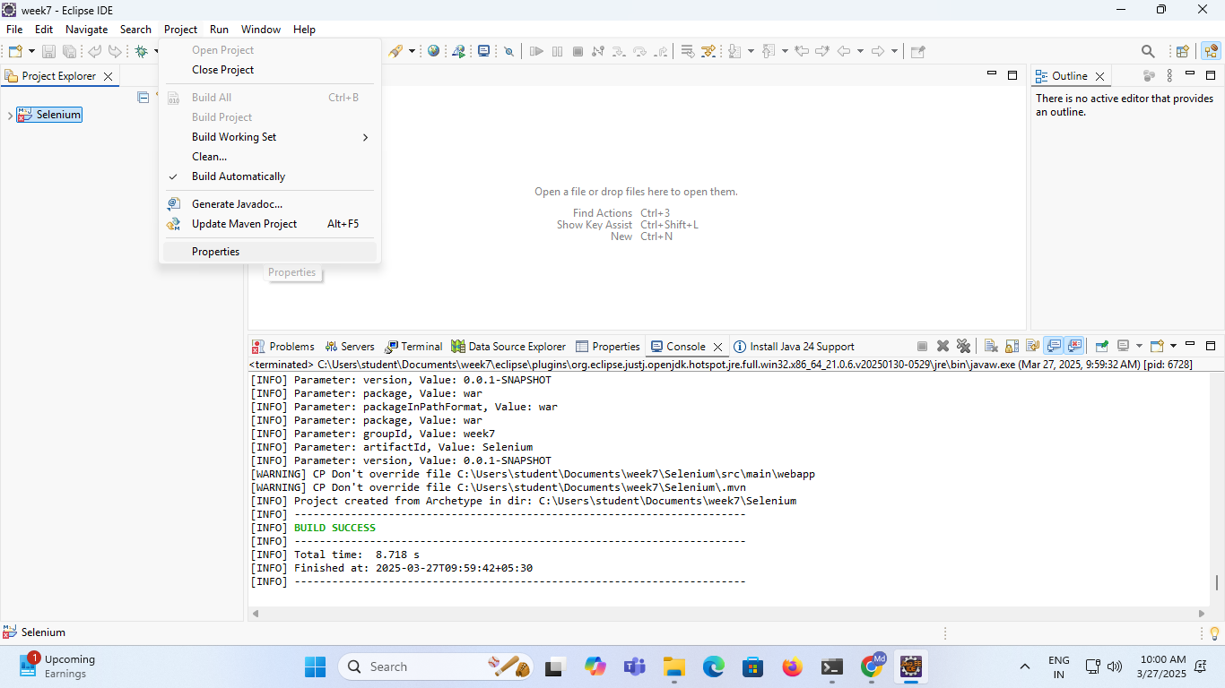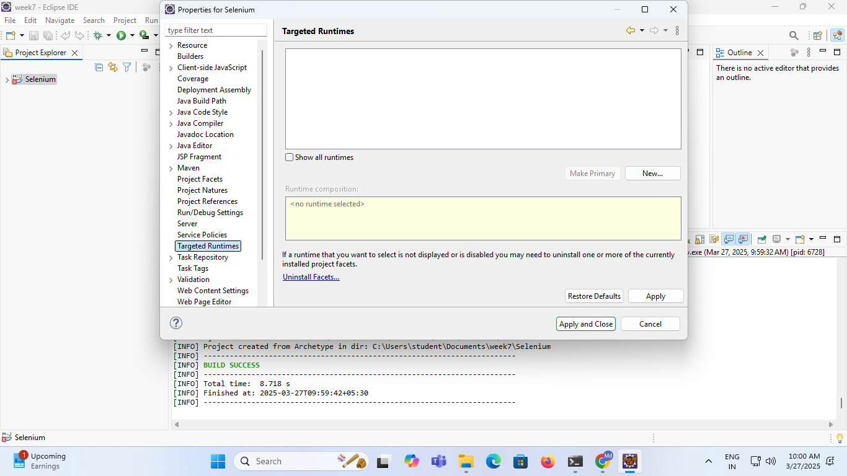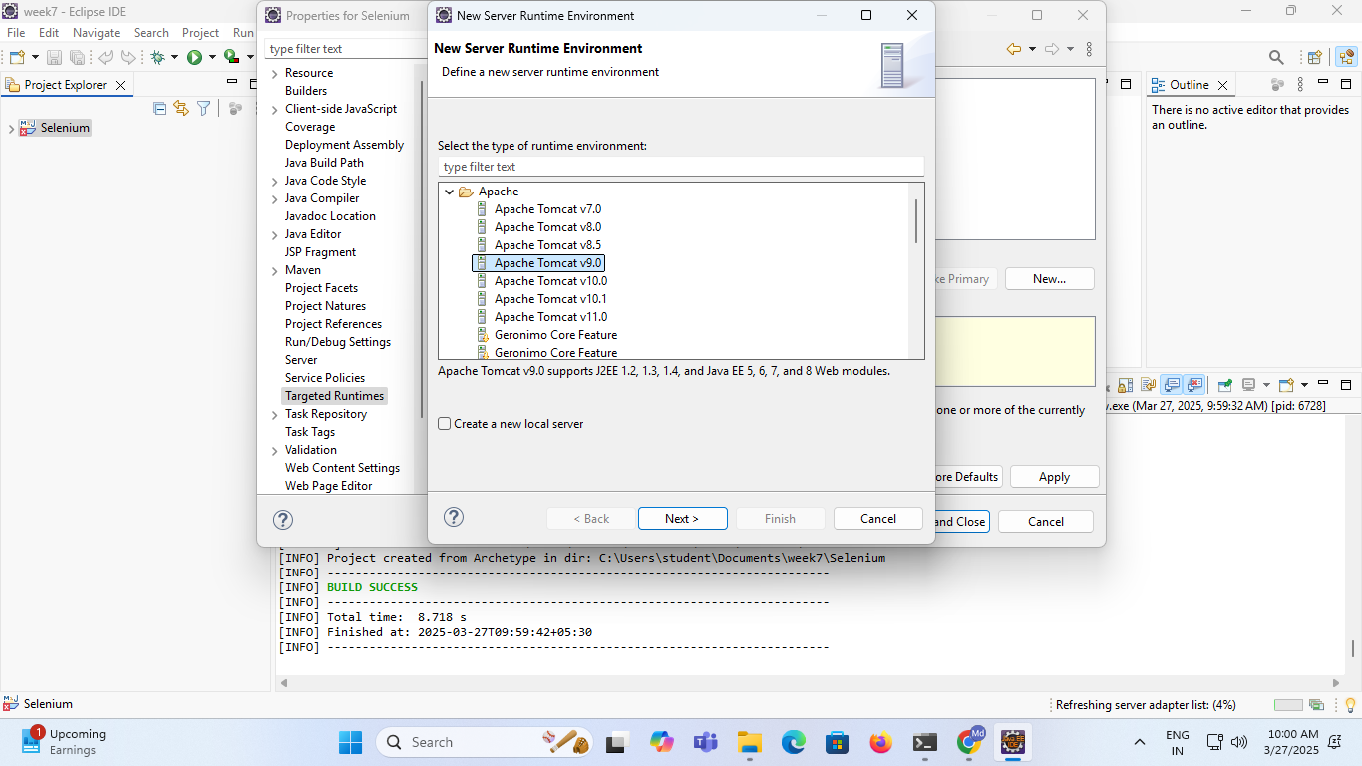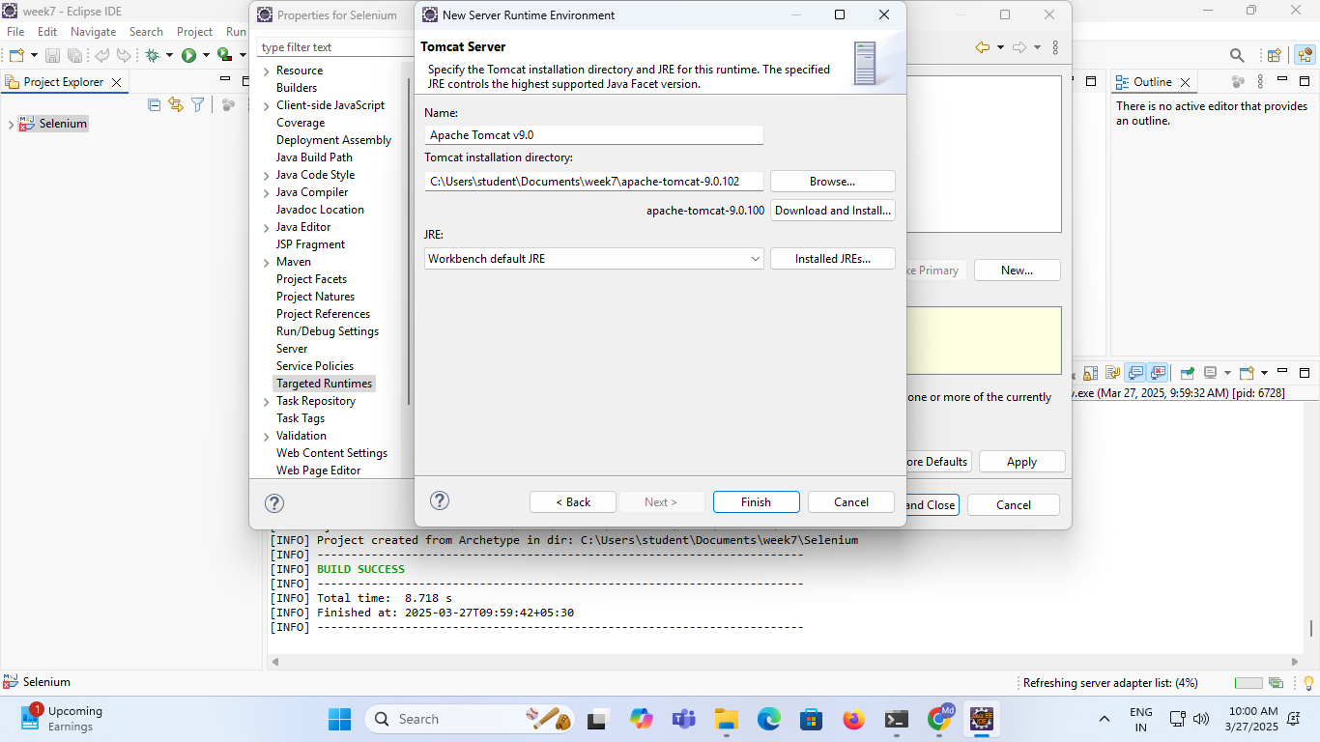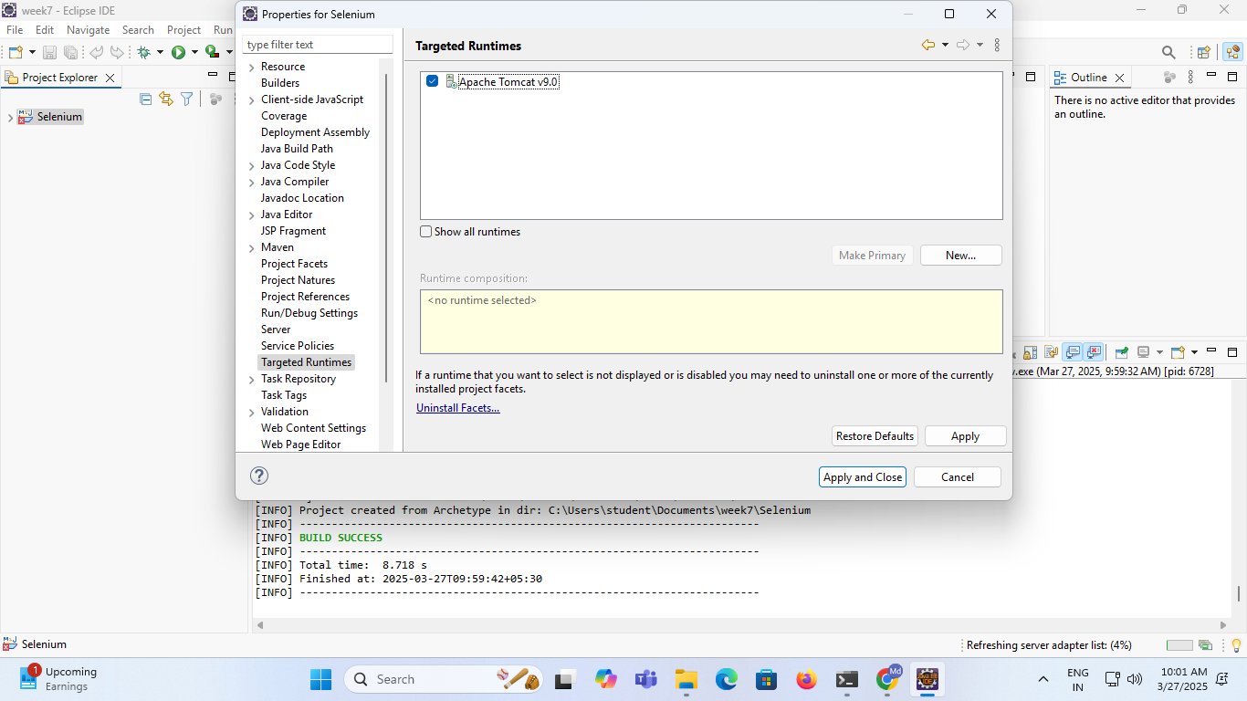

1. **Adding TestNG in Eclipse.**

**Go to help🡪Install New Software🡪Add🡪Enter Name:TestNG, Location:https://testng.org/testing-eclipse-update-site/🡪Add.**

**Select TestNG check box🡪Next🡪Next🡪I accept🡪Finish**

**Trust Selected🡪Trust Selected.**

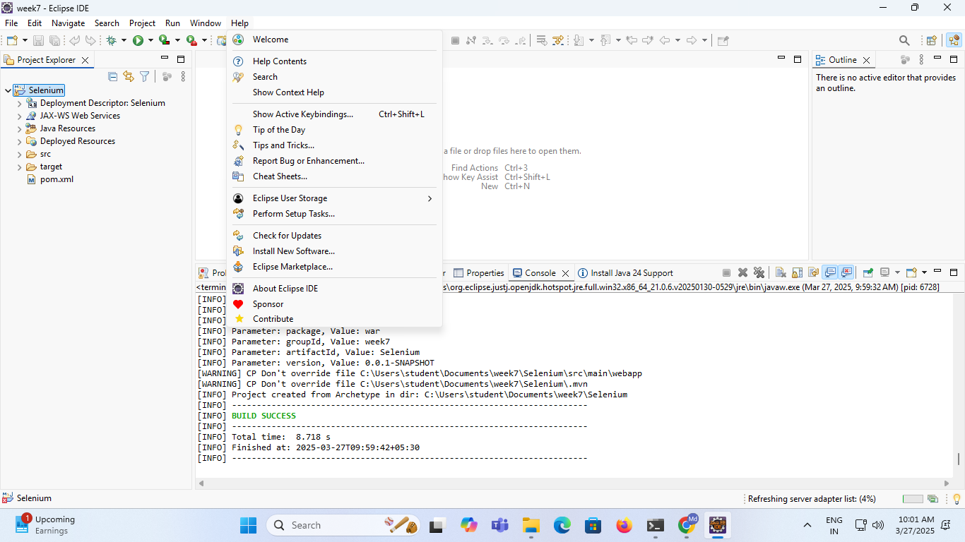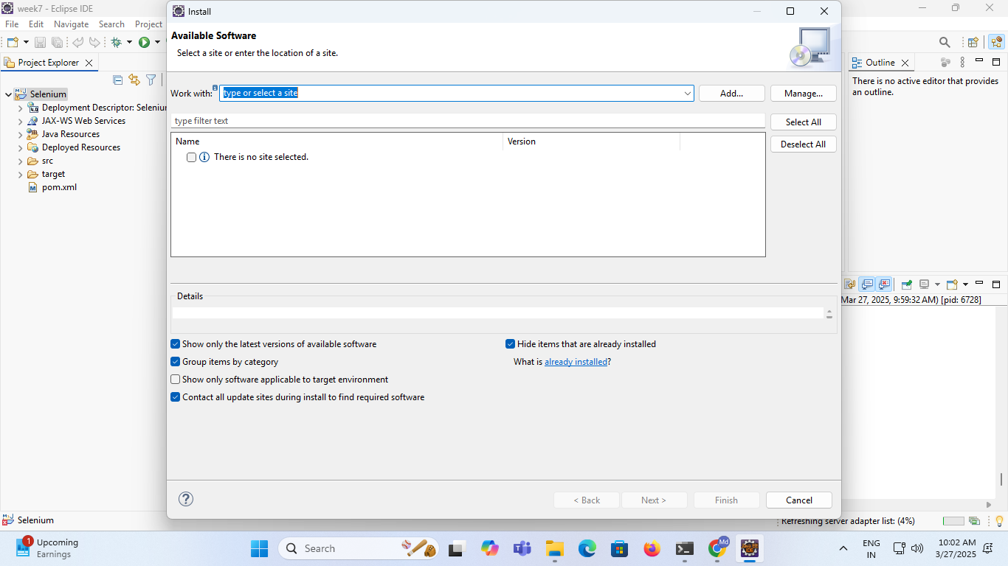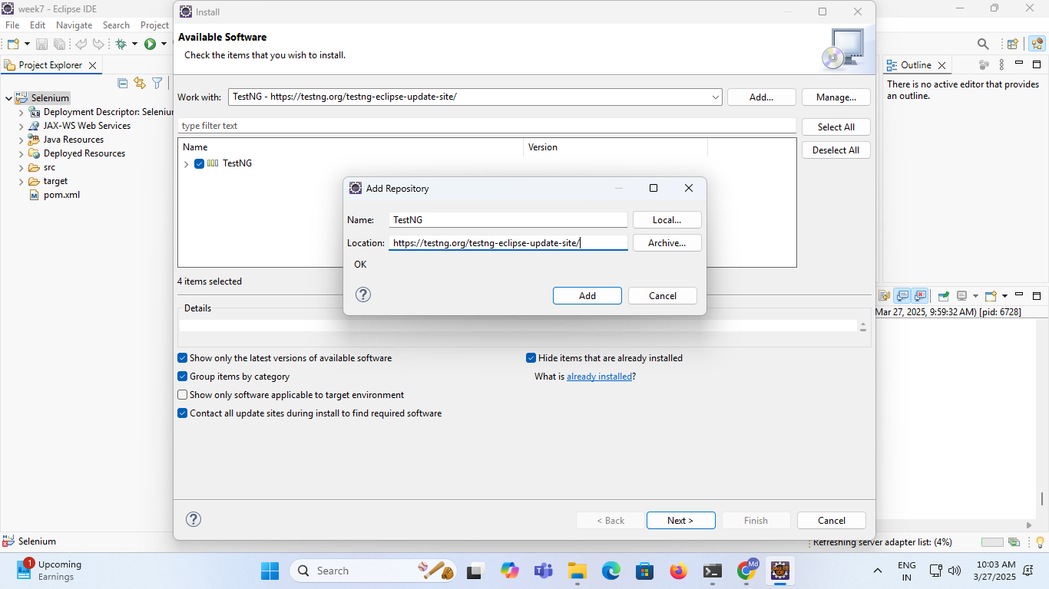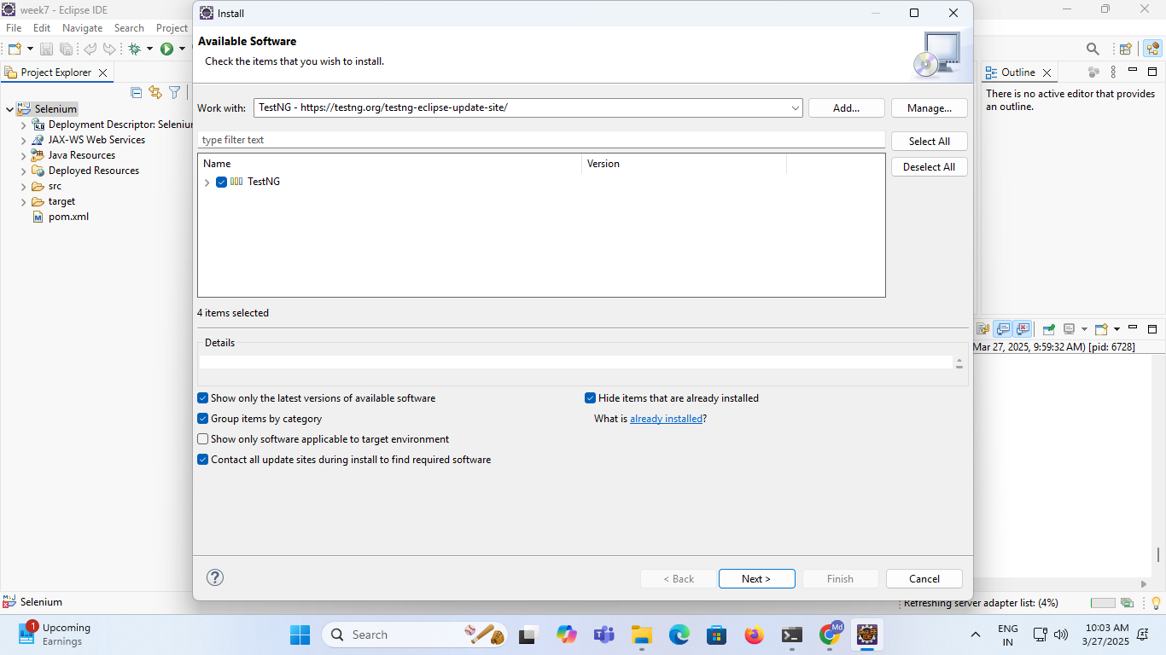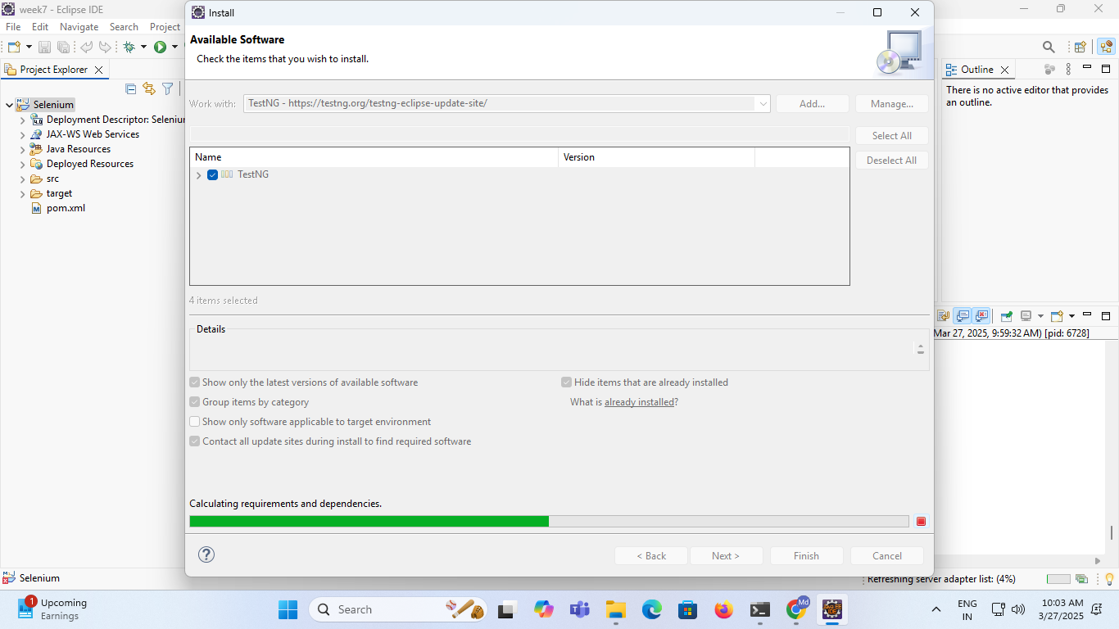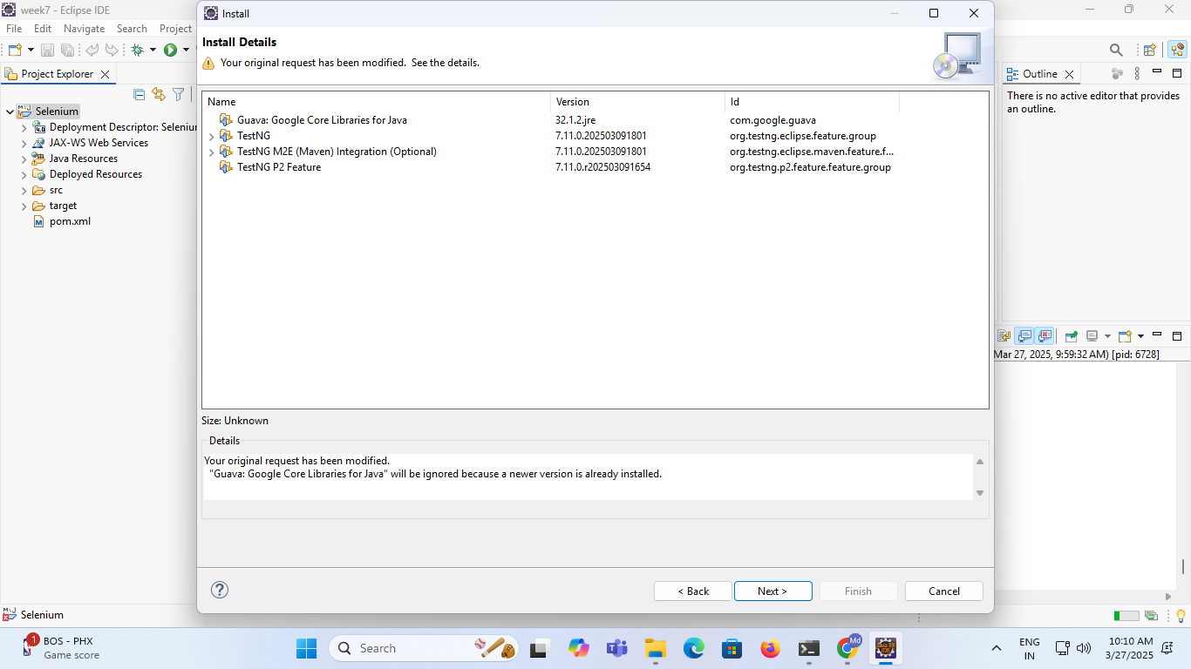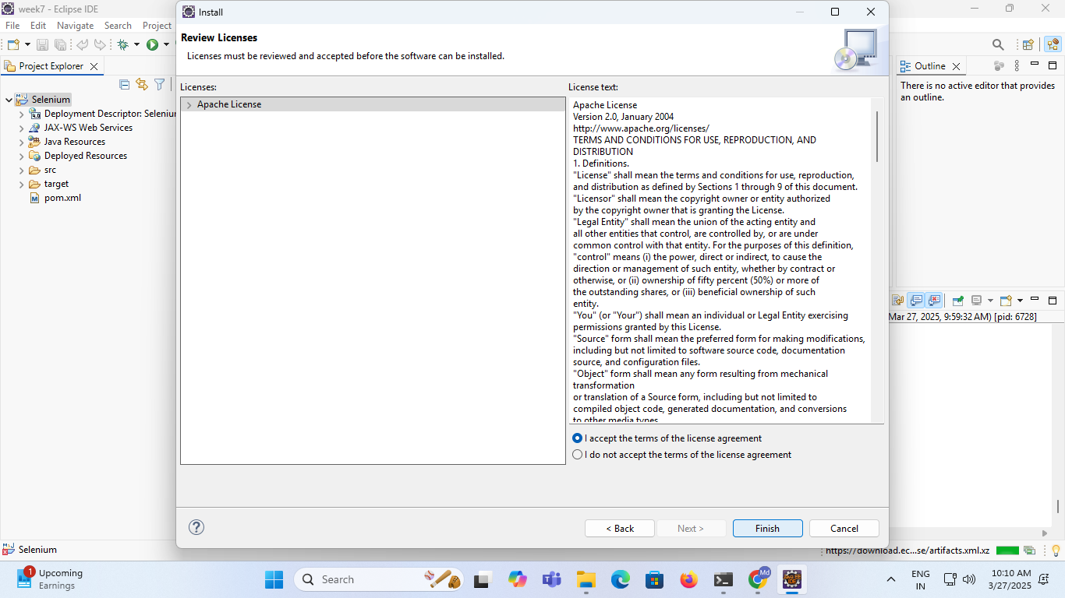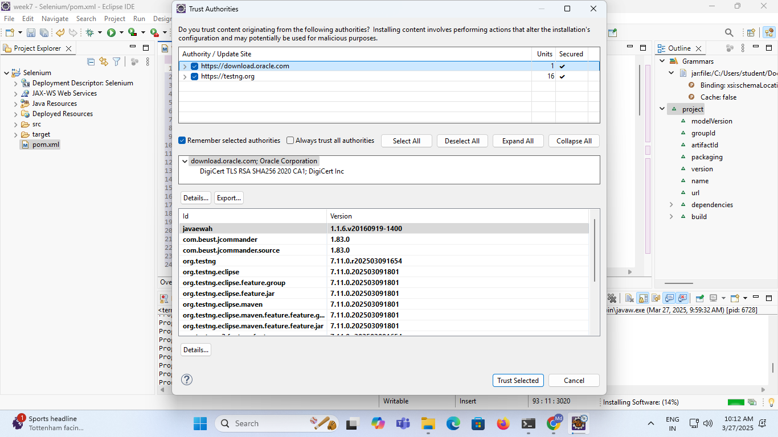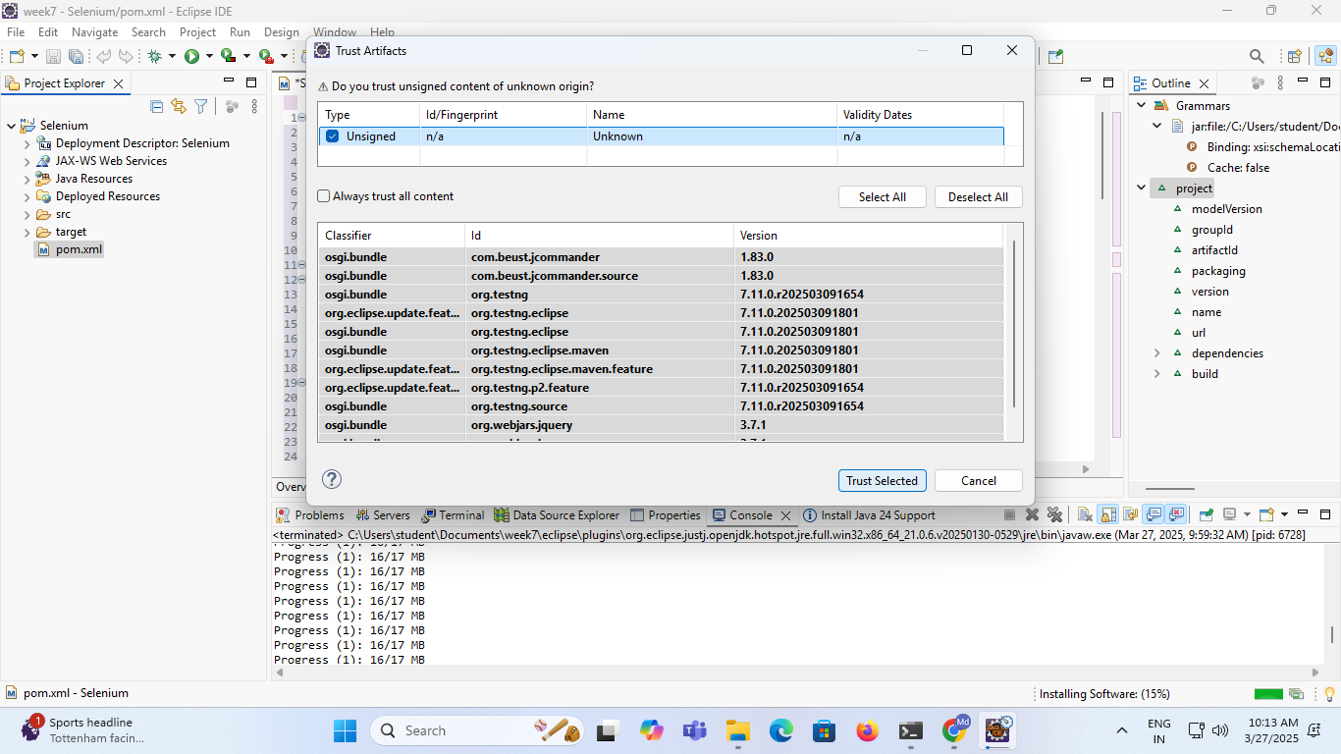

**6.Create Folder inside src 🡪test inside java.java folder select build path 🡪current folder.Right click that folder🡪new🡪others🡪class🡪next🡪give package name and class name🡪ok**

**Java file created copy paste below code.change hub address must and should.**

**Same page right click🡪run🡪TestNG 🡪Finally its run test passes.**

**SeleniumGridDemo.java**

**package com.testautomation.grid;**

**import org.openqa.selenium.WebDriver;**

**import org.openqa.selenium.chrome.ChromeDriver;**

**import org.openqa.selenium.firefox.FirefoxDriver;**

**import org.openqa.selenium.remote.DesiredCapabilities;**

**import org.openqa.selenium.remote.RemoteWebDriver;**

**import org.testng.annotations.Test;**

**import java.net.URL;**

**public class SeleniumGridDemo {**

**@Test**

**public void runTestOnChrome() throws Exception {**

**DesiredCapabilities capabilities = DesiredCapabilities.chrome();**

**WebDriver driver = new RemoteWebDriver(new URL(" http://172.16.226.24:4444/wd/hub"), capabilities);**

**driver.get("https://www.google.com");**

**System.out.println("Page title on Chrome: " + driver.getTitle());**

**driver.quit();**

**}**

**@Test**

**public void runTestOnFirefox() throws Exception {**

**DesiredCapabilities capabilities = DesiredCapabilities.firefox();**

**WebDriver driver = new RemoteWebDriver(new URL(" http://172.16.226.24:4444/wd/hub"), capabilities);**

**driver.get("https://www.google.com");**

**System.out.println("Page title on Firefox: " + driver.getTitle());**

**driver.quit();**

**}**

**}**

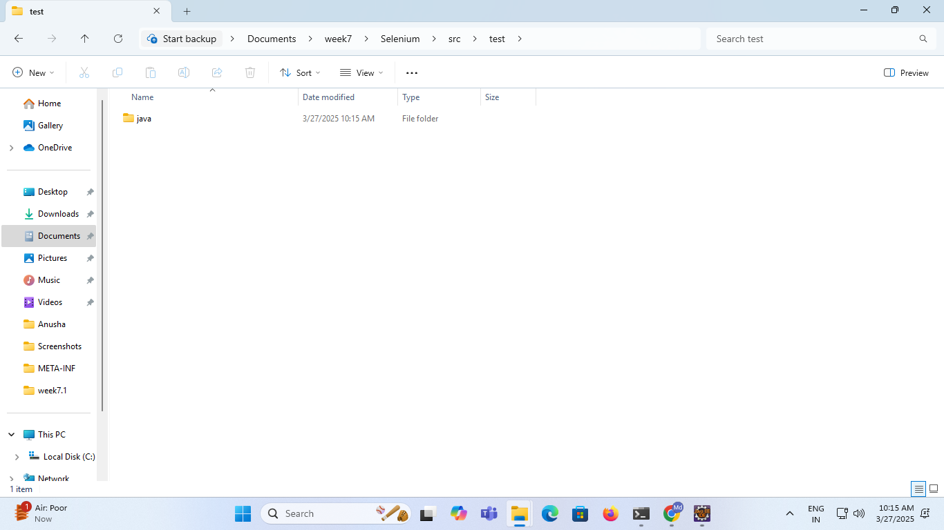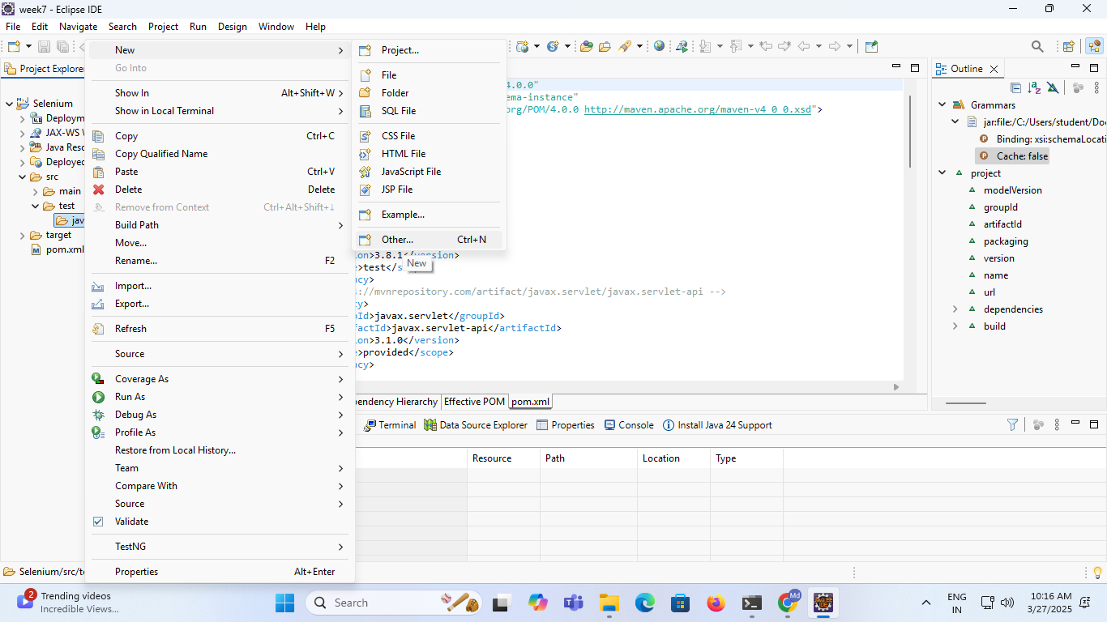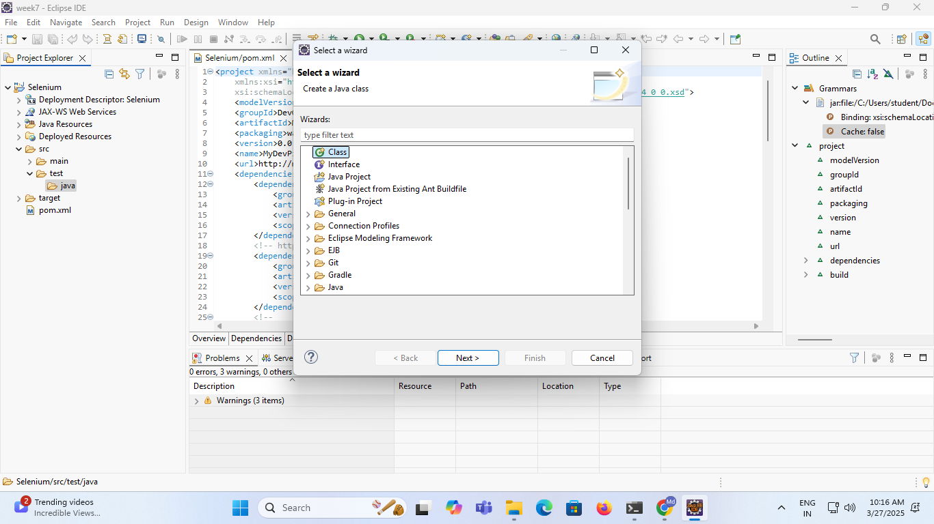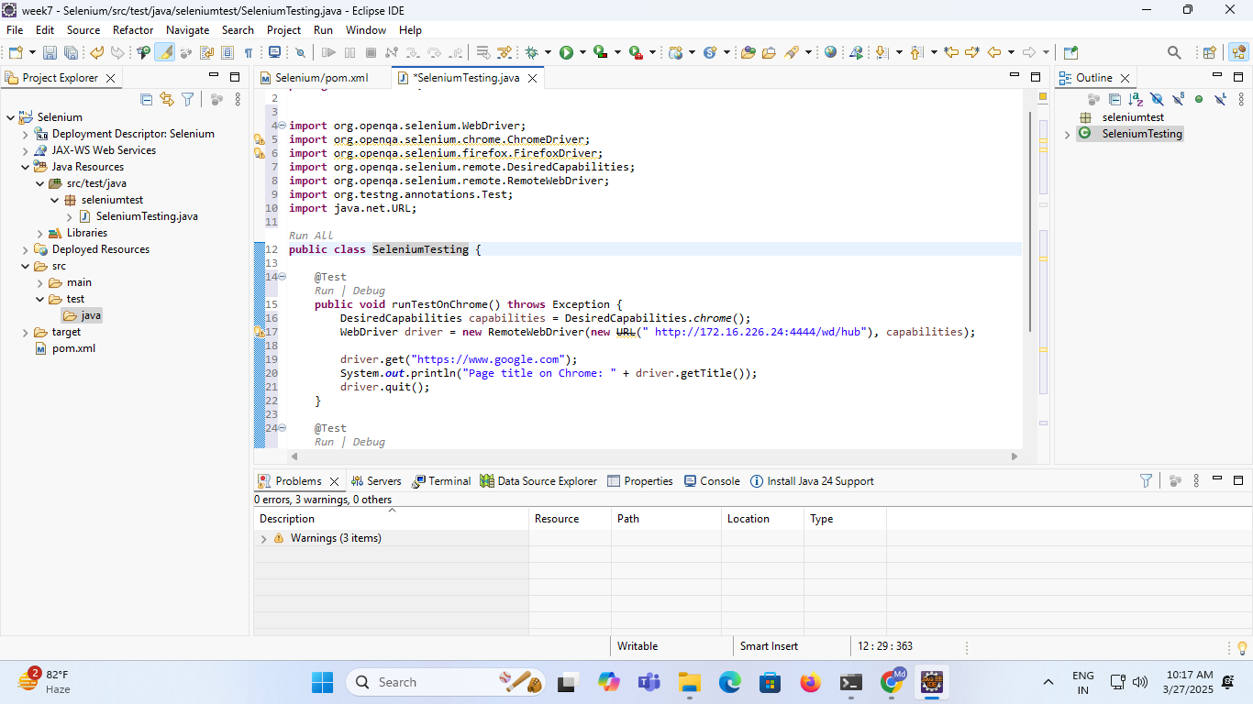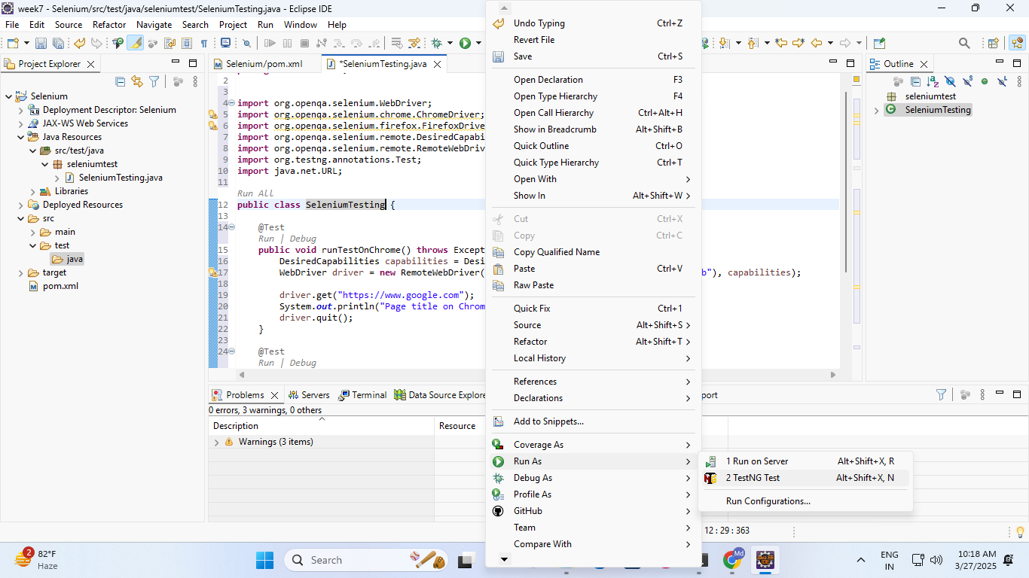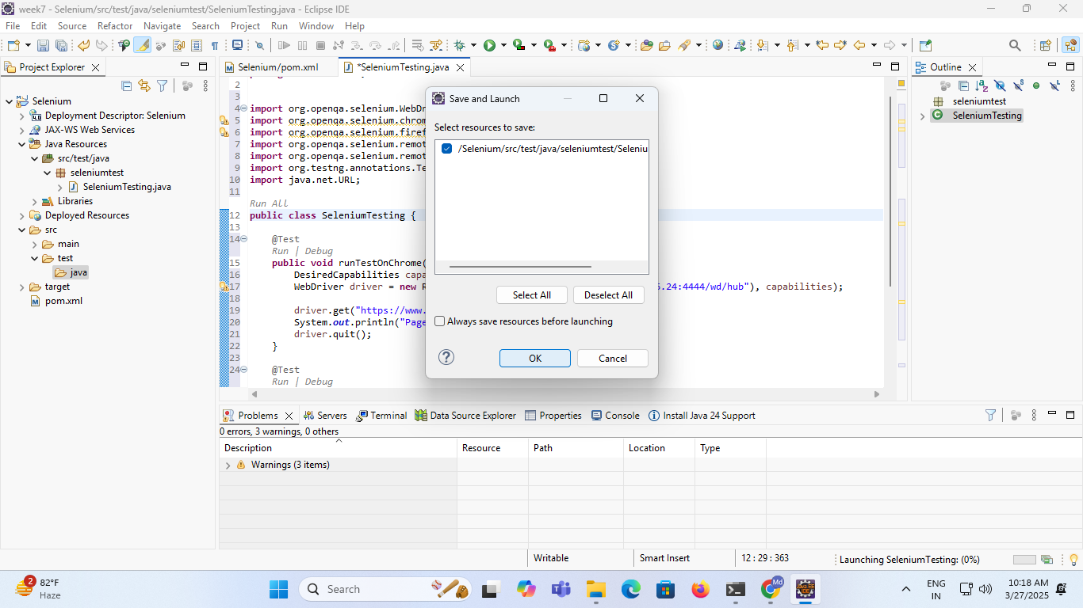

**Output:-**

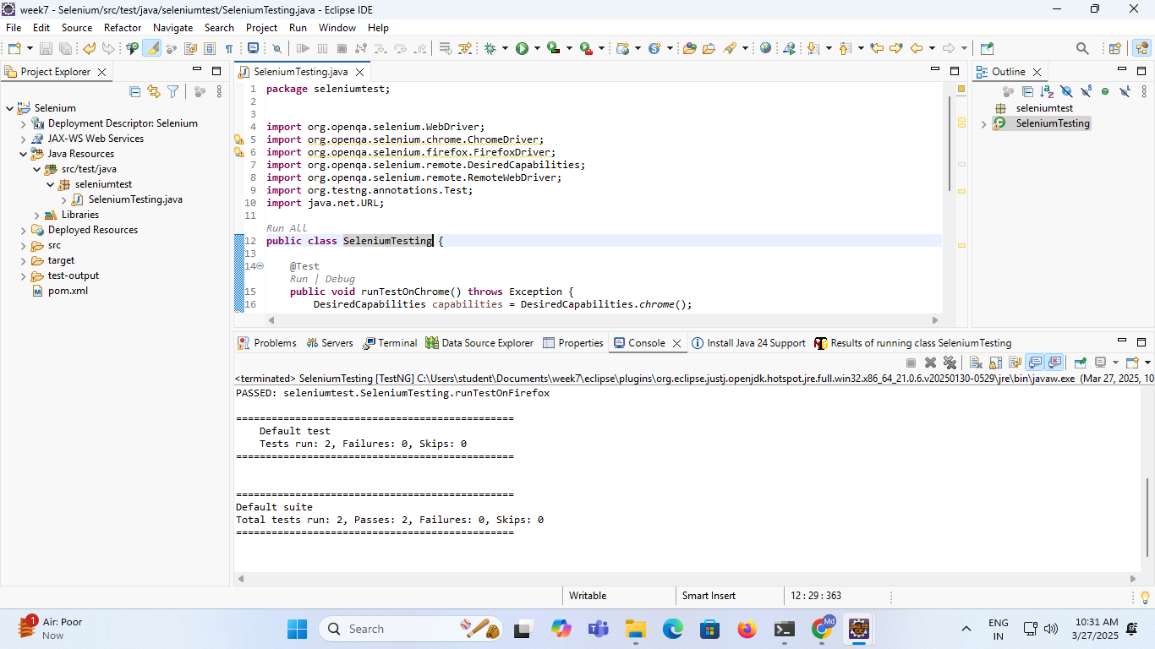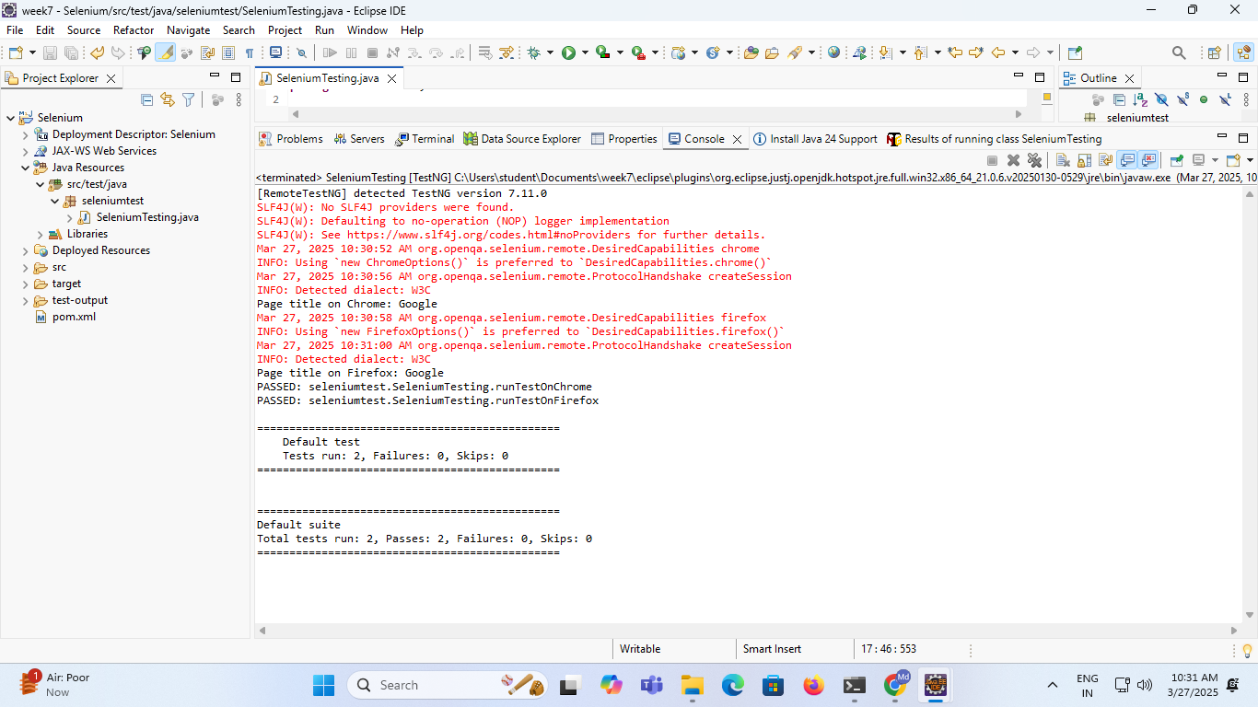

**Experiment-9**

**Aim:-Create deployment resource using Kubernetes.**

* Create the **google cloud console** free account
* It is a two step process
* It is deducting the 2 rupees from your account and it will give the 330$ free credit points.

**NOTE: Don’t active the full account**

* Once the account is created u can login to google cloud console

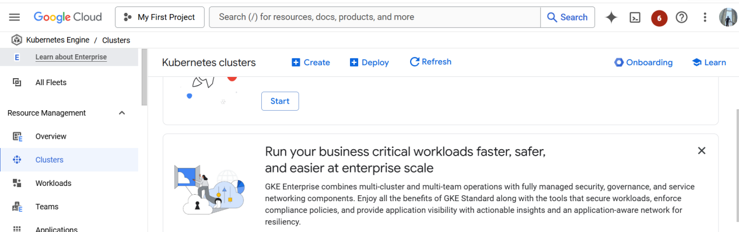

* NOW CREATE THE KUBERNETES CLUSTER

Open the cloud shell

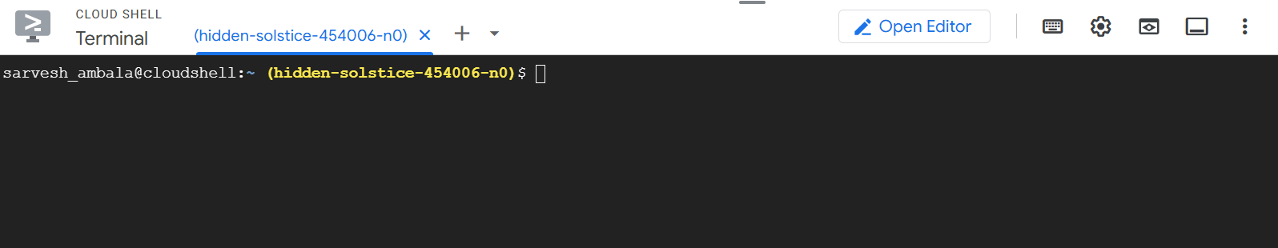

To see the cluster list run the below command

Gcloud container clusters list ( no clusters are there)



You create the cluster with below command

gcloud container clusters create my-cluster --zone us-central1-a

Cluster creation is taking 5 to 10 mints time



Once the cluster is created u can see the below message automatically

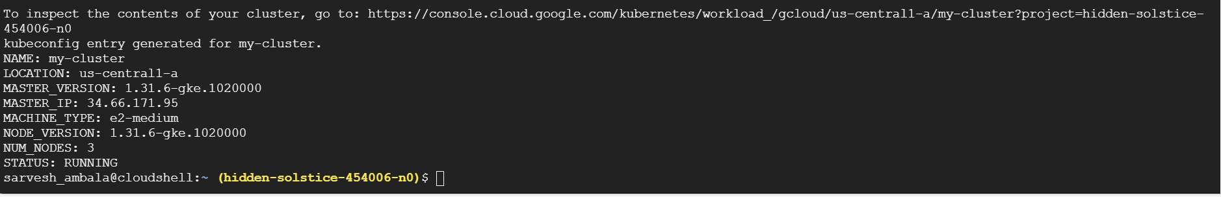

Now u go and check kubernetes engine--->cluster , you can see the my-cluster is running

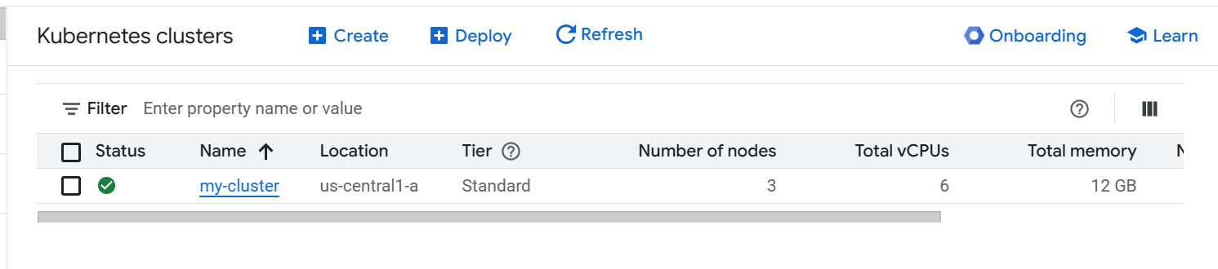

Run the below command

gcloud container clusters get-credentials my-cluster --zone us-central1-a



To see the list of nodes

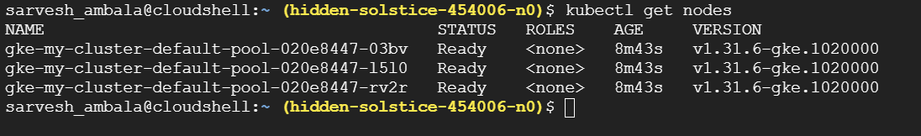

Create the pods

Kubectl run --image tomcat webserver



To see the pods list

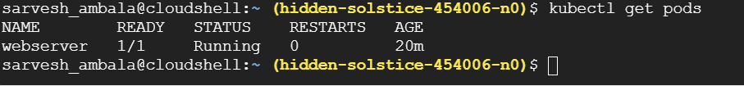

To get the list of pods along with ip address and which node the pod is running

Kubectl get pods -o wide



Actually u can create the pod using definition file

Create pd-df1.yaml

Vim pd-df1.yaml

apiVersion: v1

kind: Pod

metadata:

name: jenkins-pod

spec:

containers:

- name: myjenkins

image: jenkins/jenkins

ports:

- containerPort: 8080

hostPort: 8080

for accessing the application u need to open the port

How to open the port

gcloud compute firewall-rules create rule2 --allow tcp:8080

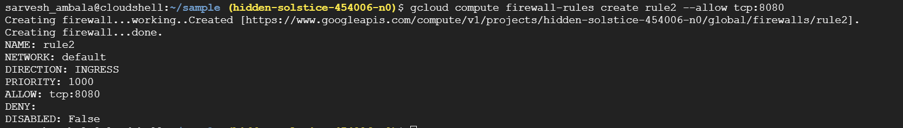

Kubectl create -f pd-df1.yaml

Kubectl get pods -o wide



Kubectl get nodes -o wide

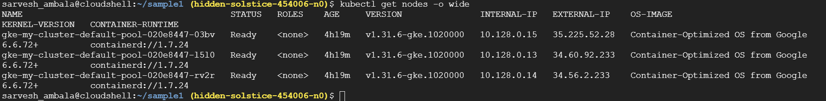

How can we access the pod

Take the external ip add the port no 8080

Open the browser paste ipaddress:8080

Now u can able to see the Jenkins

**Output:-**

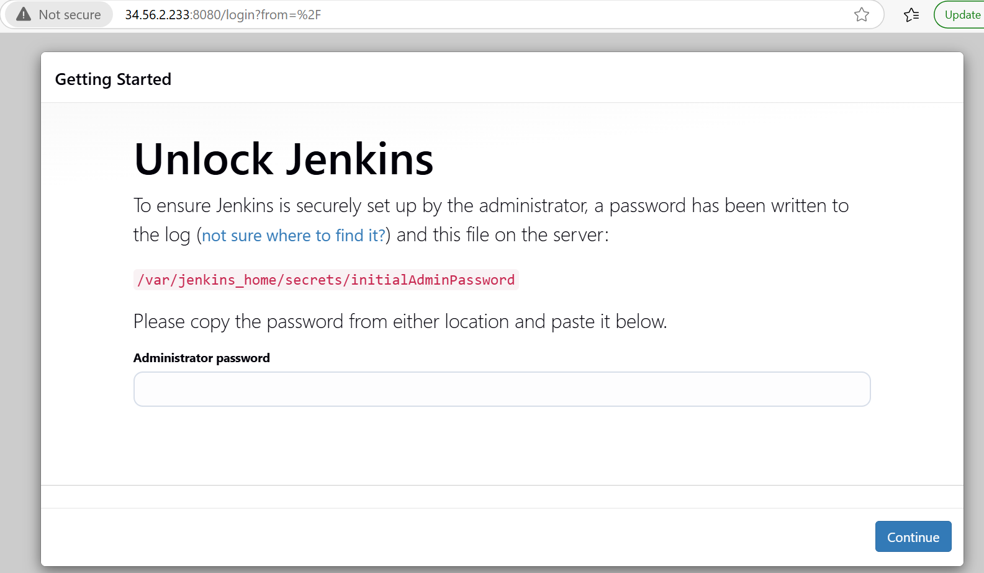

**Experiment 10**

**AIM:-Create a docker image for any application using docker file and push it to Docker Hub.**

**Step 1:-****Connecting AWS Instance Ubuntu using Mobaxterm**

1. Login AWS(Amazon Web Services) Account
2. Lunch Instance name Docker
3. Connect to Ubuntu or mobaxterm

(note:-Follow this url for docker file and application—https://github.com/devisar/devopslab)

**Step 2:-****Create Docker Hub Account and create repository in Docker Hub**

**Step 3:-Install Docker and Check Status and Start Docker in mobaxterm**

1. sudo apt update -y
2. sudo apt install docker.io –y
3. sudo systemctl status docker(come outside use command ctl+z)

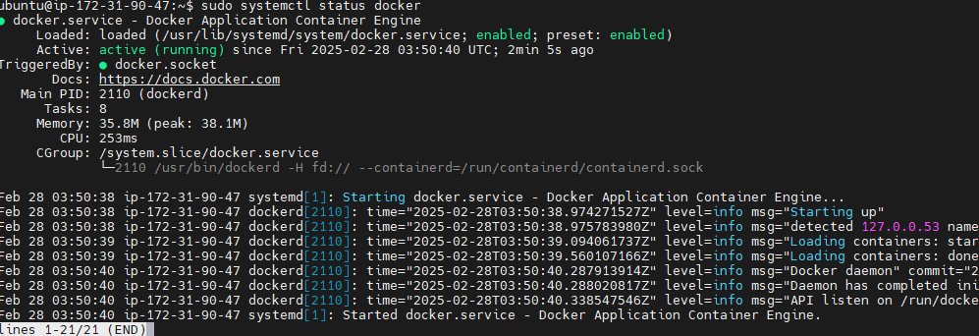

Above status command is docker running means no problem if not run use command below to run

1. sudo systemctl start docker

### Step 4:- Grant Access

### Why we give grant access means

A easy way to verify your Docker installation is by running the below command

docker run hello-world

If the output says:

### 

This can mean two things,

1. Docker deamon is not running.(start docker using “sudo systemctl start docker” )
2. Your user does not have access to run docker commands.

### Grant Access to your user to run docker commands

1. sudo usermod -aG docker ubuntu

In the above command ubuntu is the name of the user, you can change the username appropriately.

**NOTE:** : You need to logout and login back for the changes to be reflected.

1. Logout purpose use commands exit or logout

Again run command “docker run hello-world”

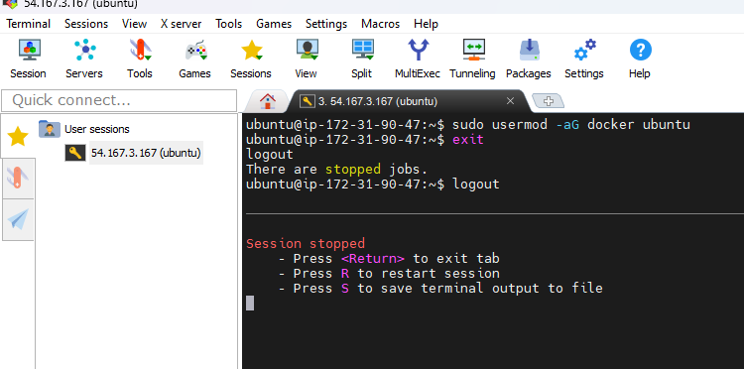

Start session

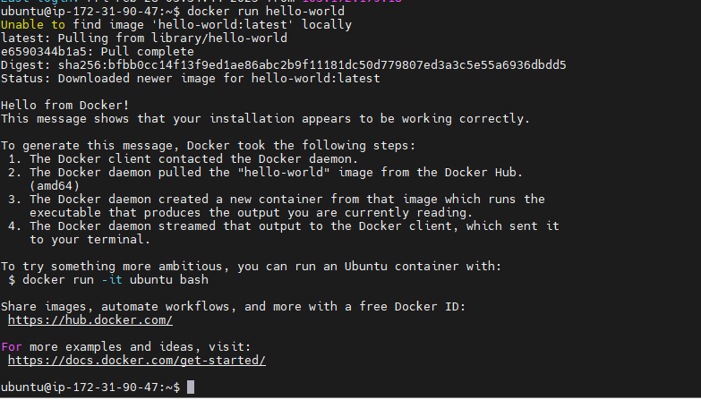

**Step 5:-Creating application and Docker file**

1. Mkdir docker1
2. cd docker1
3. vim app.py

print(“hello world”)

1. cat app.py
2. vim Dockerfile (below pic commands write lab record) typing command vim before click “i” for insert data after completion Docker file commands save before click esc use :wq!

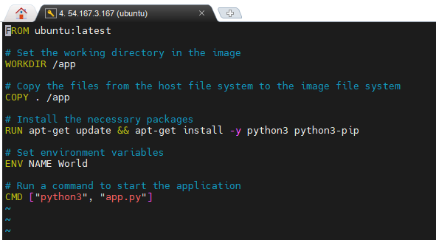

**Below image for understanding purpose**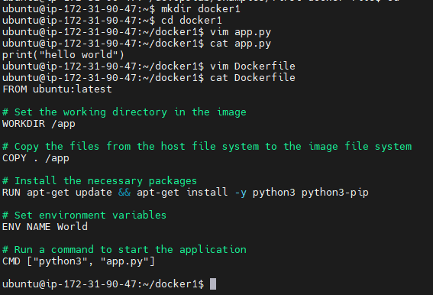se

**Step 6:-** **Build and Check Docker image**

Syntax:- docker build –t dockerhub_username/repositoryname:tag .

# docker build –t anu1308/dockerimage:latest .

1. docker images

**Below images for understanding purpose**

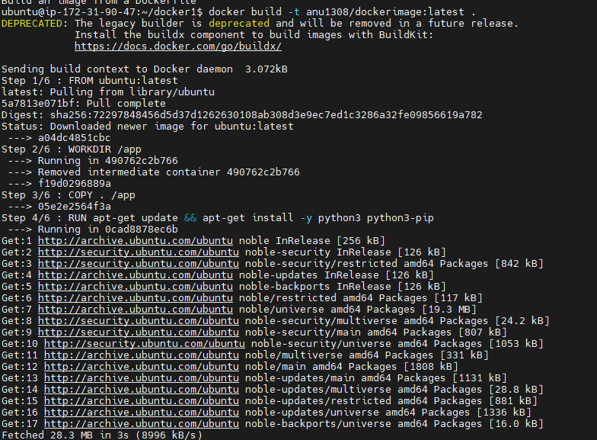 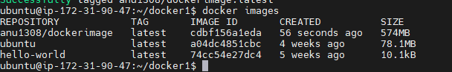

### Step 7:- Run your First Docker Container

1. docker run -it anu1308/dockerimage:latest

Output

Hello World

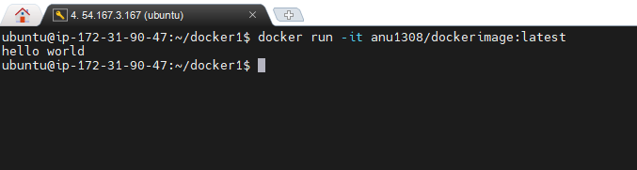

**Step 8:-Docker Login**

1. docker login

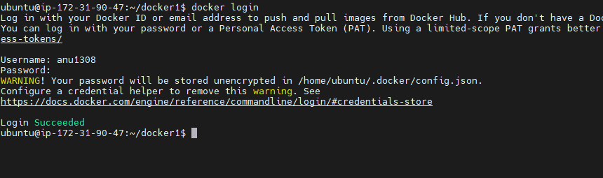

**Step 9:- Push the Image to DockerHub and share it with the world**

1. docker push anu1308/dockerimage:latest

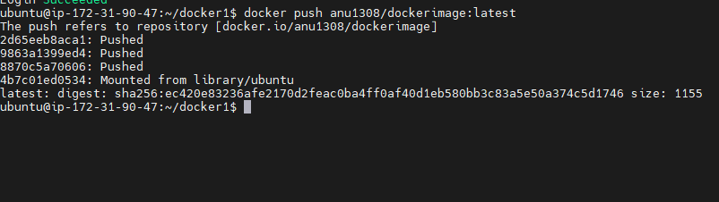

**Output:-**



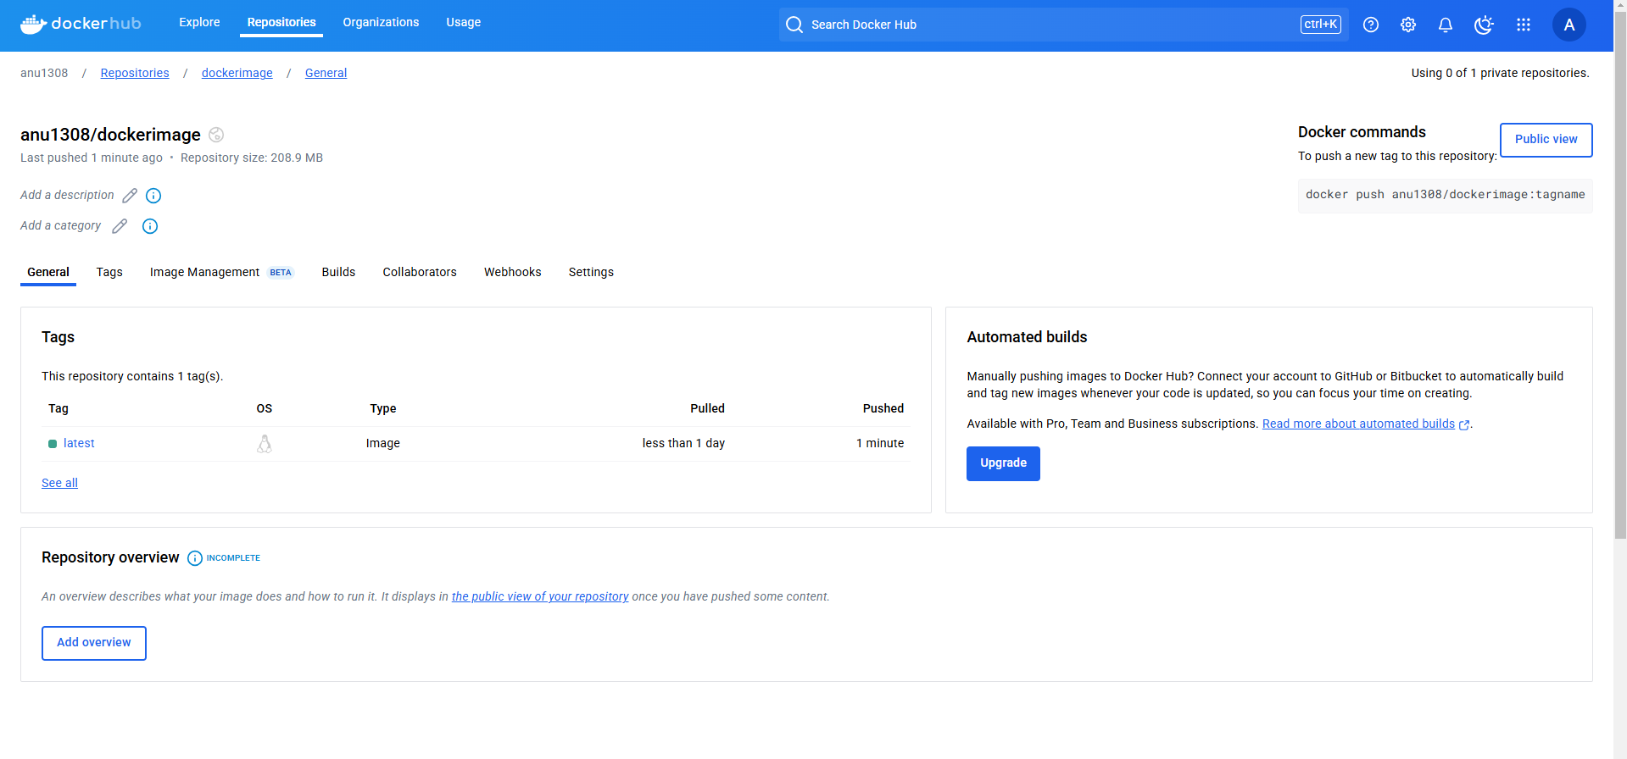

**Definitions:-**

**Docker LifeCycle**

We can use the above Image as reference to understand the lifecycle of Docker.

There are three important things,

1. docker build -> builds docker images from Dockerfile
2. docker run -> runs container from docker images
3. docker push -> push the container image to public/private regestries(docker hub) to share the docker images.

[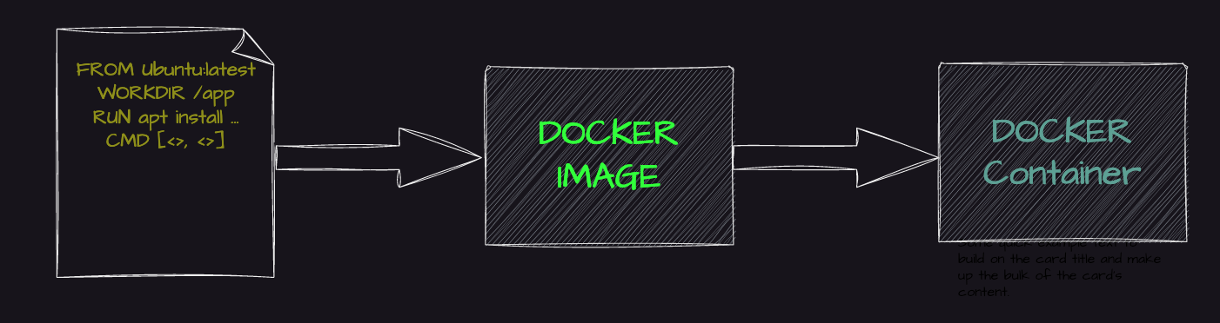](https://user-images.githubusercontent.com/43399466/217511949-81f897b2-70ee-41d1-b229-38d0572c54c7.png)

## What is a container ?

A container is a standard unit of software that packages up code and all its dependencies so the application runs quickly and reliably from one computing environment to another. A Docker container image is a lightweight, standalone, executable package of software that includes everything needed to run an application: code, runtime, system tools, system libraries and settings.

## Why are containers light weight ?

Containers are lightweight because they use a technology called containerization, which allows them to share the host operating system's kernel and libraries, while still providing isolation for the application and its dependencies. This results in a smaller footprint compared to traditional virtual machines, as the containers do not need to include a full operating system. Additionally, Docker containers are designed to be minimal, only including what is necessary for the application to run, further reducing their size.

### What is Docker ?

Docker is a containerization platform that provides easy way to containerize your applications, which means, using Docker you can build container images, run the images to create containers and also push these containers to container regestries such as DockerHub

#### Docker daemon

The Docker daemon (dockerd) listens for Docker API requests and manages Docker objects such as images, containers, networks, and volumes. A daemon can also communicate with other daemons to manage Docker services.

#### Docker client

The Docker client (docker) is the primary way that many Docker users interact with Docker. When you use commands such as docker run, the client sends these commands to dockerd, which carries them out. The docker command uses the Docker API. The Docker client can communicate with more than one daemon.

#### Docker Desktop

Docker Desktop is an easy-to-install application for your Mac, Windows or Linux environment that enables you to build and share containerized applications and microservices. Docker Desktop includes the Docker daemon (dockerd), the Docker client (docker), Docker Compose, Docker Content Trust, Kubernetes, and Credential Helper. For more information, see Docker Desktop.

#### Docker registries

A Docker registry stores Docker images. Docker Hub is a public registry that anyone can use, and Docker is configured to look for images on Docker Hub by default. You can even run your own private registry.

When you use the docker pull or docker run commands, the required images are pulled from your configured registry. When you use the docker push command, your image is pushed to your configured registry. Docker objects

When you use Docker, you are creating and using images, containers, networks, volumes, plugins, and other objects. This section is a brief overview of some of those objects.

#### Dockerfile

Dockerfile is a file where you provide the steps to build your Docker Image.

#### Images

An image is a read-only template with instructions for creating a Docker container. Often, an image is based on another image, with some additional customization. For example, you may build an image which is based on the ubuntu image, but installs the Apache web server and your application, as well as the configuration details needed to make your application run.

Below Images for Understanding purpose

**Connecting AWS Instance to Mobaxterm**

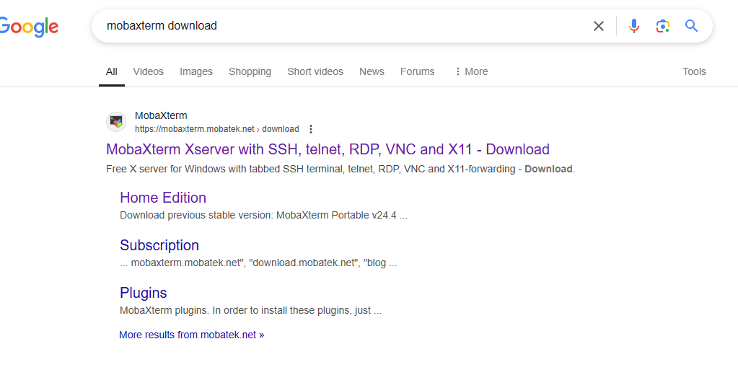

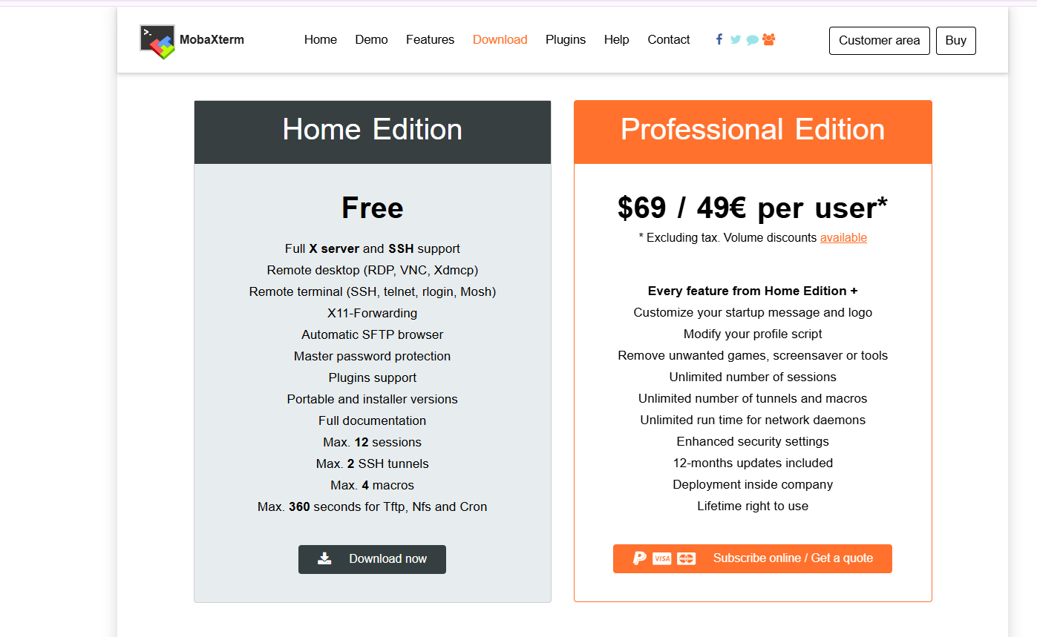

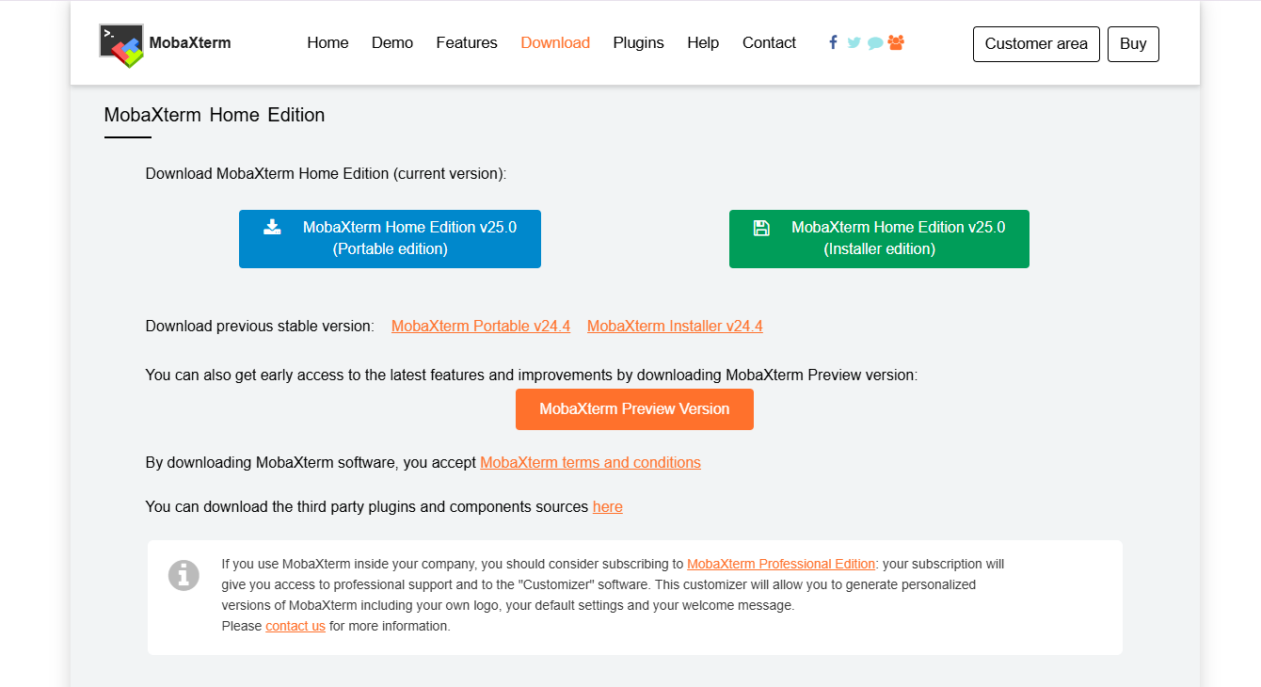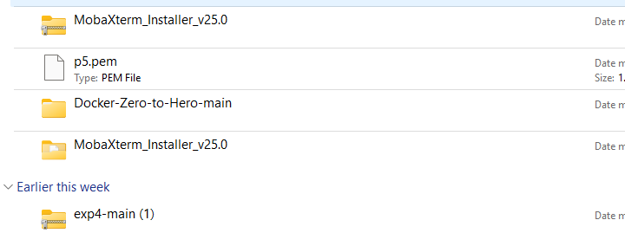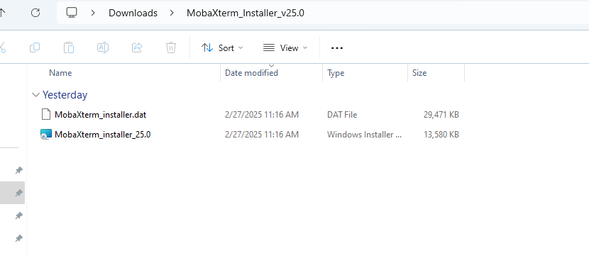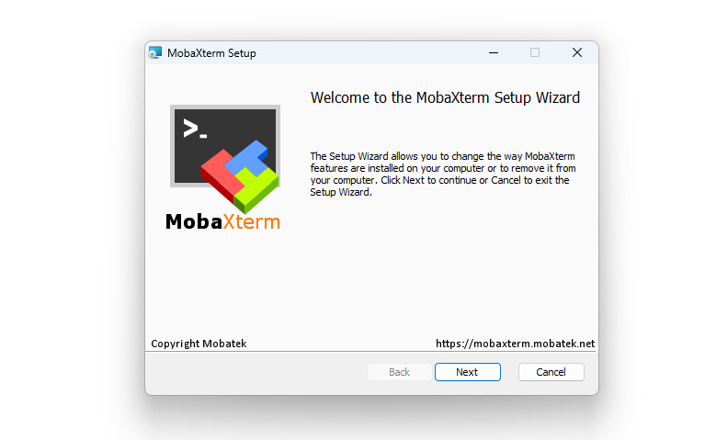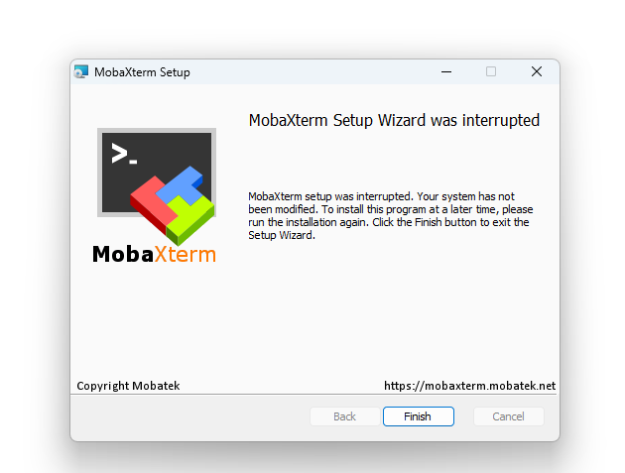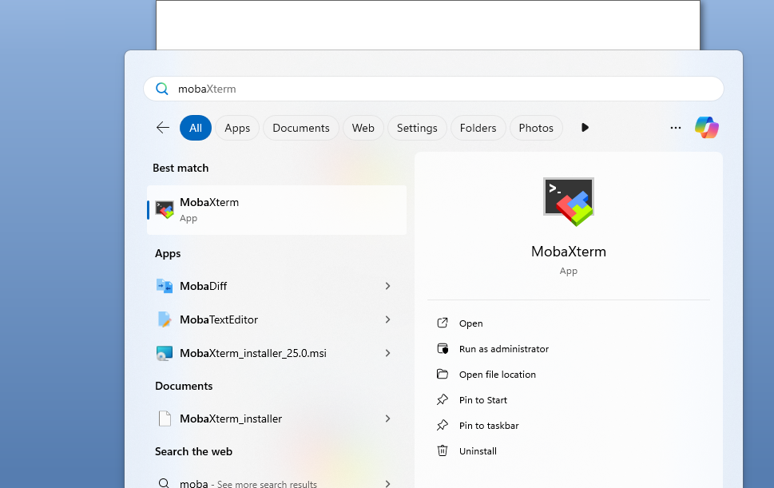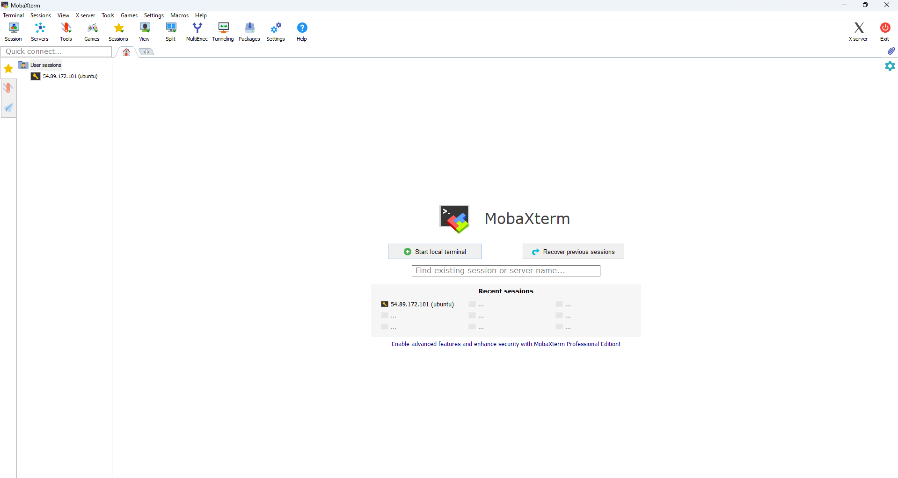

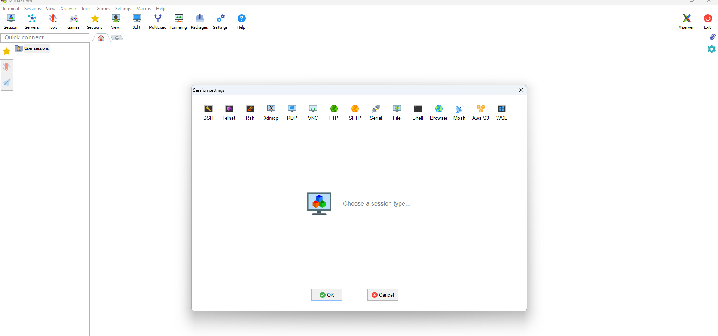

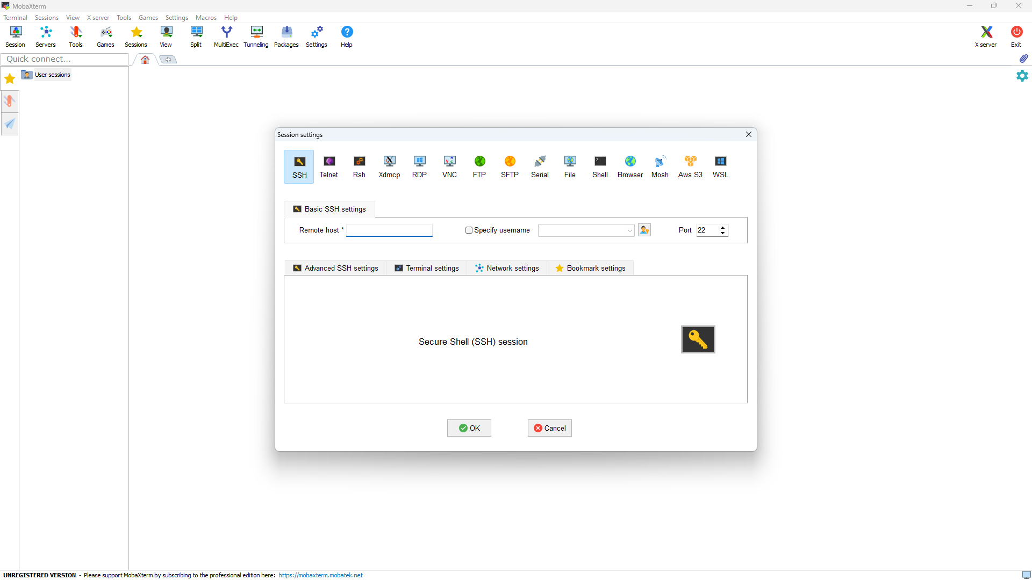

Remote host we want public key and .pem file also so login to AWS Account

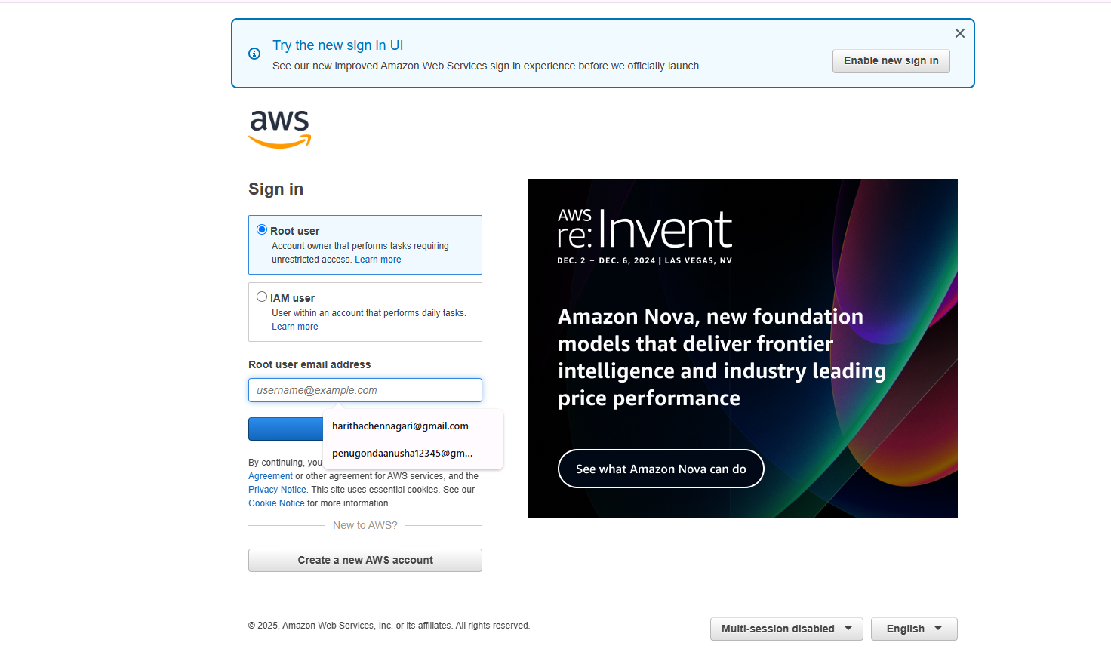

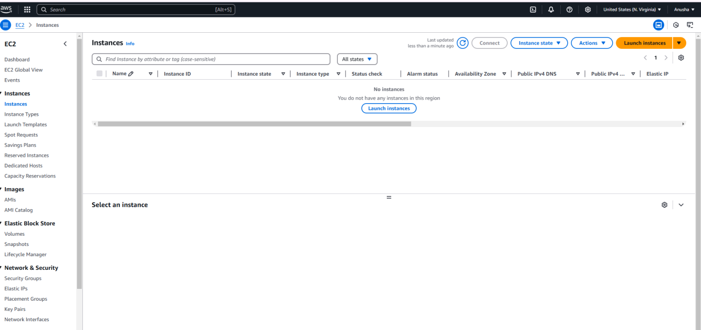

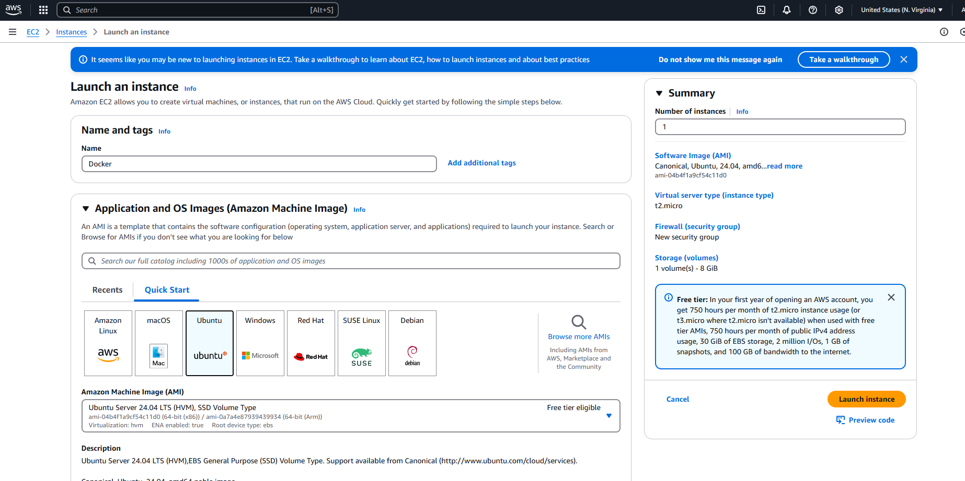

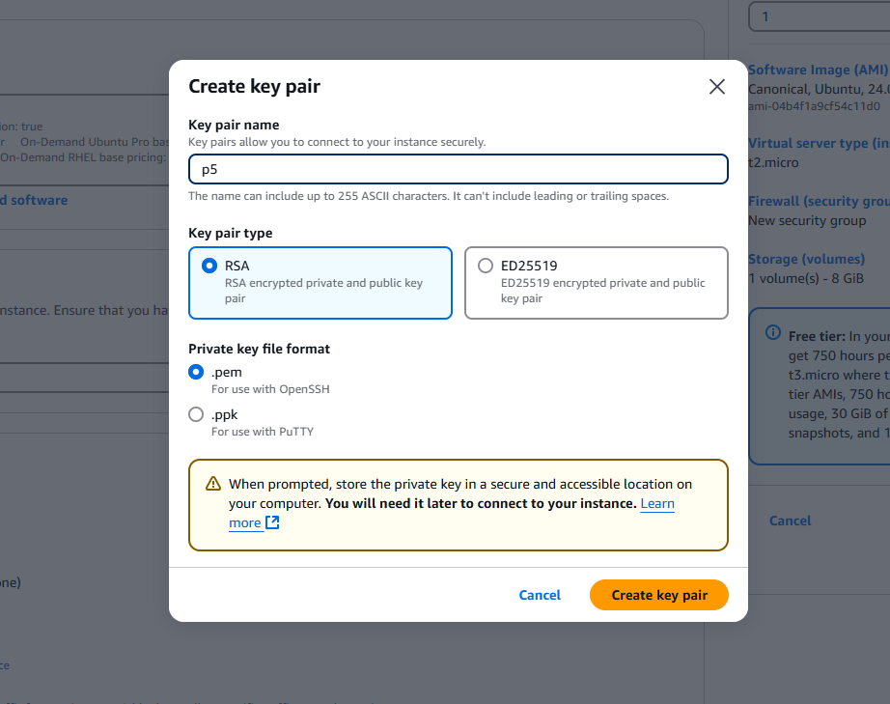

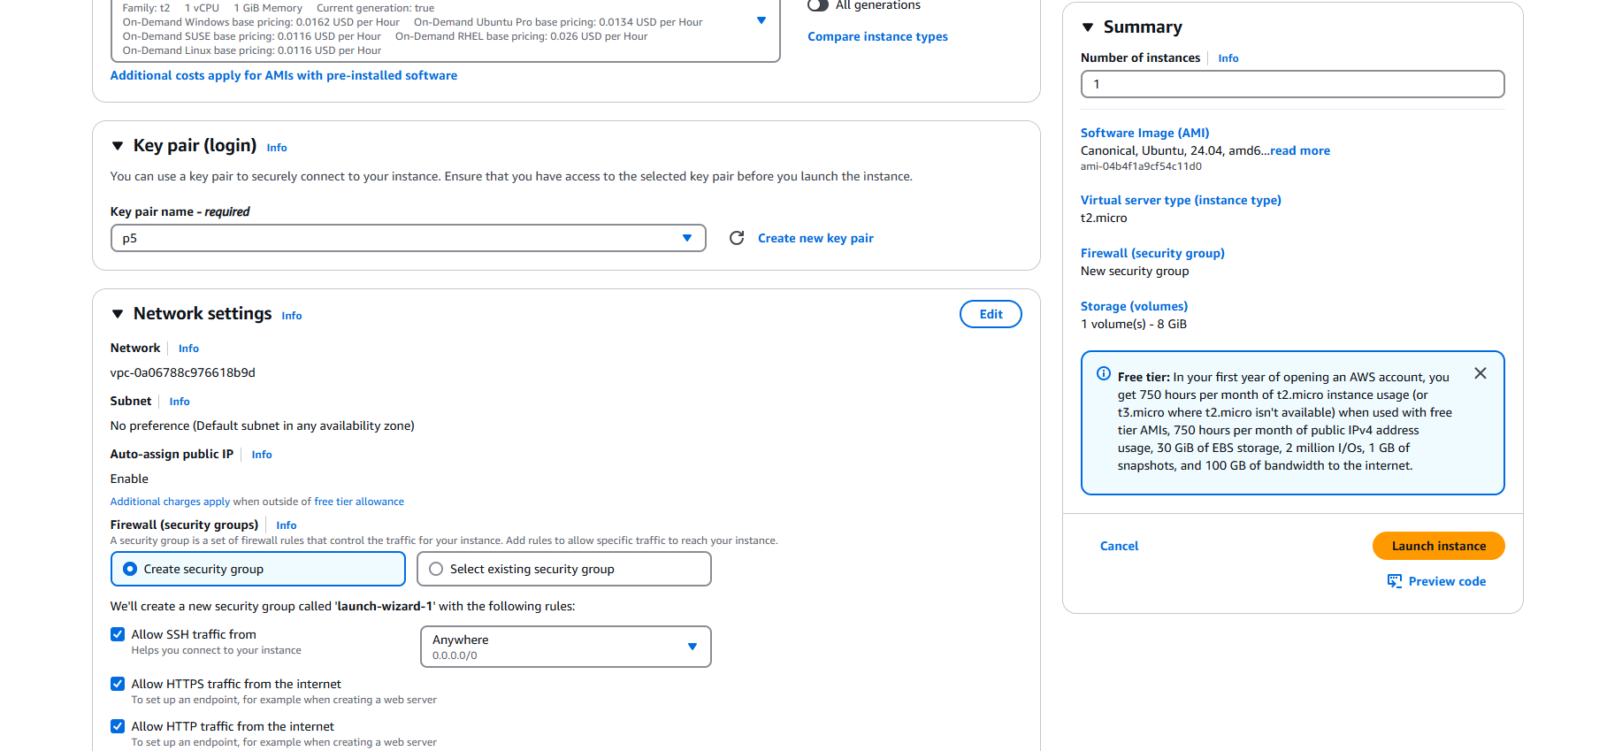

Here you can Directly connect Ubuntu also but better use mobaxterm

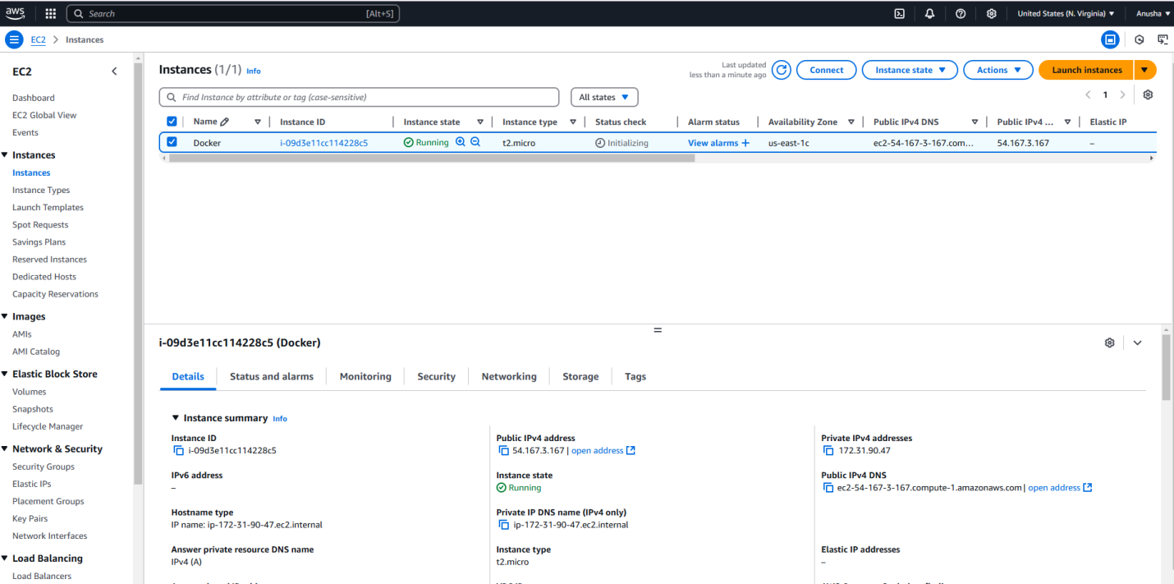

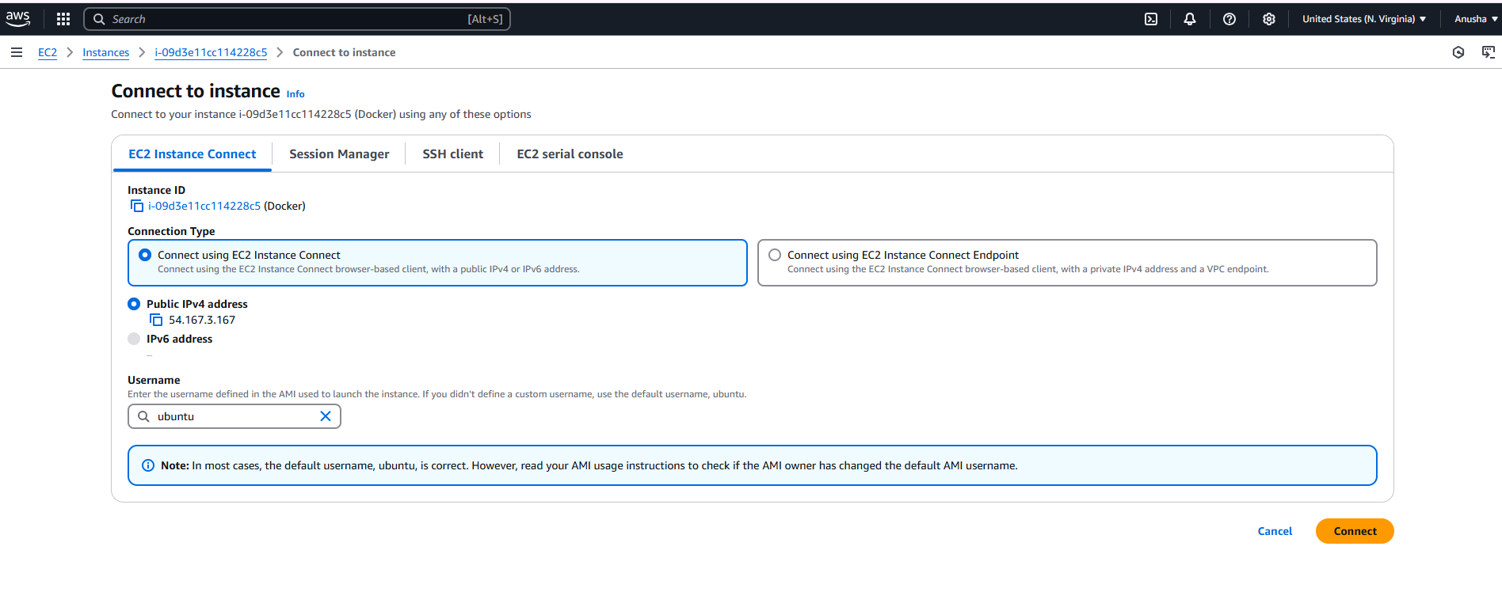

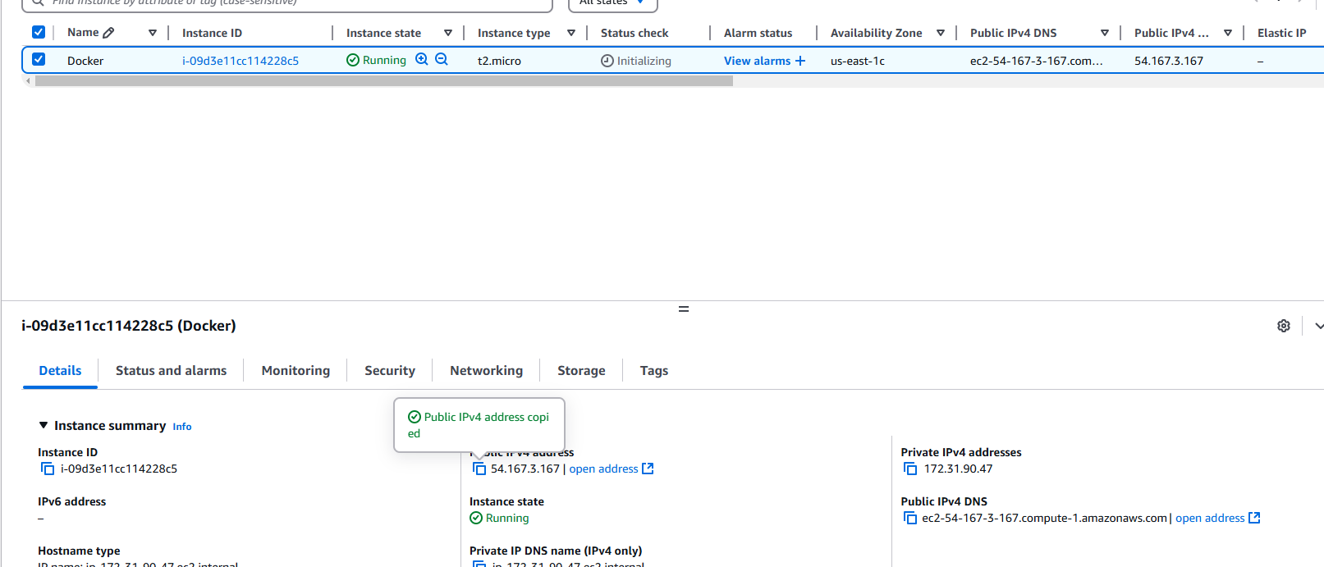

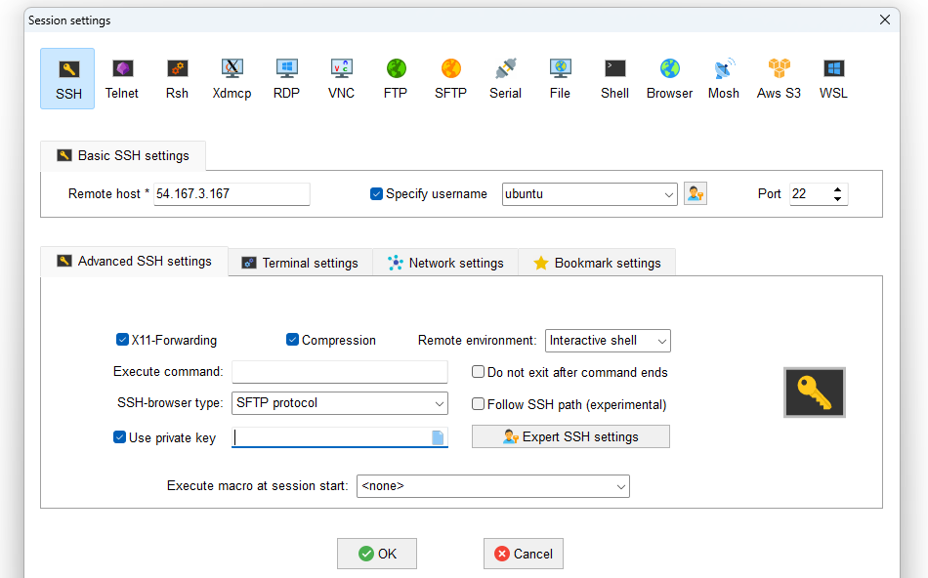

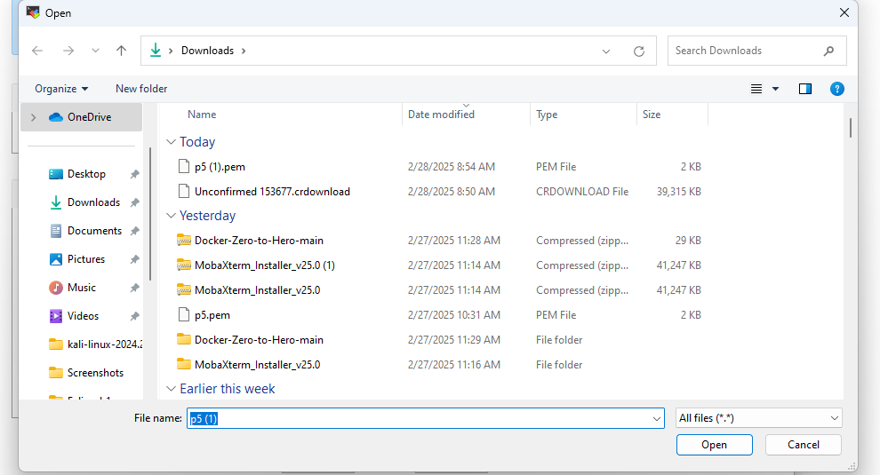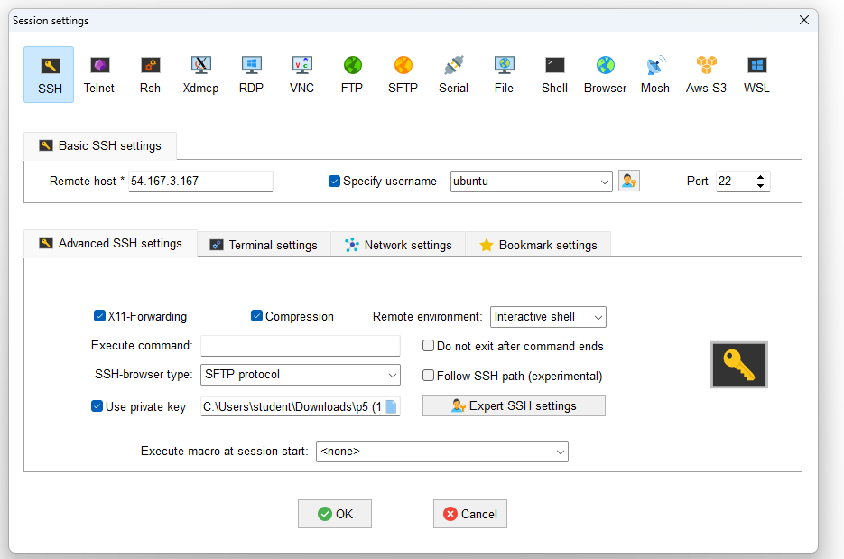

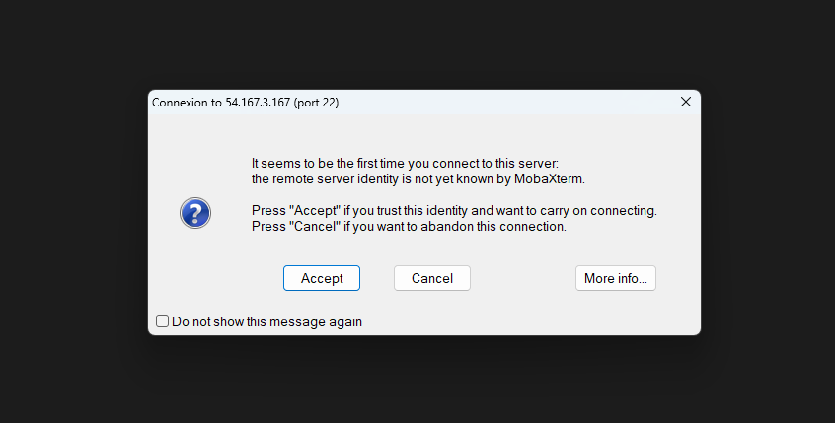

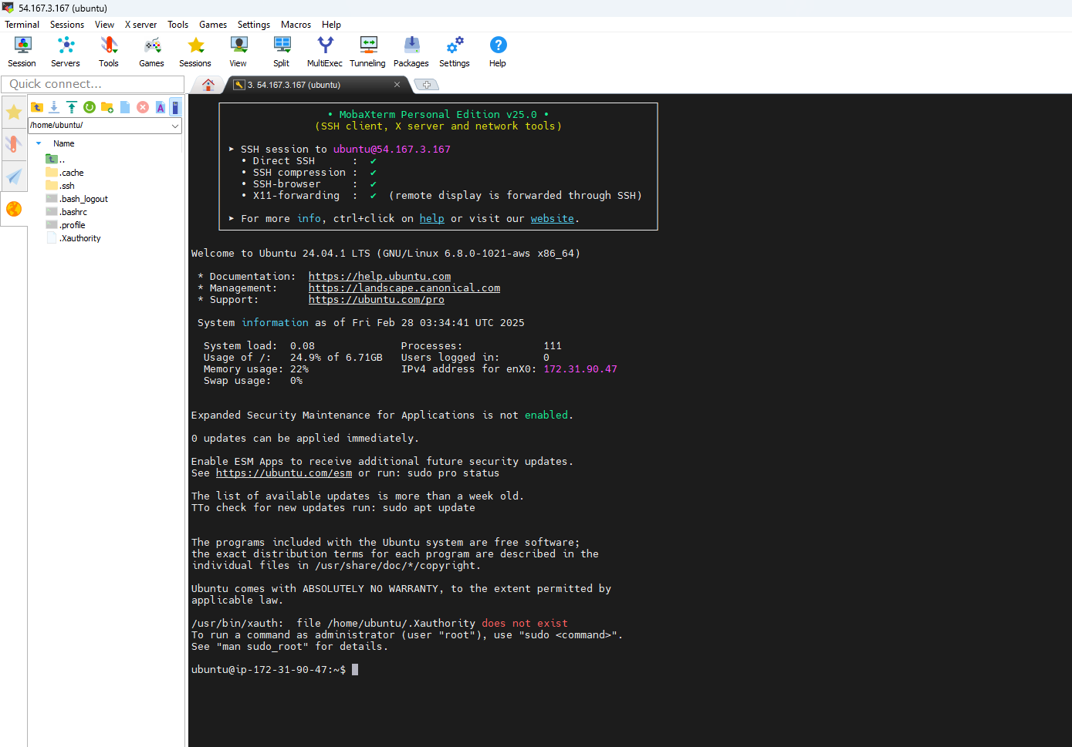

**Create Docker Hub Account and create repository in Docker Hub**

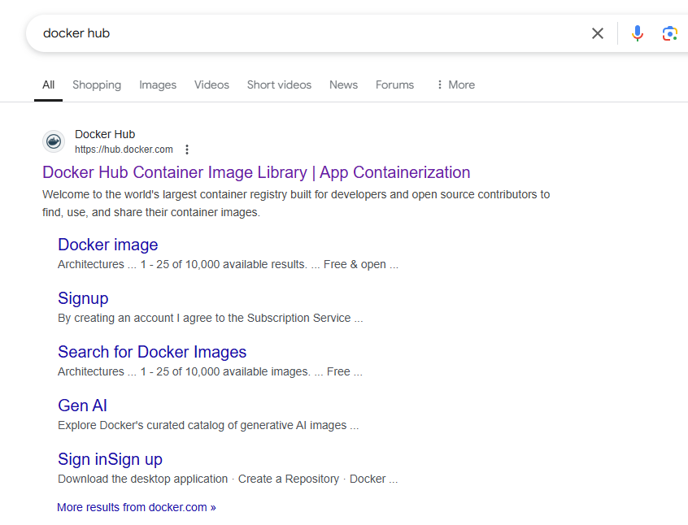 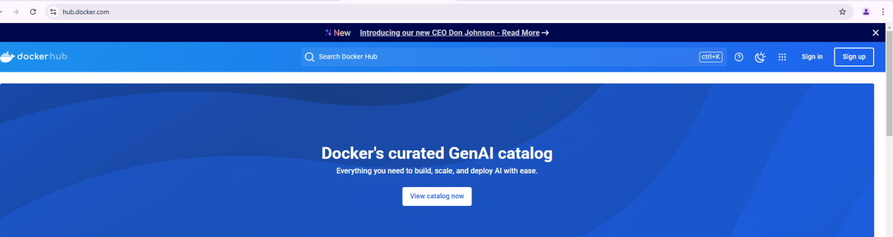 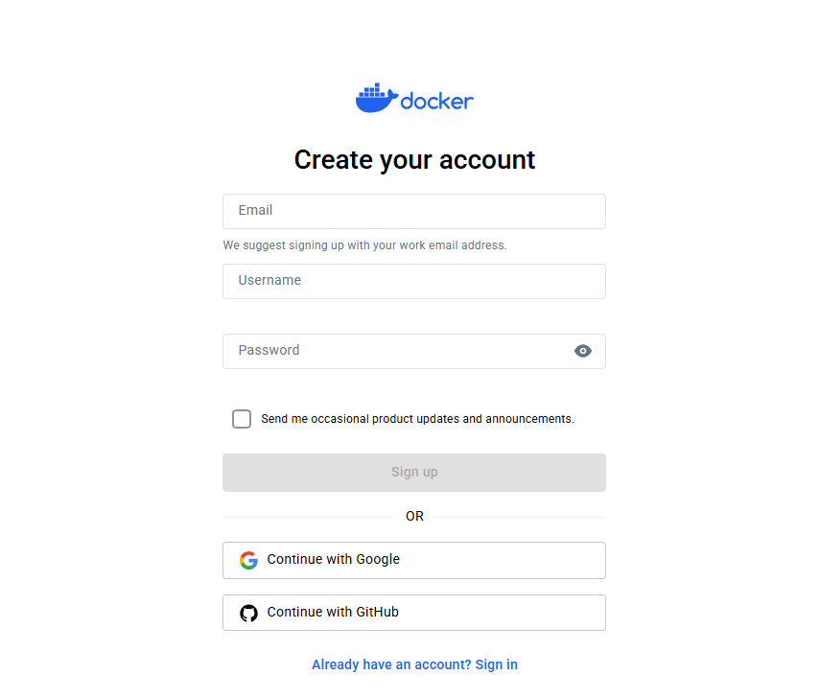 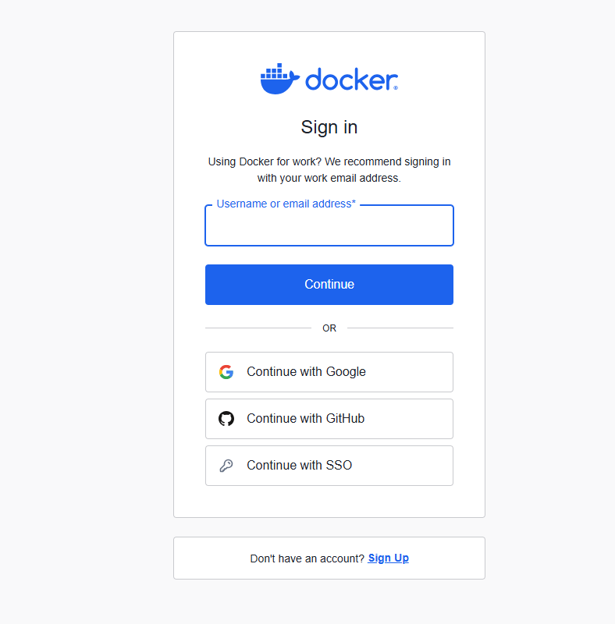 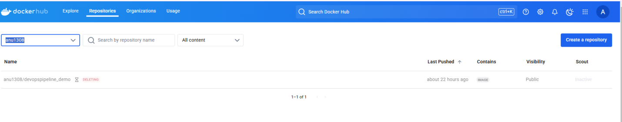

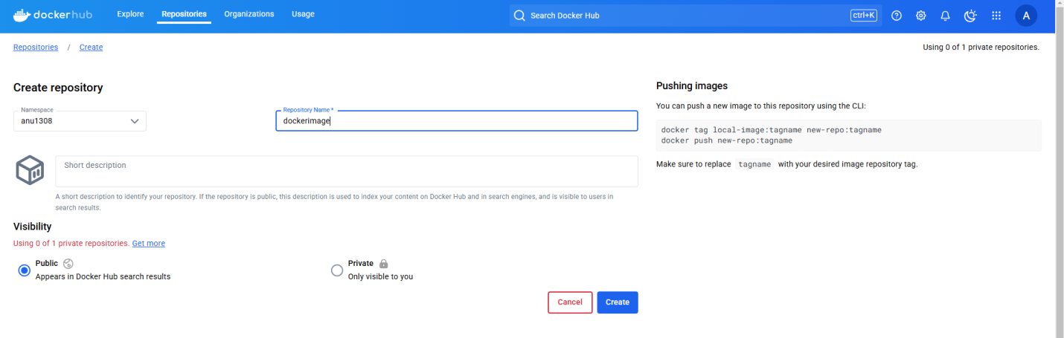 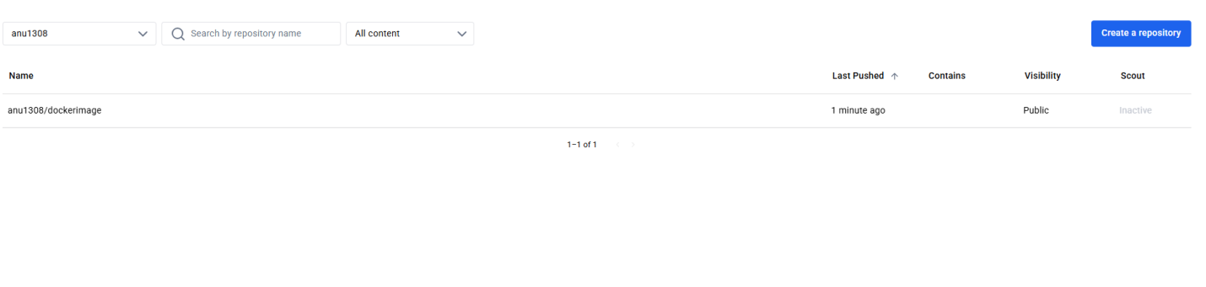 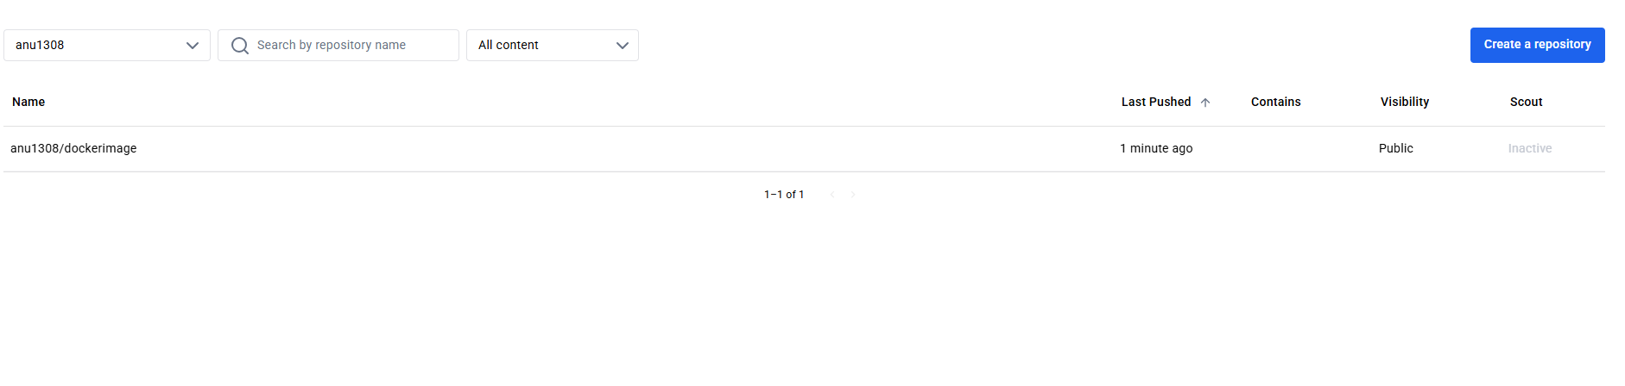

**Experiment 11**

**Aim:-Setup Grafana for Devops.**

**ACCESS GRAFANA :**

kubectl get secret prometheus-grafana -n monitoring -o jsonpath="{.data.admin-user}" | base64 --decode ; echo

If you run the above command u can see the username for grafana (**admin**)



kubectl get secret prometheus-grafana -n monitoring -o jsonpath="{.data.admin-password}" | base64 --decode ; echo

If you run the abvoe command u can see the password for grafana (**prom-operator**)



PORT FORWARDING

kubectl port-forward svc/prometheus-grafana 3000:80 -n monitoring



Click on the web preview give the port no 3000 and click on change and preview u can see the grafana

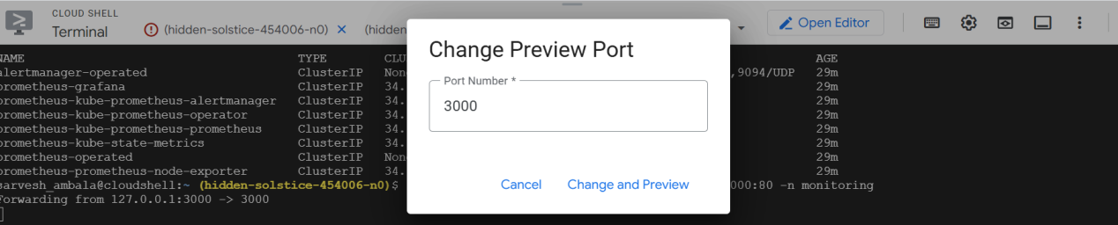

**Output:-**

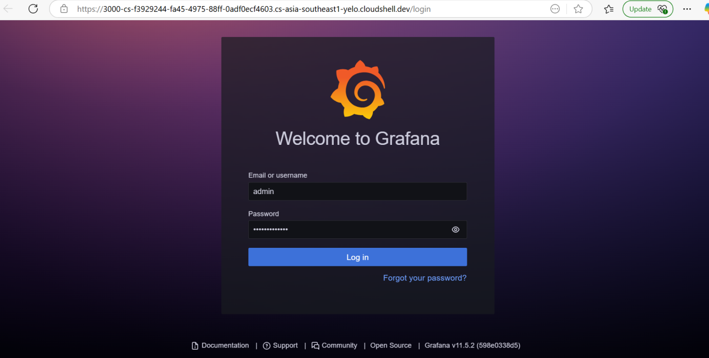

You can login with admin and prom-operator

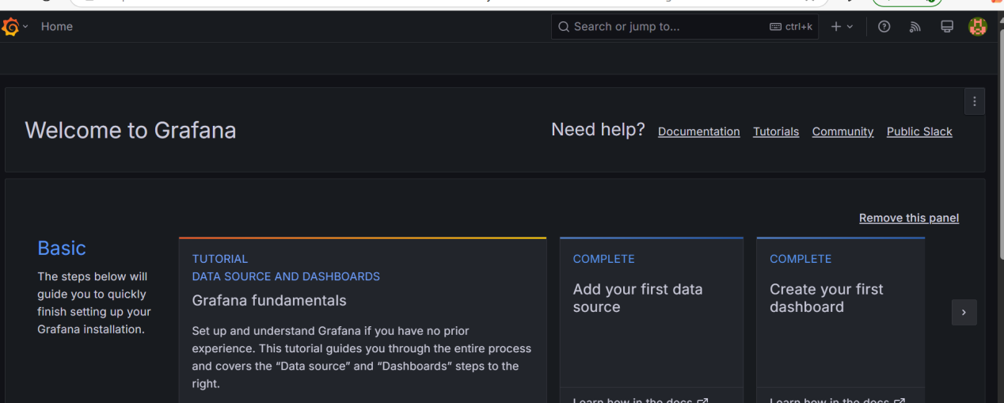

**Experiment 12**

**Aim:-Setup Prometheus for Devops.**

**PROMETHEUS SETUP:**

helm repo add prometheus <https://prometheus-community.github.io/helm-charts>



helm repo update

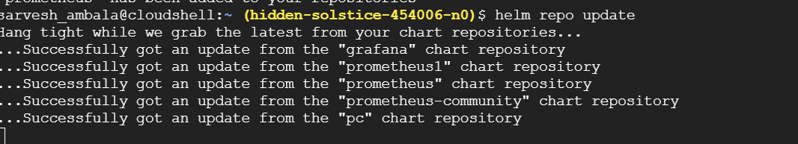

helm install prometheus prometheus-community/kube-prometheus-stack --namespace monitoring --create-namespace

This will install prometheus,alermanager and grafana



Check the prometheus pods and services

kubectl get pods -n monitoring

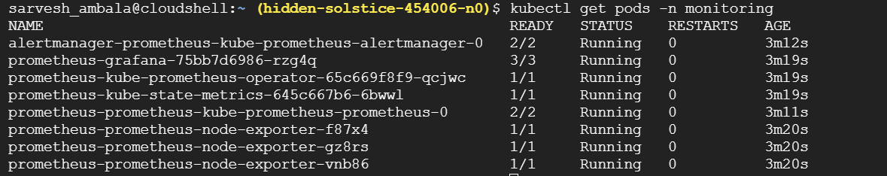

kubectl get svc -n monitoring

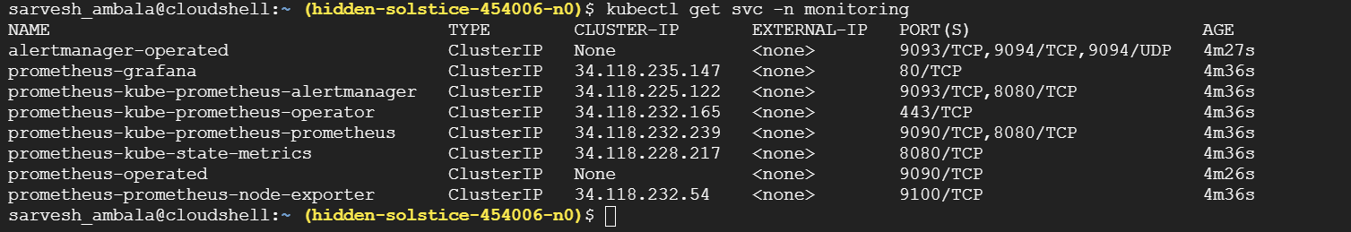

Access prometheus and port forwarding

kubectl port-forward svc/prometheus-kube-prometheus-prometheus 9090:9090 -n monitoring



Click on the webpreview

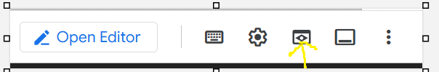

Change port no to 9090

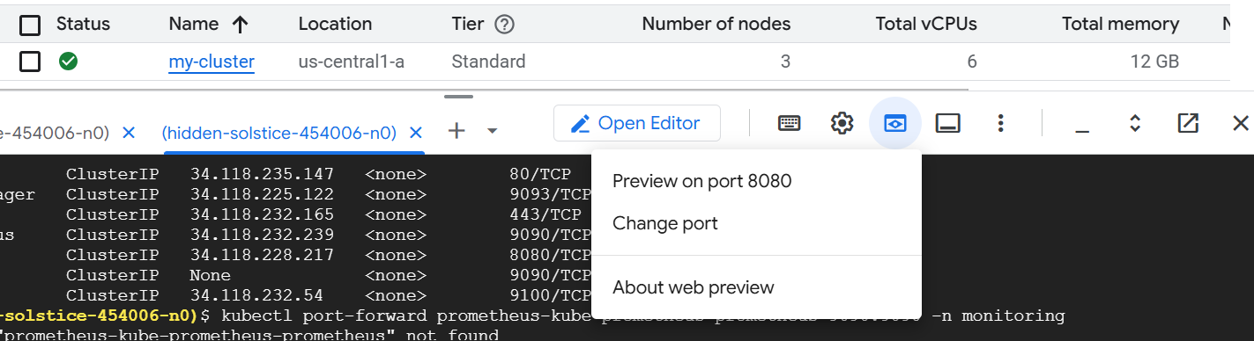

Click on change and preview

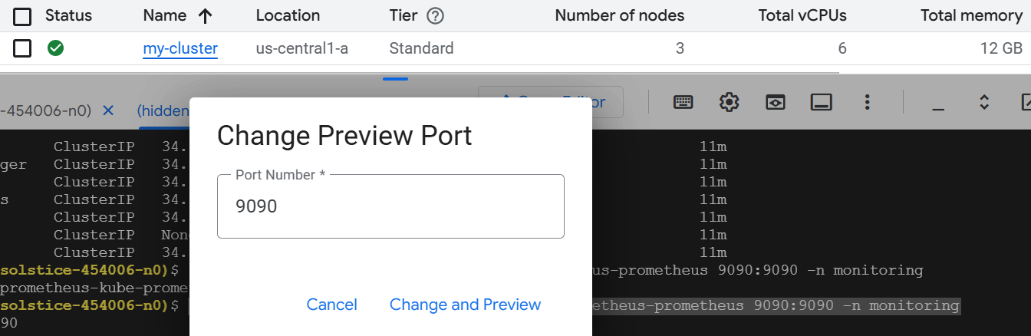

Now u can able to see prometheus in the browser

**Output:-**

